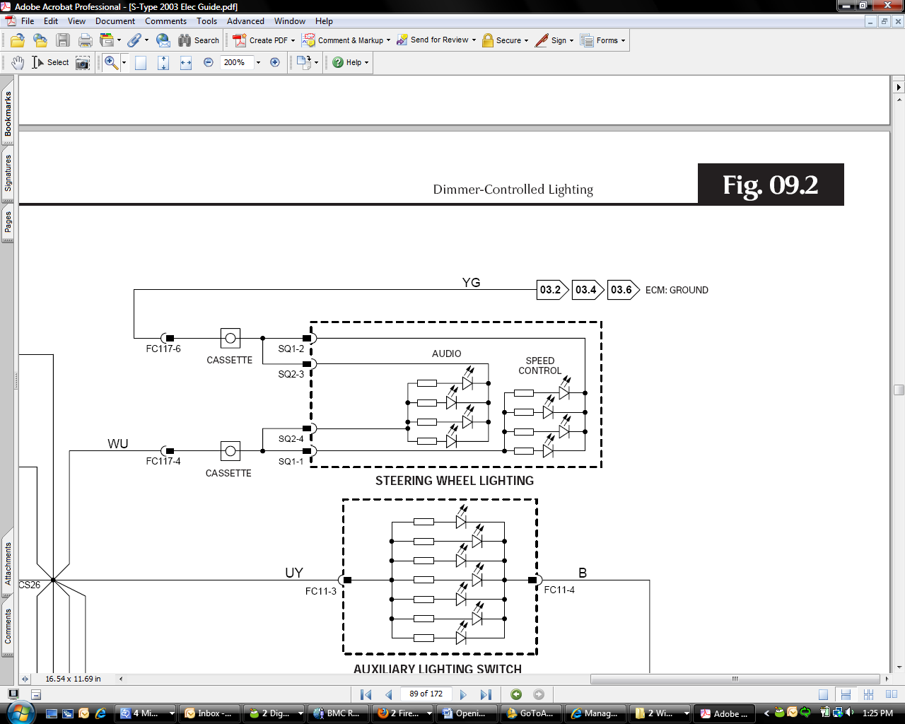
STEERING WHEEL LIGHTING SHARES A COMMON GROUND WITH THE STEERING WHEEL AUDIO CONTROL RESISTOR PACK. POSSIBLY ADDING RESISTANCE RELATIVE TO GROUND THROUGH THE LED WHEN ILLUMINATED.

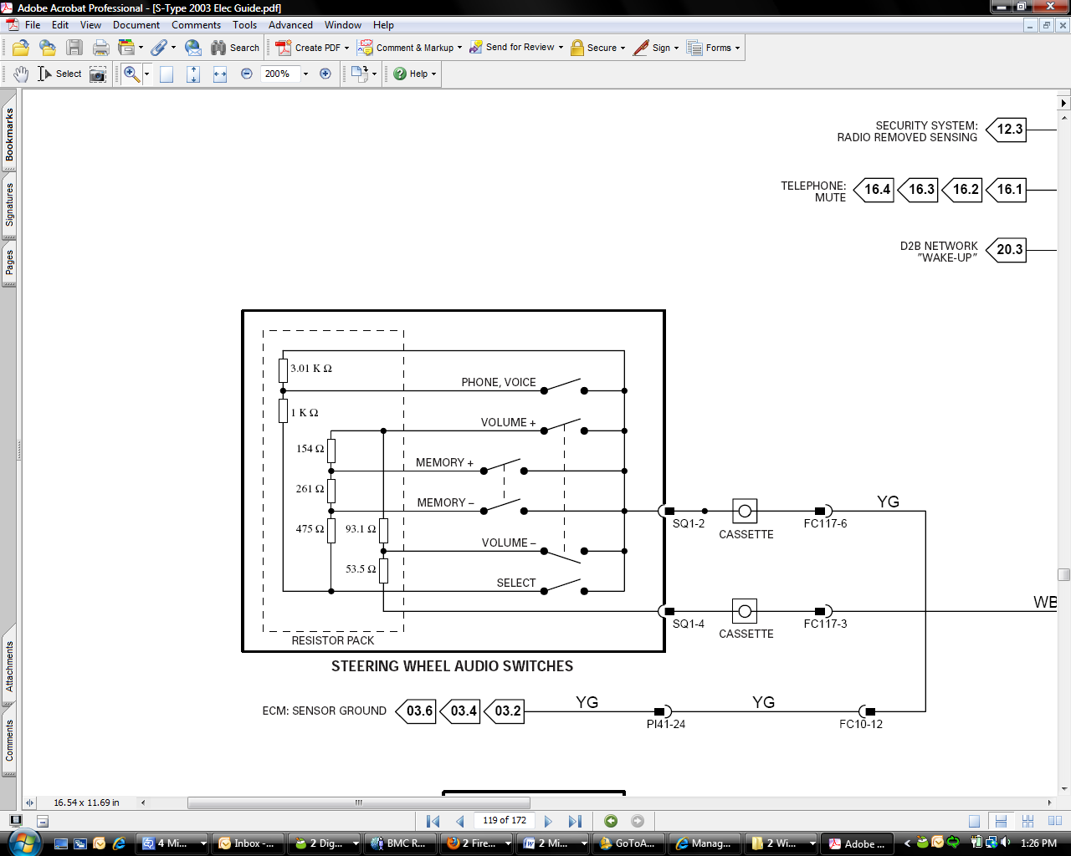
ALL RESISTOR COMBINATIONS ARE IN PARALLEL WITH THE TOP 3.01K RESISTOR
SELECT PRESSED = 53.5 ohm + 93.1 ohm + 475 ohm + 261 ohm + 154 ohm = 1036 ohm || 3010 ohm = 770.73 ohm
PHONE / VOICE PRESSED = SELECT PRESSED (1036 ohm) + 1k ohm = 2036 ohm || 3010 ohm = 1234 ohm
VOL - PRESSED = 53.5 ohm || 3010 ohm = 52.56 ohms
VOL + PRESSED = 53.5 ohm || 3010 ohm = 139.79 ohms
MEM - PRESSED = 93.1 ohms + 53.5 ohms + 154 ohms + 261 ohms = 561.6 ohms || 3010 ohm = 473.87 ohms
MEM + PRESSED = 93.1 ohms + 53.5 ohms + 154 ohms = 300.6 Ohms || 3010 Ohm = 300.6 Ohms

ONLY THE VOL AND MEM BUTTONS NO LONGER WORK WHEN STEERING WHEEL IS NOT ILLUMINATED (WHEN PROGRAMMED WITH WHEEL ILLUMINATED) SO it is lowering resistance by enough to affect those readings.

