2025-05-18 10:27:09 PM

Jaguar F-Type Calipers and Rotors upgrade

Front wheel caliper removal procedures
- Remove front wheel
- Remove brake pad sensor
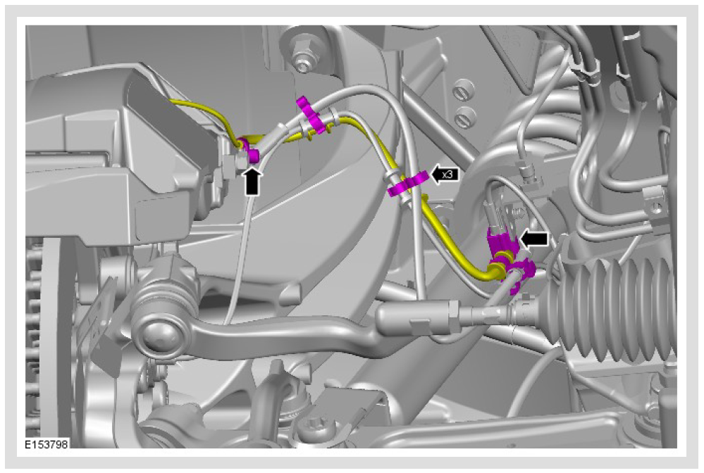
- Remove the anti-rattle spring in the centre of the spring until either side is released
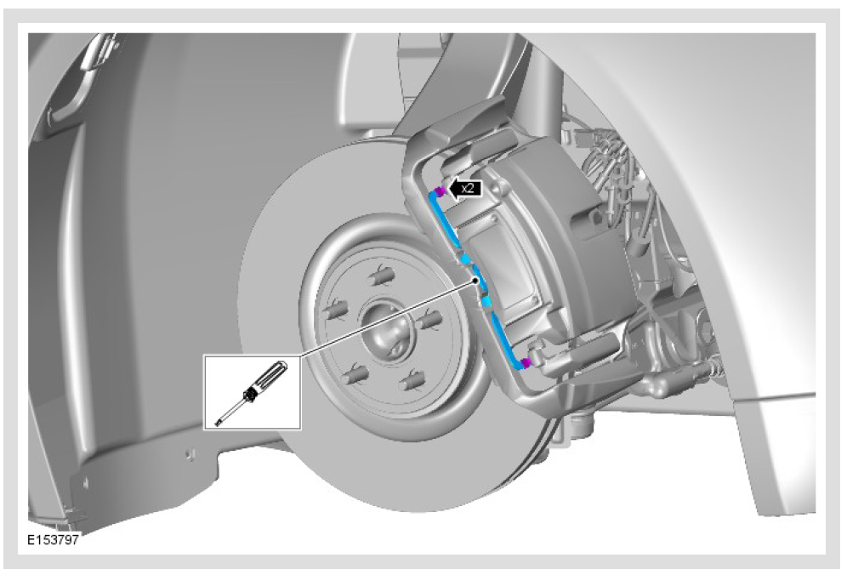
- Unscrew Caliper (Take off dust cover and unscrew 2 x 9mm hex) from support bracket
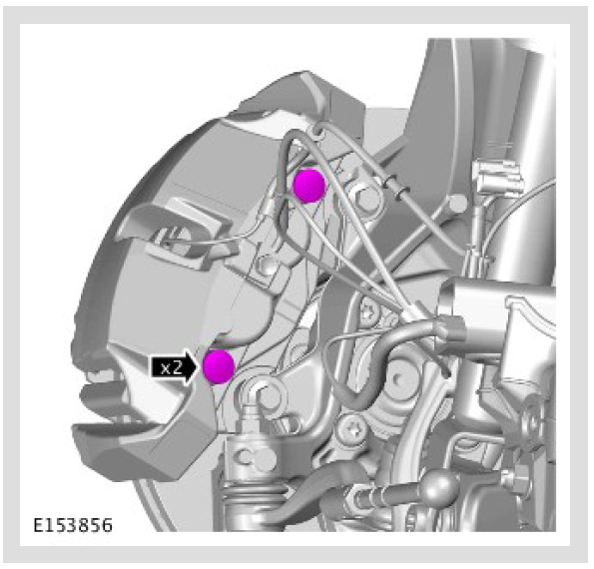
- Remove and discard pads
- Remove brake line from caliper and clamp down brake line
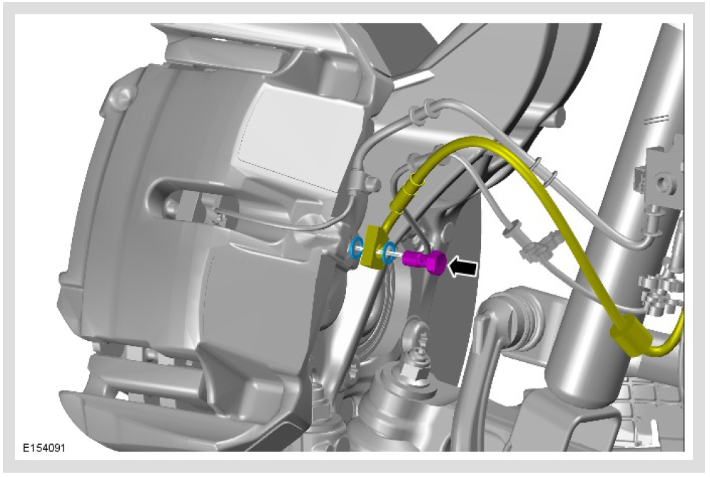
- Remove Caliper support bracket (#2 below diagram) – 2 x 15mm hex bolts
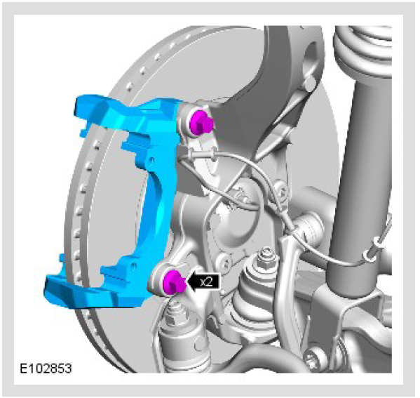
- Remove rotor
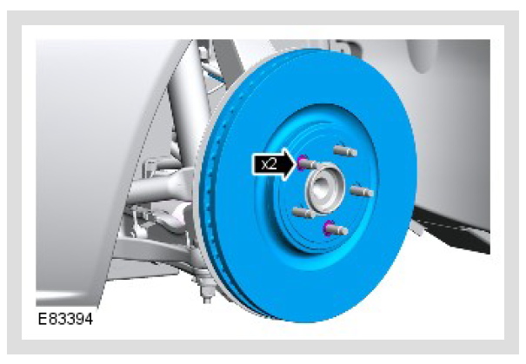
- Make sure mating surfaces (i.e. Bracket mounting area and wheel hub) are clean

Front wheel caliper installation procedures
- Install new Caliper support bracket using new bolts (Torque: 115Nm)
- Clean and Install rotor
- Install pads into new Caliper and reinstall caliper (Torque: 58Nm)
- Hook up brake lines (Torque: 42Nm)
- Replace brake pad wear sensor
- Brake system bleeding

Rear wheel caliper removal procedures
- Perform Electric Park brake service mode activation
- Remove Rear wheel
- Remove brake pad sensor
- Disconnect parking brake actuation connector
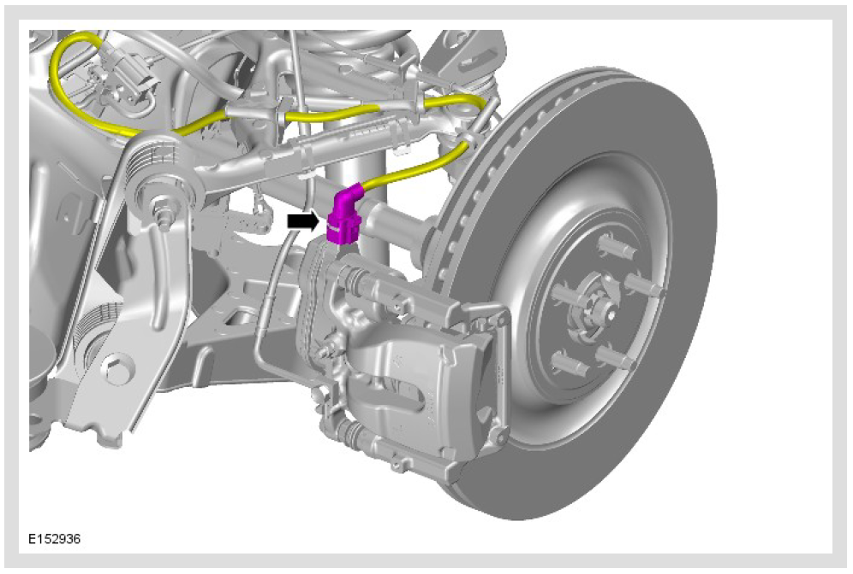
- Unscrew Caliper from support bracket unscrew 2 x 13mm hex
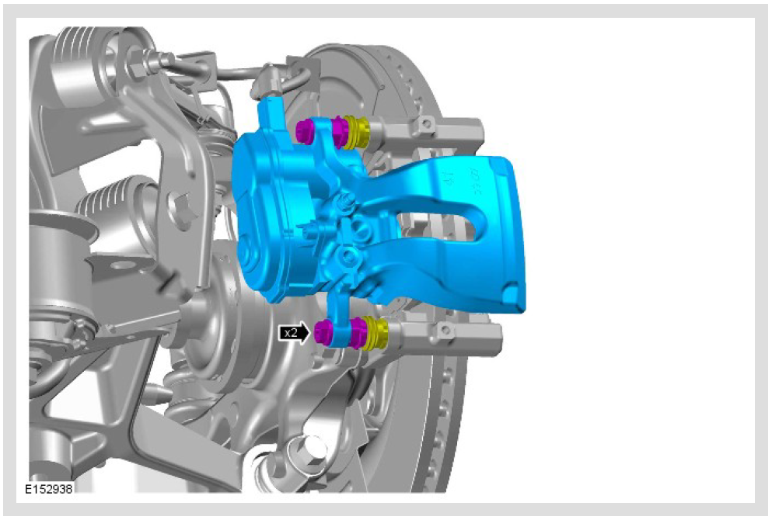
- Remove and discard pads
- Remove brake line from caliper and clamp down brake line
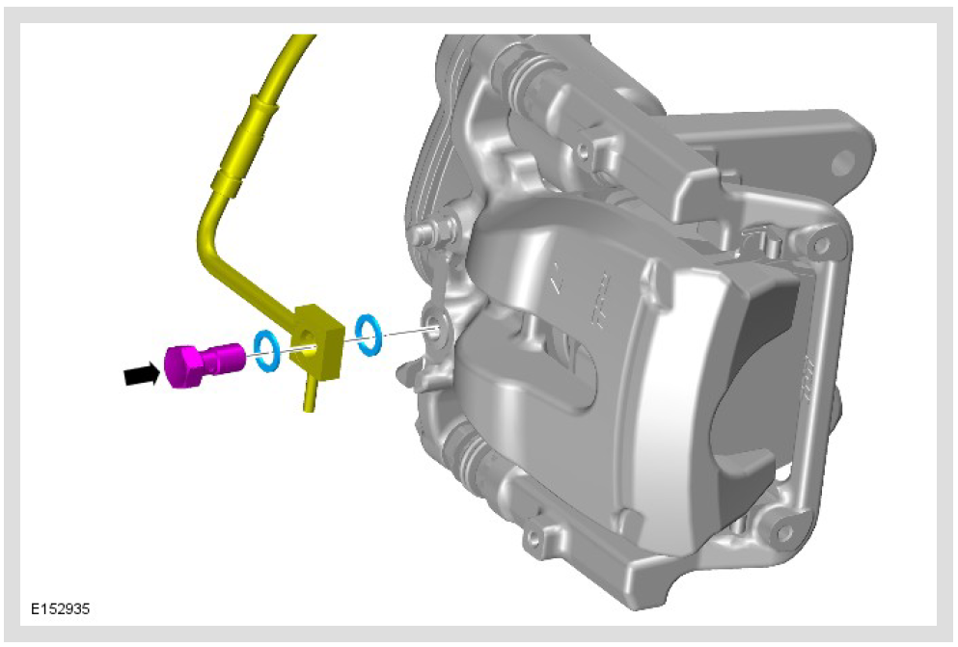
- Remove Electric Park brake actuator from caliper
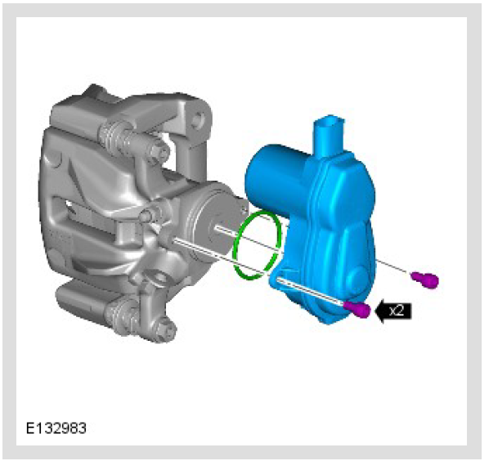
- Remove Caliper support bracket 2 x 15mm hex bolts
- Remove rotor
- Remove Splash shield
- Install Electric Park brake actuator into new caliper (New O-ring seal and bolt kit) (Torque: 42Nm)

Rear wheel caliper installation procedures
- Install new Splash shield
- Install new rotor
- Install Caliper support bracket using new bolts (Torque: 115Nm)
- Clean and Install rotor
- Install pads into new Caliper and reinstall caliper (Torque: 58Nm)
- Hook up brake lines (Torque: 42Nm)
- Replace brake pad wear sensor
- Brake system bleeding

Additional Reference
Brake system – general information – Page 2428
Front Wheel Speed Sensor Page 5279
Rear Wheel Speed Sensor Page 5310
Brake system bleeding Page 28173
