Dash and Door Veneer removal and wrapping
Time - 3 hours
Tools - T20, T30 Torx bit, craft knife, scissors and a Panel Tool.
Either vinyl or in my case alcantara wrap
Centre console and dash veneer removal.
1. Long veneer located below instrument panel. (SPEAR veneer)
This can easily be removed by hand. Slide your fingers along the bottom towards the thicker end. This is where you grasp the veneer and pull sharply towards you. Be careful not to pull out too far as you have an electrical lead that you must disconnect from the back. When relocating the Spear veneer make sure that you have reattached all of the Black clips to the back of the veneer first. Push hard all along the veneer to re-seat it.
2. Small rectangular veneer below radio controls. (BRIDGE) veneer.
This veneer does pull away and towards you from its location. This can be done by inserting a panel tool in the gap between the end of the veneer and the silver trim on the instrument panel side trim. Lever each end up a little way first then you should be able to pull off the veneer easily.
3. Big and small Cup holder veneer
Simply slide a panel tool under each corner between the veneer and the plastic lid and it pops off. When refitting the veneer press down hard in all four corners for it to click back into place.

4. Triangular veneer behind gear selection. the (PIANO) veneer.
First open storage box then in the same method as the (BRIDGE) veneer, remove the silver rectangle cover over the emergency hand brake release. This is, in most cases the trickiest to remove because damage can be caused to the holding clips which are located underneath the veneer and moulded to the centre console. There are 4 of them that receive 4 little circular pins moulded to the bottom of the veneer. If that hasn't put you off then to remove the veneer you must use a slight downward force and slide it backwards. The front end is slightly tucked under the gear selector. Use the palm of your hand.

Front and rear doors.
The front and rear doors are almost identical to take off apart from the rear doors do not have a T20 TORX screw in the outer edge below the triangle cover.
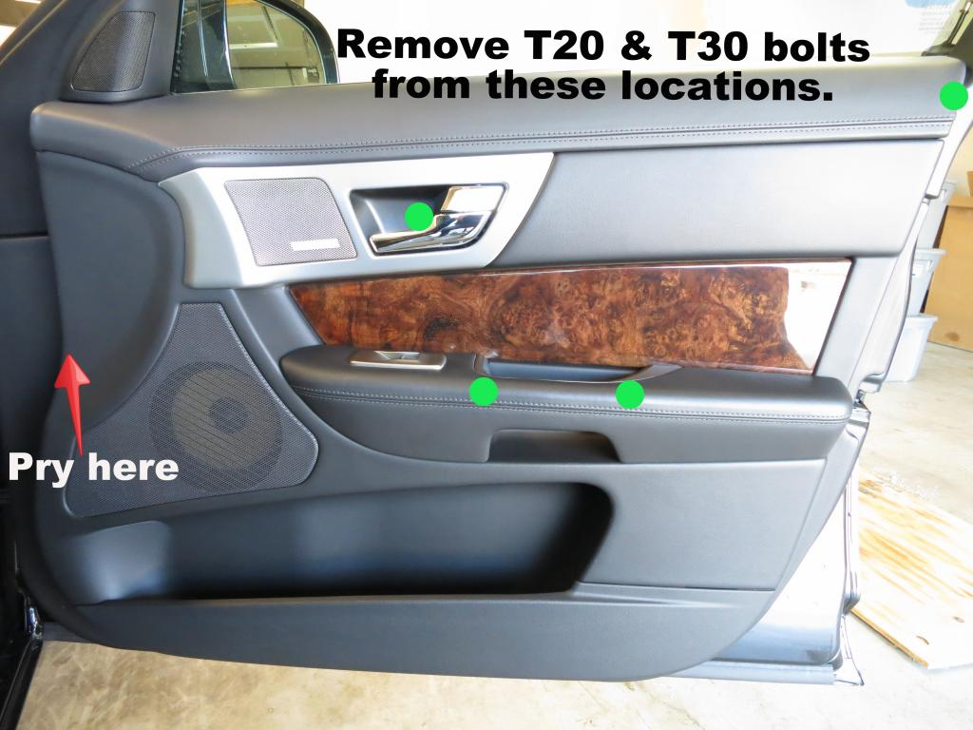
First remove the covers from the doors.

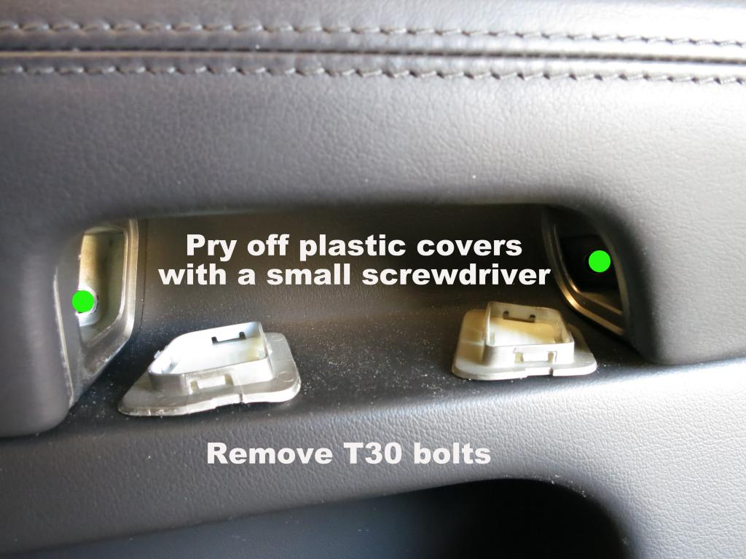
The rear door handle has a rubber cover at the bottom of the handle. Remove it to find the T30 screws.
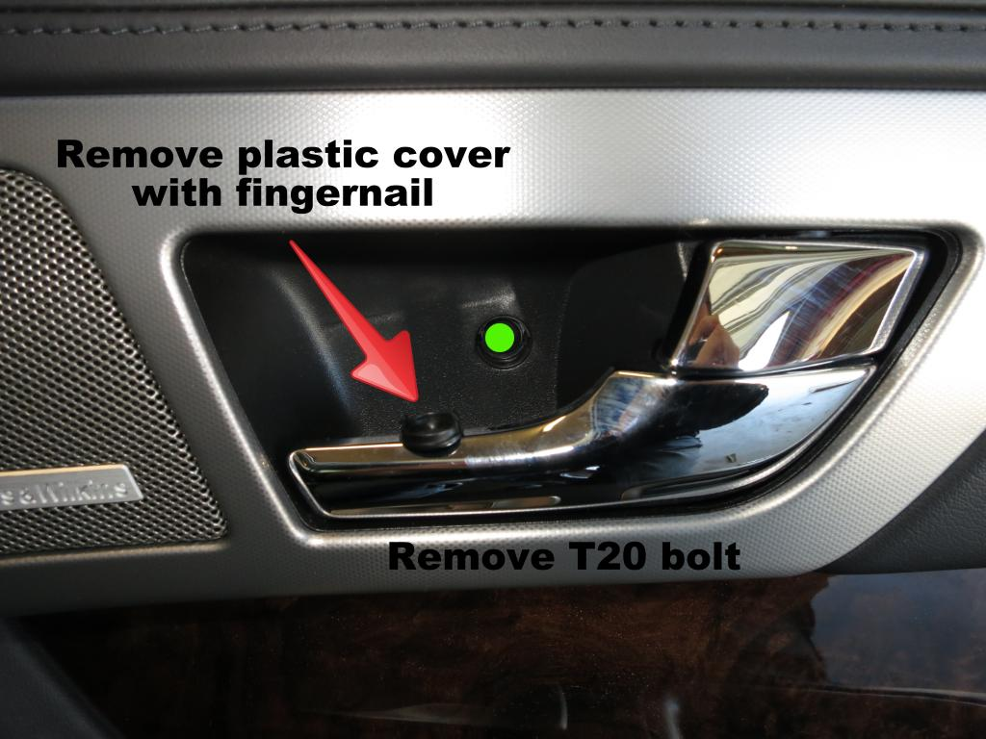
The cover is very soft but if you use your finger to twist the black cover through 90 degree’s the cover should remove. If not use a small screwdriver gently to pry out.

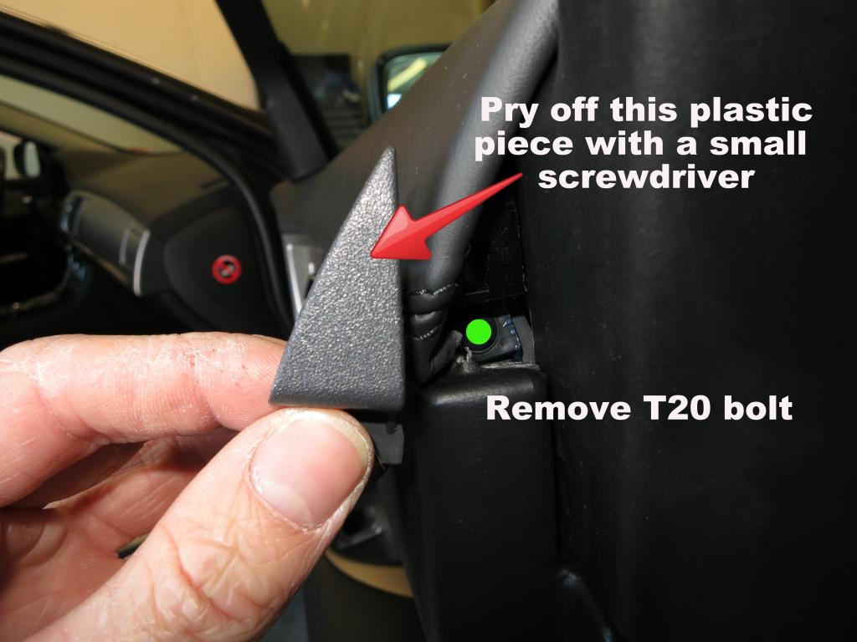
This is only required on the front doors. Now starting at the bottom corner, using the panel tool to pry the panel be careful not to break the clips pull on the panel around the outside to loosen. There are clips and the top edge that require a little force but pulling the card horizontally should loosen the clips. Once loosened careful of the electrical connections. Remove the electrical connections and then the card will be free. To replace, follow instructions in reverse.

Removing the door veneer’s
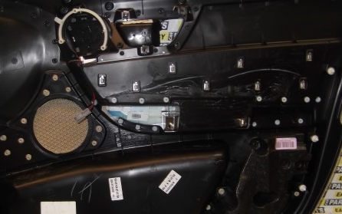

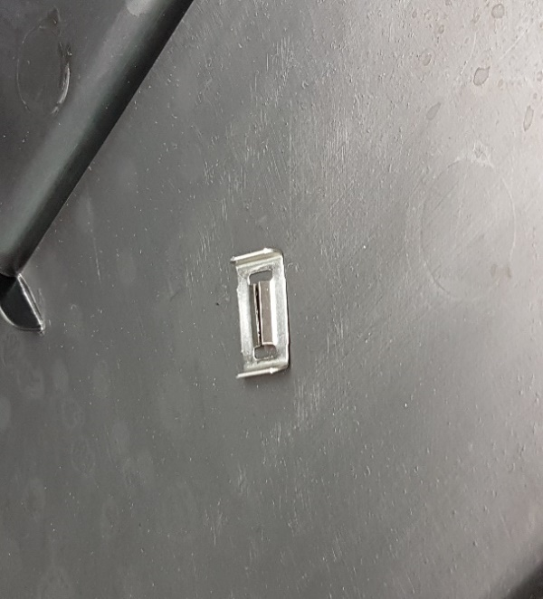
The veneers are held on by metal retaining clips on both front and rear doors. Use the panel tool to simply pry the clips off. To replace slid clip back on. I used a pair or pliers to push the clips down onto the panel.

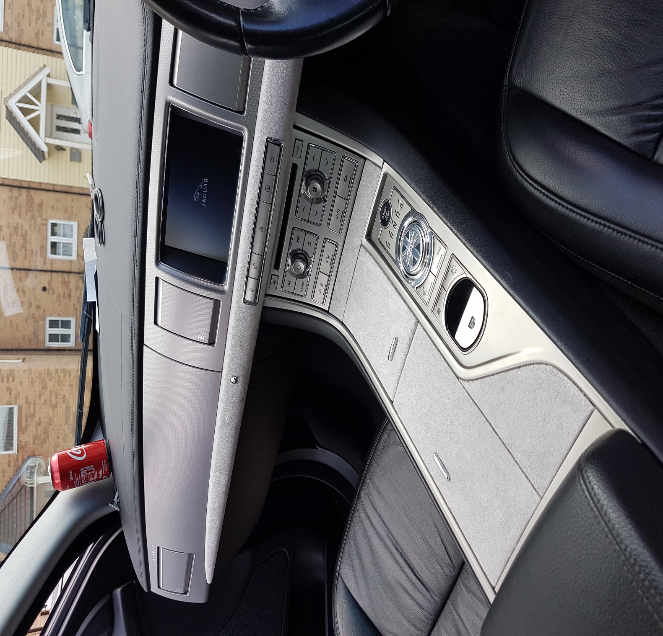
Finished Product

