Here is a design for a control switch for the starting carburetor solenoid with an indicator light.
As delivered the solenoid is powered by a green wire that comes from the A4 fuse through the brake light to the solenoid. It is powered when the ignition switch is on. The solenoid is grounded through the Otter switch near the engine end of the top radiator hose. The Otter switch controls the power to the solenoid by varied resistance depending on coolant temperature. When the coolant is cool the power goes to ground. When the engine warms the coolant the Otter switch opens and the power does not flow through the solenoid.
The solenoid with power through it raises a valve allowing fuel to enter a separate array of piping directly into the intake manifold. This fuel does not enter the manifold through the carburetor body.
For those drivers who are concerned about removing the Otter switch, achieving control of the starting carburetor with an indicator light the schematic and pictures show how it was done on my car. It may not work on yours.
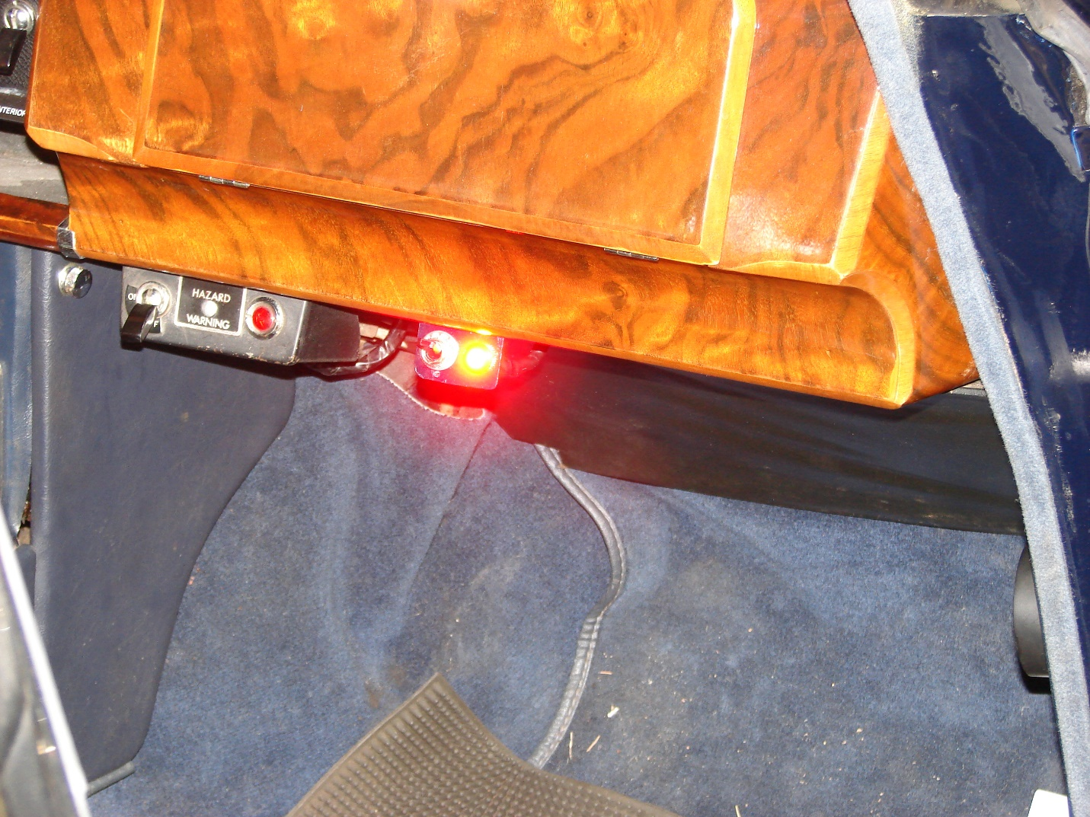

In the picture the control switch is on and the light indicates that is on. On is up. When the switch is down the solenoid powers off and the internal spring closes access to the starting carburetor distribution system to the intake manifold.
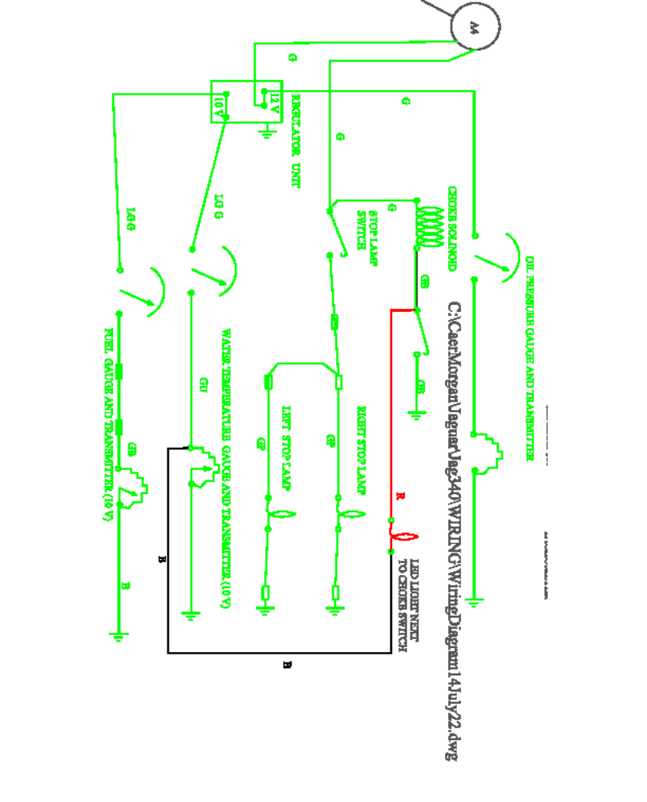

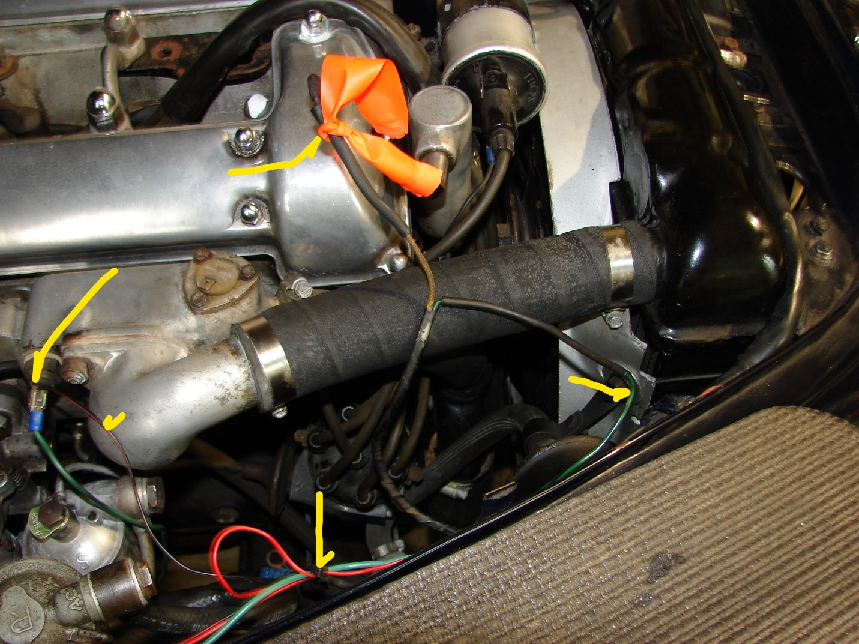

The wire with the orange ribbon is the coil wire. It is disconnected to protect the points when the ignition is on for testing. The yellow arrow on the right is the green-black removed from the Otter switch, now grounded through the new cabin switch. The bottom yellow arrow points out the new bundle connected to the green-black wire that went to the Otter switch. The bundle is made up of the green wire to ground through the new switch and the red-black pair that goes through the indicator light in the cabin. The large and small yellow arrows on the left show how the indicator light is connected to the tab for the cooling water temperature. There is an unintended benefit in that the indicator light glows solid when the engine is cold and flashes when the engine heats up.

