2004 Lincoln LS Burning oil smell, Intake Manifold Tuning Valves (IMTV)

Jaguar part # c2s40669 ? or O-Rings is XR851930, Ford,
Is this normal? If not, any ideas where it would be coming from.
Thank you goduars (get it)(I kinda like that one)
Attached Thumbnails
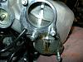
normal, make sure you’re using the new style green orings. They seal much better, we at the shop are also now working on different ideas to reduce this since I believe its the number 1 cause for misfires on cylinders 1,3,5 which are fed by the lower intake. When the oil vapor which comes from the crankcase goes through the intake it settles out in the lower plenum as your pics show, when it becomes heavy enough, it cause misfires on these cylinders. The things Ive been working on with a couple customers is switching to a 40w oil, cleaning the intake passages, and as of yesturday 1 customer is going to start using engine restore to increase ring seal and reduce blowby. All are much cheaper and better fixes so far than thowing in 3 coils, plugs and shipping..especially since it always involves removal of the intake and subsequent labor fees

the check valve (bulbous thing in the middle of the hose) on the brake boost hose is what causes the most problems in that area. If it is "white" in color, it will most likely crack underneath. The new one is shrink wrapped in black. IMT o-rings are new if they are "green" and old if they are "yellow". Since you are only getting the lean code for the one bank, look at that check valve first. Replace the IMT o-rings anyways as they will eventually need it if not already done. Last thing to look at is the PCV hose (about eight inches long and one inch diameter) slightly right of center at tyhe front of the car. If it's "ribbed" it's probably already been replaced, if not it will develop a split underneath that you can't always find just by looking.
The ls v6 oil leak issue is not to be confused with the ls v8 oil leak issue. From my research on the issue the ls v8 involves the valve cover gaskets ("vcg") in which oil leaks from the vcg onto the coils and ruins them. This is not an issue with the ls v6. Unless your particular car has developed an obvious vcg leak on the ls v6 from what I have read and seen on my own ls v6 the oil leak and burning smell have nothing to do with a leaking vcg.

I have confirmed the oil is leaking from the upper intake on the passenger side which in turn drips on the hot exhaust manifold and is suck into the hvac system and bam....burnt oil smell. I discovered a few posts today and a Ford technical service bulletin about the 3.0 liter v6 in the ls. My oil leak is coming from what are called Intake Manifold Tuning Valves (IMTV) of which there are two in the upper intake of the ls v6. They have a rubber oring around them to seal them in the intake. Mine is leaking from the bottom one. I intend to replace the oring with a new one (which is was a Ford dealer did for another poster and it fixed the problem). Here is a link to the service bulletin which involves a vacuum leak of the same parts. Do a forum search of "burning oil smell" for more info. Oh and yes I replaced the pcv in late 2009 when I replaced all the coils and spark plugs.
http://www.justanswer.com/ford-linco...blem-code.html
Mine had the exact same prob right after I bought my car 3 months ago with 66k on it. Lucky for me I just took it back to the dealer and got it fixed under warranty. Leaking from Intake manifold tuning valves, they replaced them and intake tuning ring. I personally don't know what that consist of, I just read it off my paper work...
Update...I went and got the orings today for two IMT Valves ($9.00 a piece from the dealer here, and yes I shopped around and they were the only ones that had them). I was thinking I was going to have to go through the process of taking off the upper intake manifold but in my quest to find the orings online I found a Jaguar forum that had a much easier way. It involves the Jaguar Stype with the 3.0 v6 (same engine in the LS V6) which it shares its platform with around the same model year Lincoln LS. here is the link...
http://www.jaguarforums.com/forum/sh...ad.php?t=32135
or you can do an internet search of "intake manifold tuning valve o-ring" and one of the results will lead to this.

Basically it involves removing the cowl, wiper arms, front strut tower brace, and moving a few vacuum lines. This allowed me to remove the upper IMT Valve easly. For the bottom IMT Valve I went ahead and removed the cabin air filter, cabin air filter holder, the box protecting the cabin air filter from the engine compartment, and a bracket on the passenger side strut tower which was holding some wires in place behind the IMT Valve. After that I got the bottom valve out with little effort and replaced all the o-rings. Then just put it all back together. Lots easier then removing the upper intake imo. Be mindful the Jaquar is slightly different but you should be able to figure things out easily. I will update to see if this solved the oil leak. I also cleaned the engine as there was oil in several locations. Thanks for all the replies.

the easy way to remove your wiper arms is to remove cap and the 13mm bolts on them. with your hood closed fold the wiper arm up if u press down at the hinge and wiggle the wiper arm up at the sametime it will come right out. My car is making a similar smell but is leaking from the plastic tube part of pvc hose onto the exhaust. ford sent me a letter stating the have a new style of hose for the pcv that will fix my problem. heres a link to the sorta the letter i got. this is the one the dealers got mine says it will be replaced free of charge for 10 years or 100k miles. http://www.allstatetrucks.com/Recall...20bulletin.pdf

Parts: Dealer part number located bottom of this post or aftermarkets available from MotorcarsLTD: http://www.motorcarsltd.com/C2S40669.html
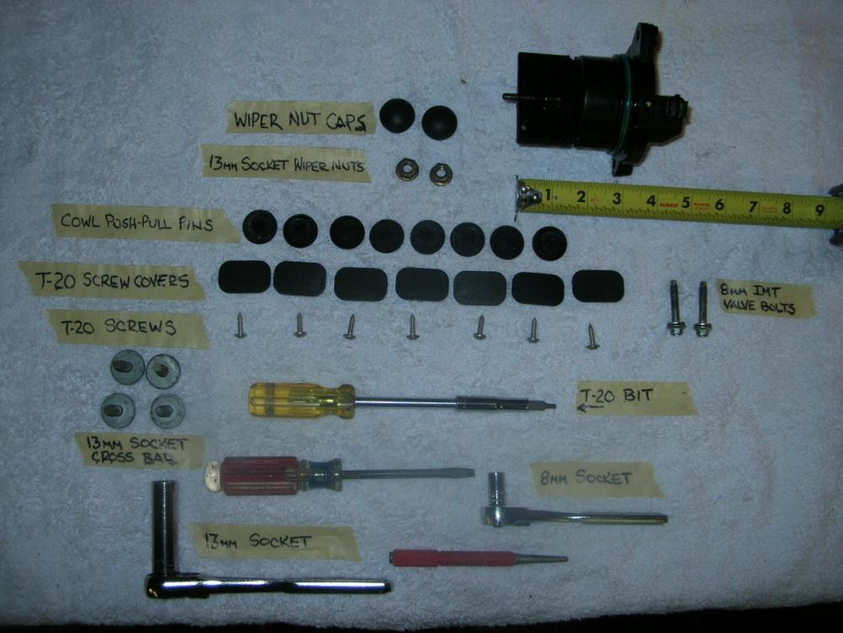
This procedure was done on a 2005 3.0
First start off start with removing wiper arms:
Disconnect wiper washer supply lines, being very carefull not to snap off nipples!
Remove wiper arm 13mm (socket) nut covers, loosen nuts to top of stud. Grab ahold of wiper arm closest to nut as possible, while pulling up on arm strike the nut with small hammer (arm assembly should "pop" on third hit). DO NOT remove nut then strike stud this will lead to possible stud damage! If you get this far everything else is down hill. If not have someone else do the replacement.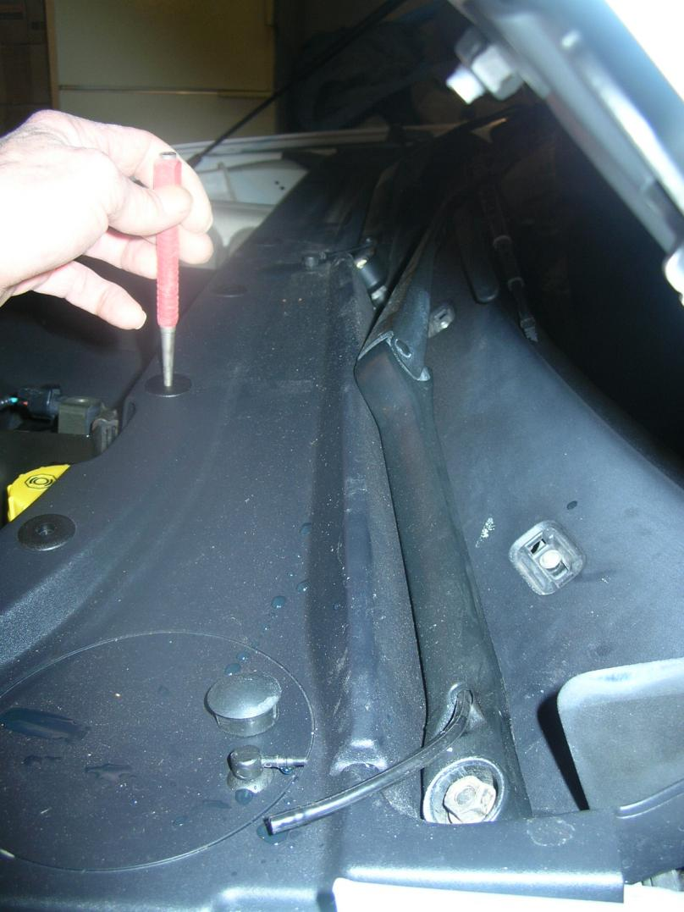
Using "optional" nail set, push down on center push/pull pin on front cowl (8 pieces). Using flat screw driver or finger nails pull up on washer. Remove 1 at a time! (To reinstall these, push the pin from the underside up so it protrudes the top of its washer).
Remove (7) rear cowl T20 screw covers and screws. You are now able to slide cowl cover away from work area. The wiper washer supply line is still connected to underneath cowl, it has alot of play to just set over front of engine bay.
Optional use vacuum to suck up what appears to be paper fiber insulation under cowl and rear of engine bay. Mine was deteriorated bad (now I have none). Good time to clean wiper arm drain as well (drivers side US)
Remove (4) crossbar 13mm (socket) bolts, set bar aside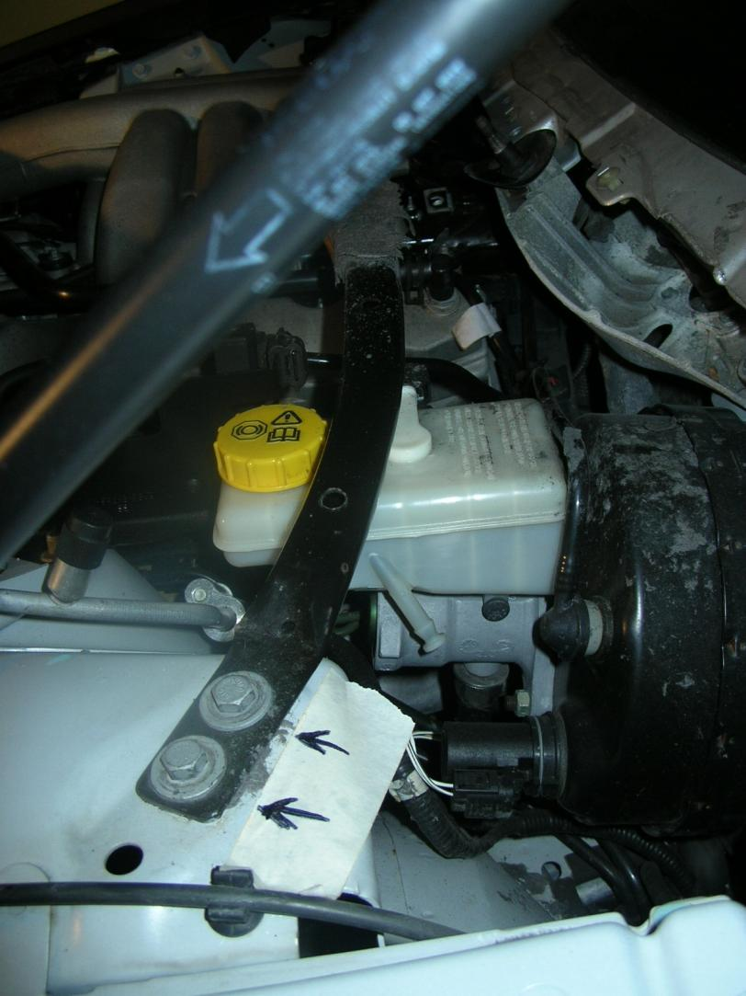
Now theres a clear but very tight view of the IMT tuner valves. Disconnect wire harness using thumb pressure from upper tuning valve. Using 8mm socket (or wrench) remove (2) tuning valve bolts, wiggle valve out of intake manifold. Tricky part now is to find the right spot where the valve can be wiggled out of the engine bay. Lower IMT tuning valve same removal process. There may be as much as a 1/3 cup of oil that drains out of the lower port! Using clean rags and cleaner, clean the lower IMT port. Replace yellow IMT O-Ring with new GREEN O-Ring.
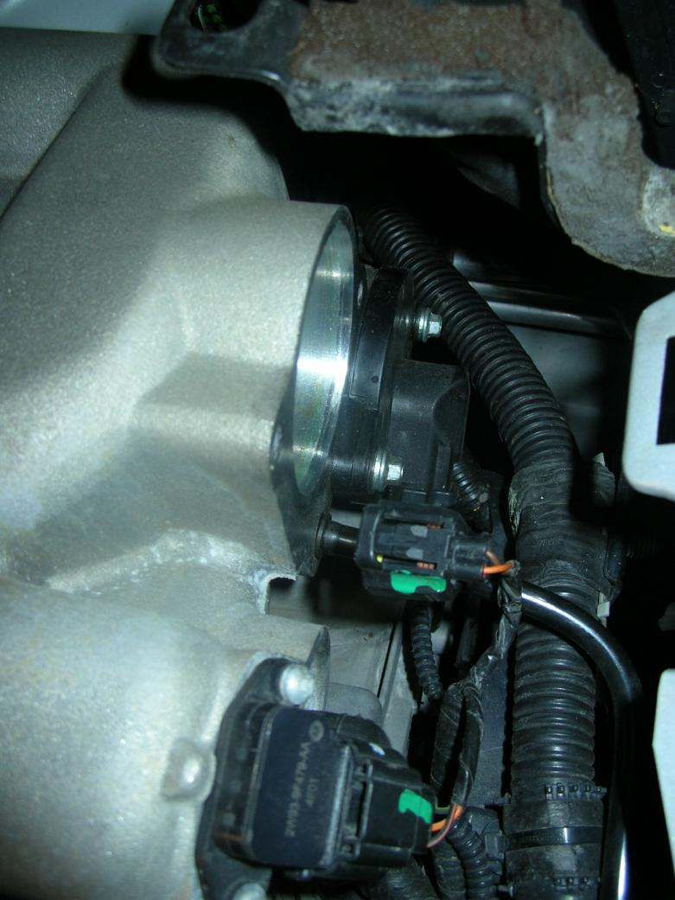
Install, reverse procedure. When going this route you cannot properly torque IMT valve bolts. They should be snug but not over tightened! Also when reinstalling cowl, the awl comes in handy to match up the T20 screws.
Words of advise: On the underside of cowl there are thin black washers that hold the T20 screws, they are very easily moved or can fall out, use caution if you do not want to loose them. Also note the fins on the underneath cowl these are the washer fluid main line holders (see photo).
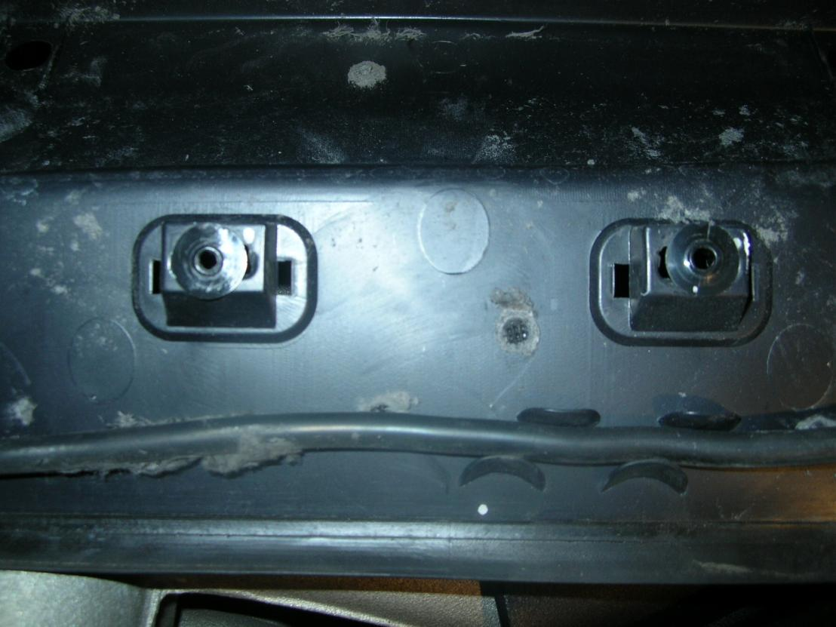
If your vehicle is close to needing spark plugs, then you should consider IMT Replacement "long route" which would require the intake manifold to be removed.
*Also now is a good time to replace the cabin/pollen air filter or at least vacuum it out!
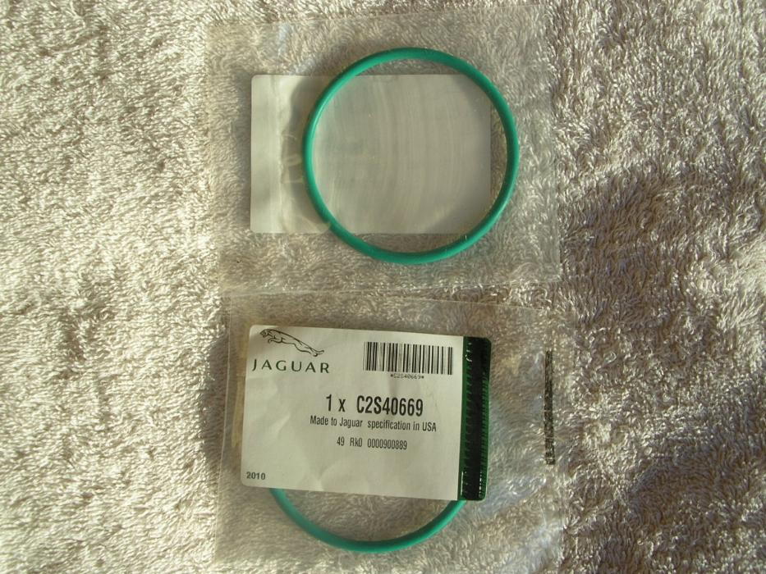
The only additional tip I would add is that there is a rubber-like flexible shield surrounding the area where the pollen filter sits, essentially to protect the pollen filter from engine dirt and grime. We didn't remove this shield, but we found that if we loosened a couple of the nuts that hold it in place over in the area where the IMT valves are, we could move this shield a few inches out of the way and that really opened up some additional working room for me with my huge hands. If we hadn't loosened those shield nuts, I could not have gotten my hands far enough down into the area behind the intake manifold to re-install the lower IMT valve....
I found our pollen filter to be pretty clean, so I just used my shop vac to clean it up a bit more....
The new-style green IMT O-rings are noticeably thicker and rounder than the factory-installed yellow ones. Also, the green color is actually a sealant that takes effect once you get those IMT valves seated back into their chambers and heat up the engine....
As common as this problem is there's no question that sooner or later, any owner with the original yellow factory IMT O-rings will develop leaks and must replace them. If you can do this yourself, the cost of the repair is less than $5. My two new O-rings cost $2.15 plus tax each....
The intake manifold tuning (IMT) valve system uses variable air induction tuning in order to achieve maximum performance and efficiency over the entire operating range of the engine. The characteristic torque curve of a normally aspirated engine depends mainly on how the engines average pressure changes over the engine speed range. The average pressure is proportional to the volume of the air mass present in the cylinder when the inlet valve is closed. The design of the inlet system determines how large an air mass can be drawn into a cylinder at a given engine speed. An IMT valve is used to change the intake manifold plenum configuration. When the IMT valve is open, the intake manifold is configured to one large plenum. When the IMT valve is closed, the intake manifold is configured to 2 smaller plenums. The 2 intake manifold plenum sizes result in different torque curves, which improves performance at low and high engine speeds. During low speed, high load conditions the IMT valve is closed creating a longer runner path inside the plenum, which increases torque. During higher engine speeds and loads, the IMT valve opens creating a shorter runner path inside the plenum, which increases horsepower.

Intake Manifold —Upper

Removal
1. Disconnect the battery ground cable.
2. Drain the engine cooling system.
3. Remove the engine appearance cover.
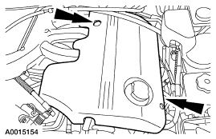
4. Remove the air cleaner outlet tube.
5. Disconnect the throttle position (TP) sensor and the idle air control (IAC) solenoid electrical connectors.
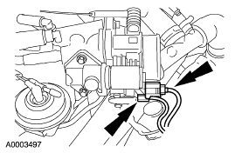
6. Disconnect the accelerator and speed control cables.
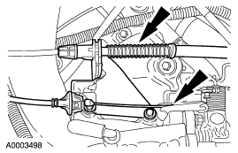
7. Remove the cable bracket.
1. Remove the bolts.
2. Remove the bracket.
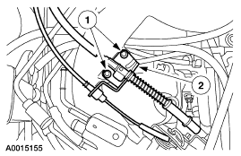
8. Disconnect the throttle body hoses.
1. Disconnect the coolant hoses.
2. Disconnect the positive crankcase ventilation (PCV) hose.
3. Disconnect the vapor purge hose.
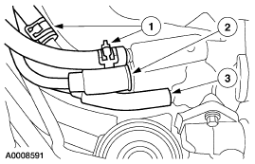
9. Disconnect the vacuum hose.
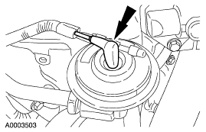
10. Disconnect the EGR to exhaust manifold tube nut.
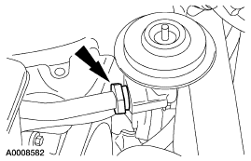
11. Remove the cowl vent screen.
12. Remove the brace.
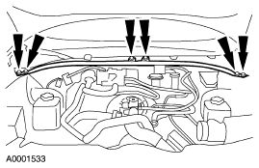
13. Remove the vacuum hoses from the mounting bracket.
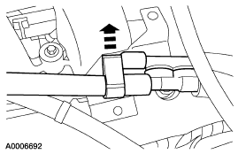
14. Remove the bracket and position the accelerator and cruise control cables aside.
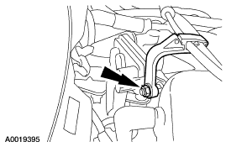
15. Disconnect the differential pressure feedback EGR electrical connector.
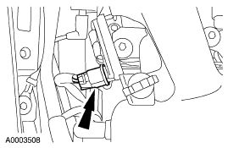
16. Remove the stud and nut and position the differential pressure feedback EGR transducer aside.
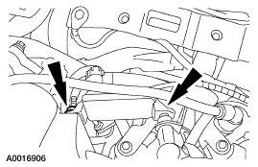
17. Remove the fuel pressure sensor shield.
1. Remove the nut.
2. Remove the bolts.
3. Remove the shield.
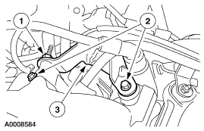
18. Disconnect the vacuum hose from the rear of the upper intake manifold.
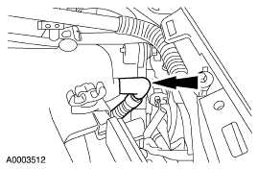
19. Disconnect the intake manifold tuning valve (IMTV) electrical connector.
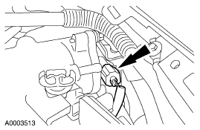
20. Disconnect the exhaust vacuum regulator (EVR).
1. Disconnect the electrical connector.
2. Disconnect the vacuum line.
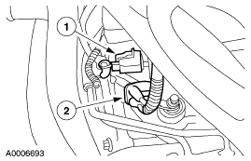
21. Remove the upper intake support bolt.
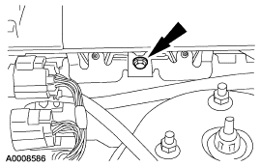
22. Remove the front intake manifold support bolt.
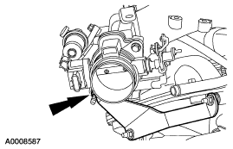
23. Remove the bolts and the upper intake manifold.
• Inspect the gaskets and discard as necessary.
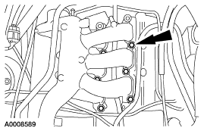
Installation
1. Position the upper intake manifold and gaskets.
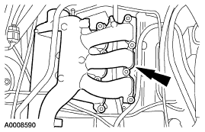
2. Install the fuel pressure sensor shield.
1. Position the shield.
2. Install the nut.
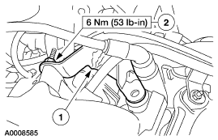
3. Install the upper intake manifold bolts and tighten in the sequence shown.
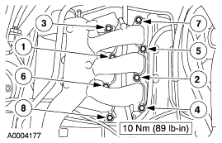
4. Position the differential pressure feedback EGR and install the nut and stud.
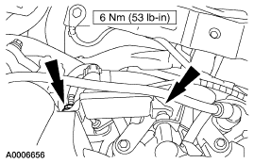
5. Install the upper intake manifold support bolt.
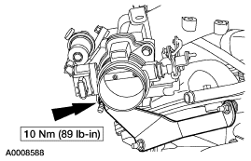
6. Install the upper intake support bolt.
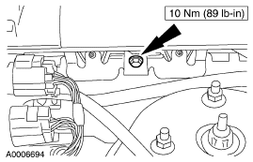
7. Connect the exhaust vacuum regulator (EVR).
1. Connect the electrical connector.
2. Connect the vacuum line.
8. Connect the intake manifold tuning valve (IMTV) electrical connector.
9. Connect the vacuum hose to the rear of the upper intake manifold.
10. Position the differential pressure feedback EGR electrical connector.
11. Connect the differential pressure feedback EGR electrical connector.
12. Position the accelerator and cruise control cables and install the bracket.
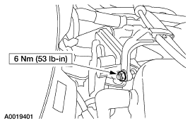
13. Clip the vacuum hoses into the mounting bracket.
14. Install the brace.
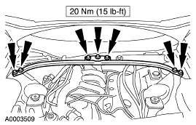
15. Install the cowl vent screen.
16. Connect the EGR to exhaust manifold tube nut.
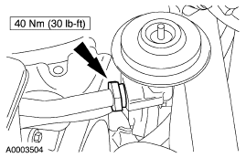
17. Connect the vacuum hose.
18. Connect the throttle body hoses.
1. Connect the coolant hoses.
2. Connect the PCV hose.
3. Connect the vapor purge hose.
19. Install the cable bracket.
1. Position the bracket.
2. Install the bolts.
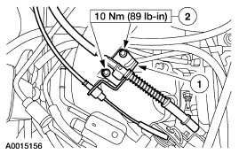
20. Connect the accelerator and speed control cables.
21. Connect the TP sensor and the IAC solenoid electrical connectors.
22. Install the air cleaner outlet tube.
23. Install the engine appearance cover.
24. Fill the engine cooling system.
25. Connect the battery ground cable.

