Shock Absorber and Spring Assembly
Removal
- Remove the wheel and tire.
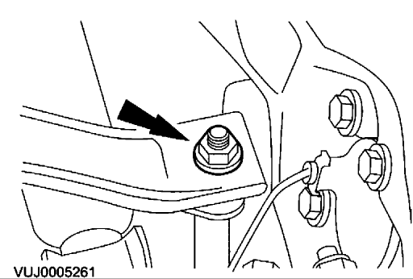

- Remove the stabilizer bar link retaining nut.
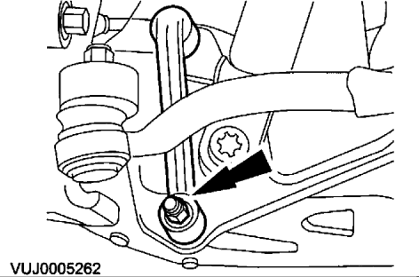

- Remove the stabilizer bar link.
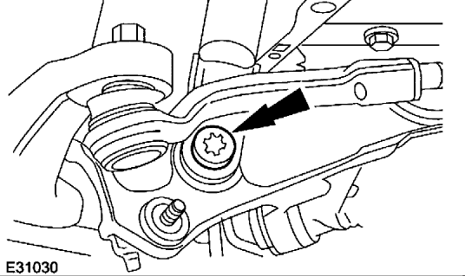

- Detach the shock absorber.
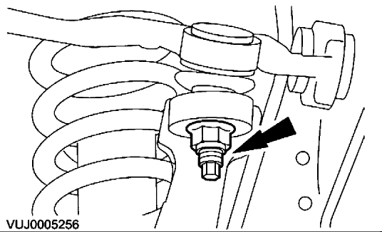

- CAUTION: Make sure the wheel knuckle is supported. Failure to follow these instructions may result in damage to the vehicle.
Detach the upper arm.
- Lower the vehicle.
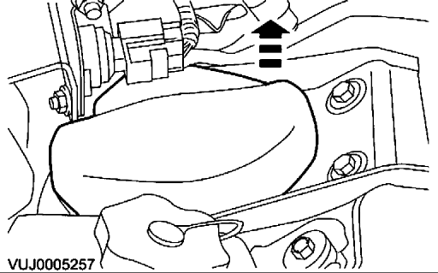

- Remove the shock absorber and spring assembly mounting cover plate.
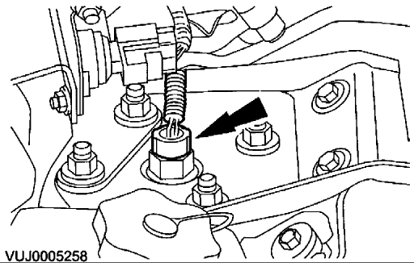

- Disconnect the electrical connector.
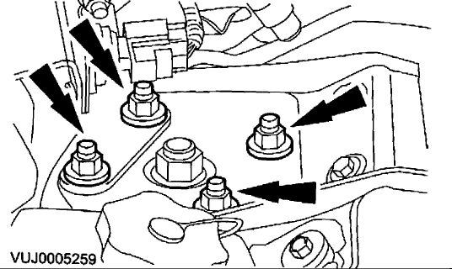

- Remove the shock absorber and spring assembly.
Installation
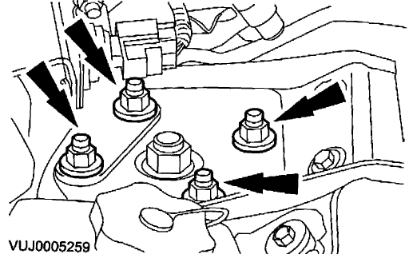

- Install the shock absorber and spring assembly.
- Tighten to 27 Nm .
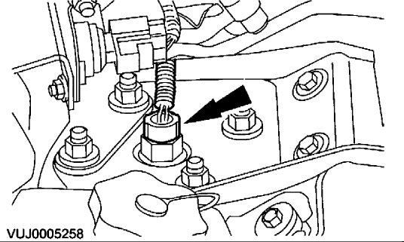

- Connect the electrical connector.
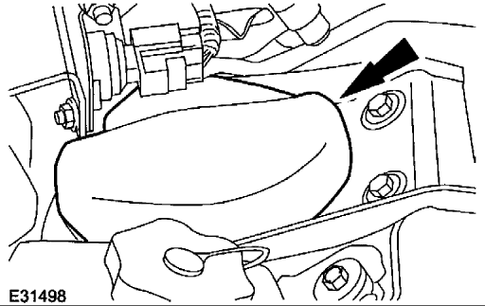

- Install the shock absorber and spring assembly mounting cover plate.
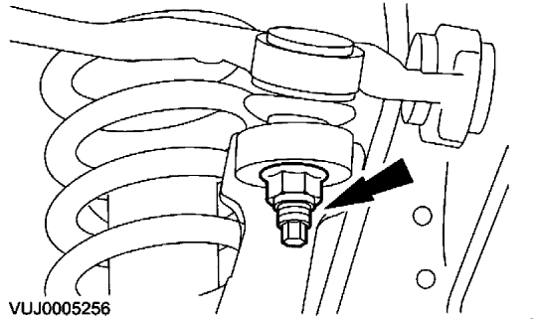

- CAUTION: Make sure the wheel knuckle is supported. Failure to follow these instructions may result in damage to the vehicle.
Attach the upper arm.
- Tighten to 90 Nm .
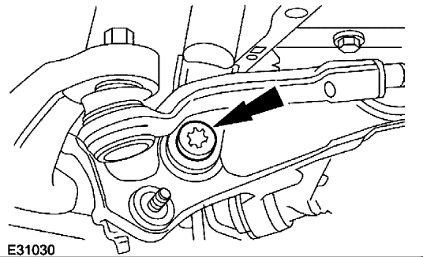

- Attach the shock absorber.
  - Tighten to 175 Nm .
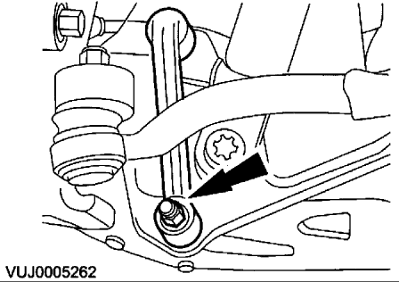

- Install the stabilizer bar link.
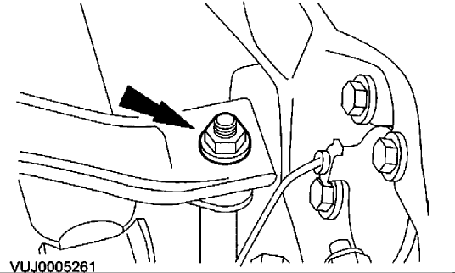

- Attach the stabilizer bar link.
  - Tighten to 47 Nm .
- Install the wheel and tire assembly.
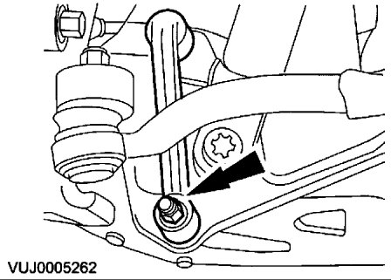

- Tighten to 70 Nm .

