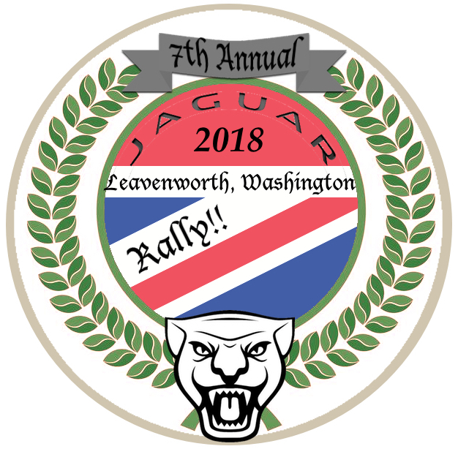
WELCOME...
...to the 2018, Seventh Annual Leavenworth drive!

This event is to allow Jaguar owners the opportunity to meet and share the unique experiences of owning and driving such wonderful cars. This is a family event! We would like to encourage the camaraderie and fun found in the wandering back roads of our area, far away from the rapid pace we live in today. If you have children attending, please pay utmost attention to their safety!

Where to meet:

Attendees will meet in the Safeway parking lot in Monroe WA between 8:15 and 9:00 AM. Chain Lake Rd and Hwy 2 Monroe, WA

Our driver’s meeting will take place at 9:00 AM for a prompt 9:15 departure. Safeway offers Coffee and doughnuts, and a Starbucks is just the next lot over. A McDonalds shares the parking lot for those wanting a McMuffin or such. Come early to meet everyone and joke around a bit before the serious driving starts!

Come Prepared:

Fuel: Please arrive with a full tank of gas. Shell and Chevron stations are both visible from the Safeway parking lot. The group can’t hold for fueling! Other chances for fueling will be in Leavenworth and Cle Elum.

Papers: Make sure you have up-to-date registration and insurance paperwork. Bring your Discover Pass for parking at state parks.

Safety: Make sure your car is ready by checking fluid levels, lights and indicators. Follow at safe distances, and allow fast drivers to pass into and out of our group. Bunching up and hogging passing opportunities for cars trailing us may encourage tempers. Be courteous, be safe...

Communications: We will utilize FRS 2-way radios (available at Best Buy, Target, etc.) for car to car communications on channel 4 (Alternate Ch7). If you own a pair, please bring them with fresh (and spare) batteries. If you have extra radios to loan, please bring them to share!

Weather:
Watch weather conditions for the day of the event. Crossing the Cascade range can offer a wide variation of weather conditions from 55 degree torrential downpours on one side, to 82 degrees and sunny on the other. Come prepared.

Vehicle Breakdowns
We take care of each other. A car failure will not halt the procession, but we will make sure the car and owner are made safe, and arraignments for transportation are in place. At that point the group will continue the drive.

Parking:
No one protects your beloved car better than another Jag owner! Park together, and with reasonable space for egress. (Do not leave excessive gaps between cars less you wish a rusted Toyota pickup to wedge itself in there!) Leavenworth parking is always a challenge and might be 2 to 3 blocks from downtown.

Speed:
We advocate adherence to all posted speed limits. We will place the “spirited” drivers near the front, and designate a second leader for those who have come to sight-see. No one will be left behind. Traffic will mostly keep us in a bunch anyway, but should the fast and slow groups get separated we will meet up again at every designated way point.

Lunch
Seating arrangements will be made for as many as possible at Andreas Keller German style Restaurant. A head-count of those joining us there will be needed before leaving Monroe. You are free to dine where you like.

Schedule: (approximate) This is a full day event.
8:15 AM Arrive Safeway, Meet and Greet
9:00 AM Drivers meeting
9:15 AM Depart Monroe
Start along N-S Lewis St, go South across the Skykomish River, turn left on Ben Howard Road. Rejoin Hwy 2 in Sultan, stay on Hwy 2 to Mile Marker 55. Turn left on Old Cascade Hwy and re-group. Follow Old Cascade to the Train Caboose (Restroom Break)

10:45 AM Depart Iron Goat
Arrive Lake Wenatchee State Park
*** Per Vince: “Lake Wenatchee/ Chumstick hwy will be determined as we drop down the eastern side of the pass. From the looks of it, I think it will be a go, but if not, we stay on Hwy 2, driving alongside the pristine Wenatchee river (There are several nice stops in route) into Leavenworth, and arrive a tad early. (Maybe a chance to take in the parade, or shop a bit?)”

11:30 AM Depart Lake Wenatchee State Park
Arrive Leavenworth via Chumstick Hwy

12:30 LUNCH: Probably at Andreas Keller German style Restaurant

TBA: Depart Leavenworth
Arrive Cle Elum Dairy Queen.

TBA: Depart Cle Elum
Other stops/routes determined by remaining participants

~6:00 PM Dinner in North Bend or Issaquah, place TBD
Maps and Links
Check for the most up-to-date information on the Jaguarforums website, Northwest region,

