Mildmitch Hi,
This is a (hopeful) guide for you to Bypass the Air Conditioner Pulley.I have followed the advice from the start of the Forum Topic, and as I found out the Belt originally proposed would get you home,but I think would not last a long time.
This is the Belt Path,as original.
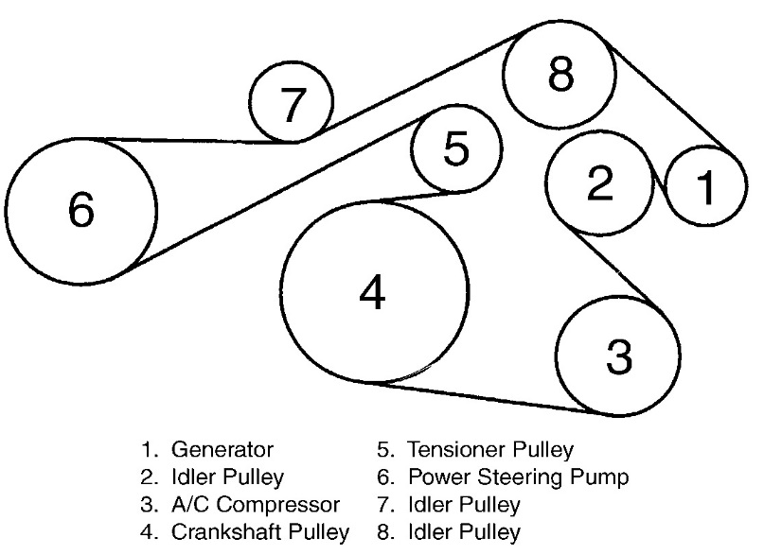
This is what you need to finish up with.

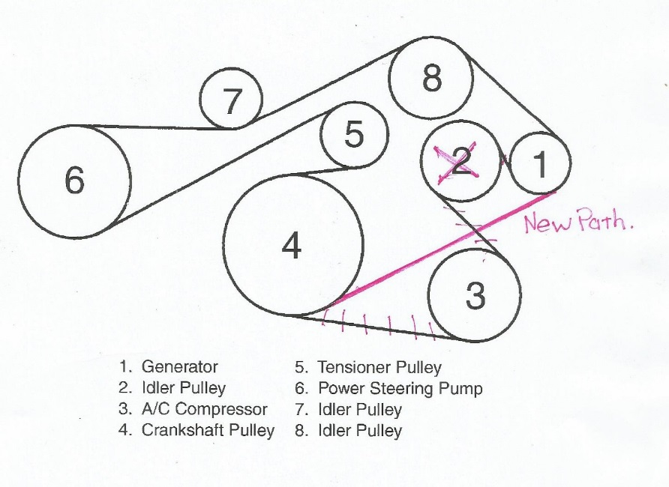
The work is requires the Car to be Jacked up, at least on the RH front wheel side. Remove the wheel. Then spend days removing the plastic Cover panels, I removed the one under the car first, it makes a bit more room and your hands will fit better. The forward section of the wheel arch will lso be removed. DO NOT LOSE THE SCREWS.
Then you will have access.
You should start inserting the Belt sideways behind the Tensioner. Then it is easy to fit around and over each pulley. 6,7,8 and 1 is the best order. Then down to the Crank Pulley 4
Now you are at the Tensioner 5. I found that a Breaker bar is best. See In Photos. With the Head at Right angles it will just fit in the square on the Tensioner. Have the Bar fitted towards the firewall and if you don’t have enough strength a length of steel tube will give you up to 15” of leverage. Even my broken hands managed this bit.
Its ON and you are mobile.
Melbourne (Australia) weather has been cold and so the car mists up a lot without A/C, I will have to fit a Compressor before summer.
My photos are not very good,sorry,but I didn’t think of taking any while doing the Job.
Good Luck
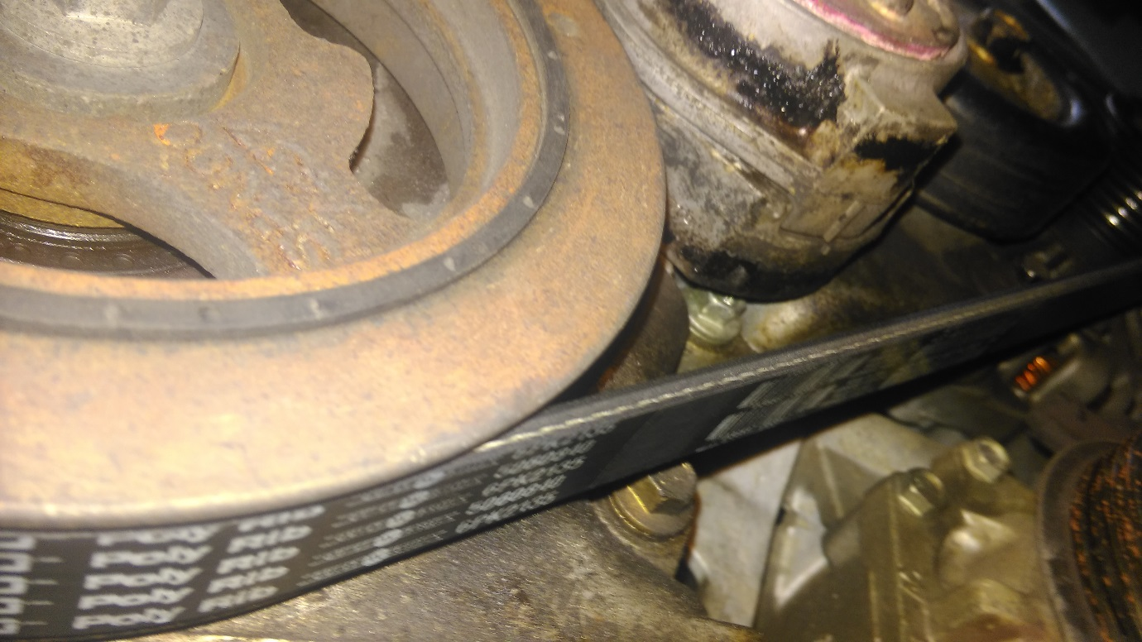
THIS SHOWS THE PATH FROM CRANK BACK TO ALTERNATOR. ALSO THE NOT USED IDLER (2) IS JUST VISIBLE

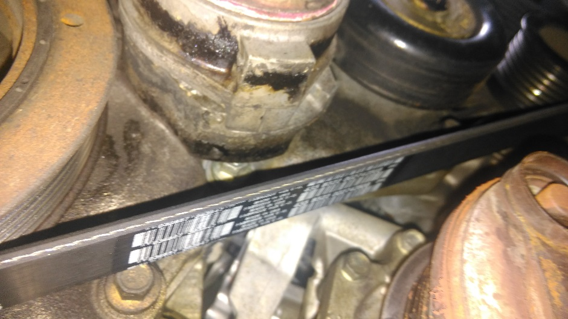
ANOTHER SHOTSHOWING UNUSED IDLER (2)
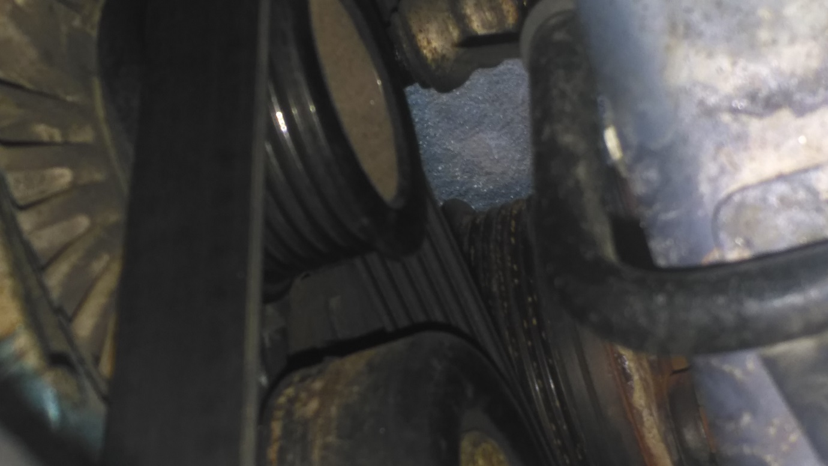
ALTERNATOR PULLEY, FROM TOP. THIS IS ABOUT THE MINIMUM THAT WILL DRIVE AN ALTERNATOR AT FULL LOAD.
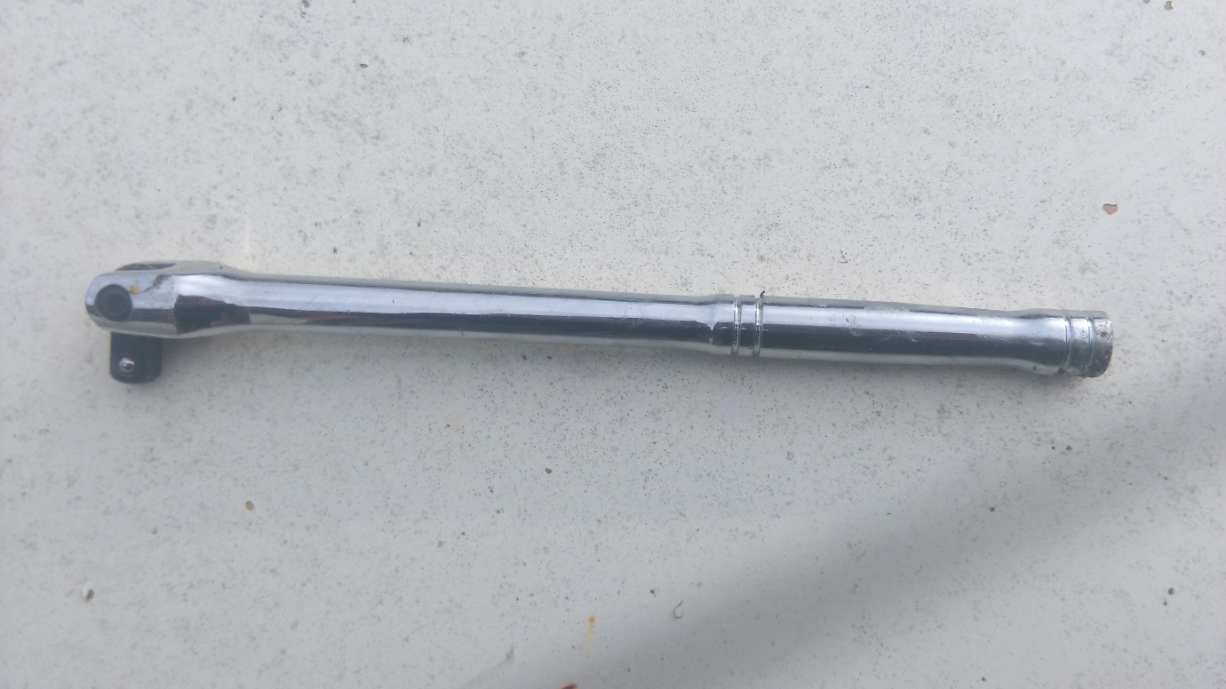
MY BAR. ANY MAKE OF TOOL SHOULD HAVE AN EQUIVALENT .

