This is a picute of half of the engine computer(ECM).
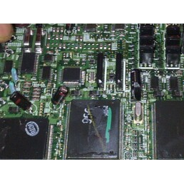
Im pointing at the engine computer chip.
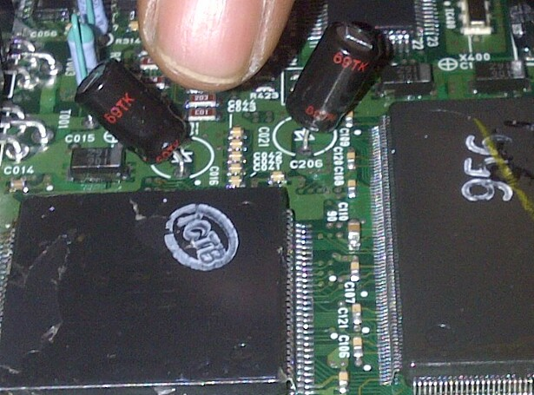

As you can see in this picture, one of the connectors is broken/burned off. There is actuallly another one that’s broken on the other side.
