CHANGING THE FLUID IN THE X TYPE 2.0/2.5/3.0 AUTOMATIC GEARBOX

Although the official Jaguar maintenance schedule for the JATCO auto gearbox on the 2.0/2.5/3.0 litre X type states that it is ‘Filled for Life’, the generally held view of many owners is that there comes a time when their idea of ‘life’ may be diverging from that of Jaguar and something must be done! After 13 years and 70,000 miles I felt that a change of fluid would be a good move and in practise, changing the fluid is not difficult and is well within the capability of anyone who undertakes other routine servicing and maintenance tasks on their car. Let the following photographs and associated notes be your guide.
Set the car on four axle stands to give yourself safe access underneath the gearbox. The car should be level, (checked at one of the door sills) and if your particular X Type is one fitted with a tiebar as shown, removing it from under the drain point will make for a less messy job! the With a suitable container at hand, remove the drain plug and when the fluid stops flowing, replace the drain plug. The drain plug has a plain aluminium sealing washer and although new ones are easily available through Ebay, time was against me so I re-used after annealing it. To anneal an aluminium washer, after cleaning it up, rub it all over with a bar of hand soap. Then heat it gently in a flame and when the soap turns black, remove the heat and allow the washer to cool.
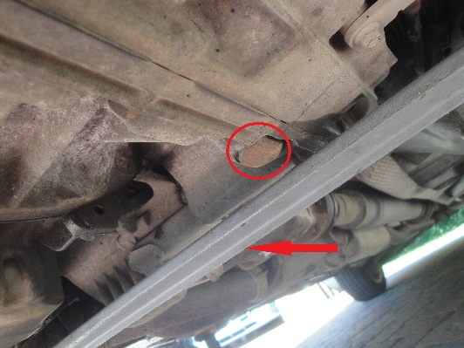

Measure how much fluid has been removed as a guide to how much will be required to refill. If there have been no major leaks it will probably be in the order of 4 to 5 litres. Total capacity is a fraction over 8 litres, but the cooler and the torque converter will not drain fully. I bought 6 litres of Motul Multi ATF from Opie Oils at £12.95/litre and had a litre left over for next time!
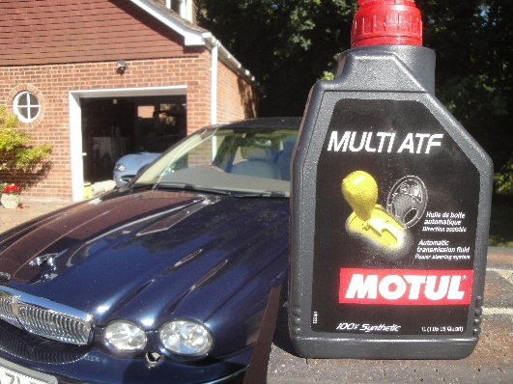

Remove the battery and battery box for access to the gearbox fill point, closed with a black rubber cap. A small funnel will help make it easier to fill and initially, put in the same amount you got out, plus an extra 1.0 litre. Replace the rubber cap and replace the battery.
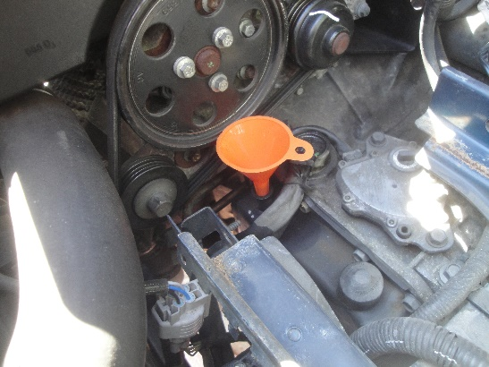

The next stage is to carry out a fluid level check using the level plug. Unusually, this is positioned on the underside of the gearbox. Underneath the gearbox towards the left hand side of the car will be seen a heavy steel protection cover over the end connection of the gear selector cable. This plate must be removed to give access to the level plug, that may have either an ordinary hexagon or an allen head, depending on model year.
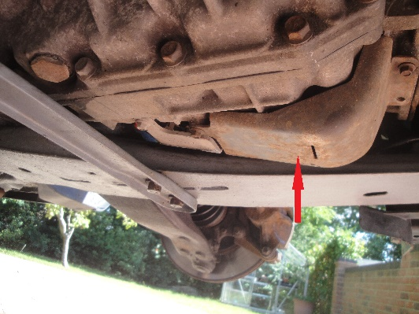

The check should be carried out with the gearbox at a temperature of between 30 and 40C and so while, still on the axle stands and with the footbrake firmly applied, start the engine. Take the selector lever through Reverse, Neutral, Drive, 4, 3, 2 and back again pausing for a second or so in each position until the gear box temperature reaches 30C. When engaging Reverse with the rear wheels off the ground there can be a disconcerting clunk from the rear suspension as it flexes. Be ready for it!
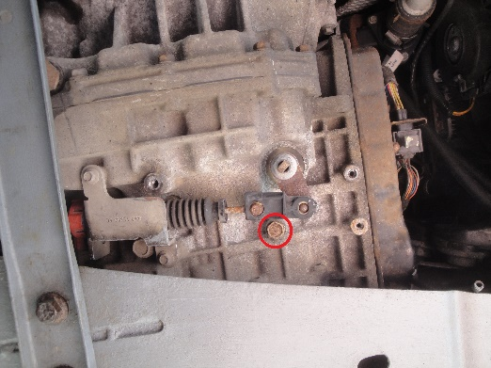
Some diagnostic scanners will read either transmission temperature directly or the resistance value of the gearbox sensor. A range of 30 to 40 C equates to a sensor resistance range of 1.25K to 0.82K. If you have a meter that reads temperatures, attach the thermocouple to the gearbox casing. If neither of these methods is available, remember normal body temperature is 37 C and thus a useful guide.
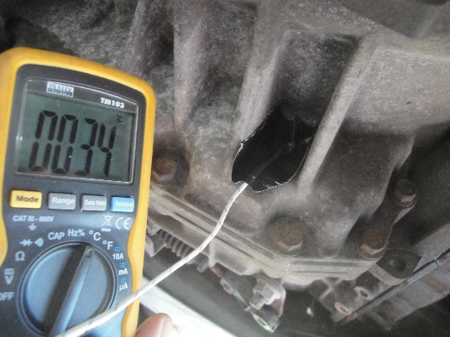
Leave the selector in P and the engine idling. Underneath the car, remove the level plug and allow the fluid to come out of the fluid level tube until the flow stops. Replace the level plug. If no fluid comes out, then the level is too low. Add more fluid in 0.5 litre steps until there is an overflow and then replace the plug when the flow stops.
The level plug is M12 and sealed with an O ring
If the temperature exceeds 40°C during this stage, replace the level plug, stop the engine and allow the temperature to come back below 40c before carrying on.
The job is now complete and your autobox will be the better for it, with smoother changes, especially on engaging kickdown, and you can feel the better in knowing that whatever Jaguar imagine the gearbox’s lifetime to be, you have surely just extended it!
A final word of warning! The unusual, hidden location of the level plug in the base of the gearbox has resulted in some owners and garages assuming that a large, odd-shaped bolt head on the rear side of the gearbox, above the lefthand CV joint must be it. This special bolt secures one end of the reverse gear brake band and if removed, not only will reverse gear be lost, but putting it right will require the gearbox to be removed and stripped down.
