Symptoms
Engine overheating while at idle or in slow traffic
Engine temperature is properly regulated at highway speeds
Cooling fan does not come on when air conditioner engaged
Cooling fan does not come on when engine is operating above normal range (90C is when thermostat opens, at 104C the cooling fan should be operating)
Part Numbers
Tools
- Torx T25
- Torx T30
- Standard metric sockets
- Standard imperial sockets
- Philips screw driver
- Flat blade screw driver
Procedure
- Remove engine cover
- 4 friction fit rubber fasteners integrated into the engine
- Lift up at the front of the cover and pull towards the front of the vehicle

- Remove intake cowls
- Remove 6 plastic anchors

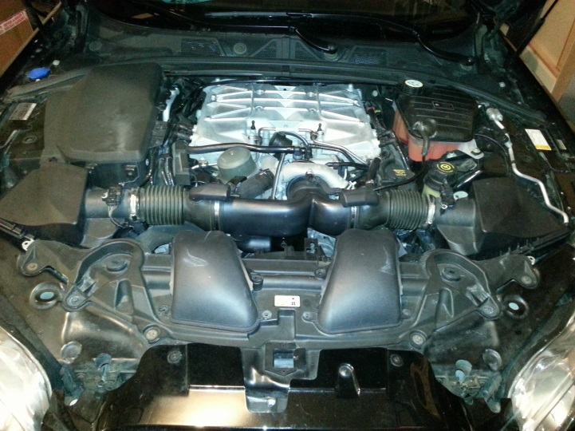

- Gently pull and wiggle the tubing connected to the airboxes until it separates

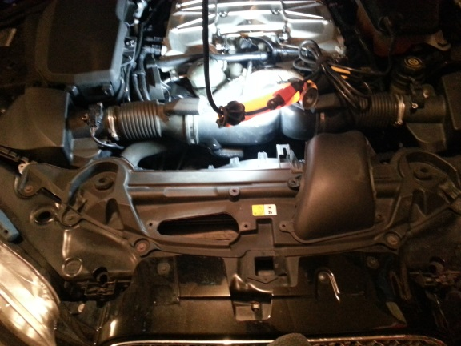

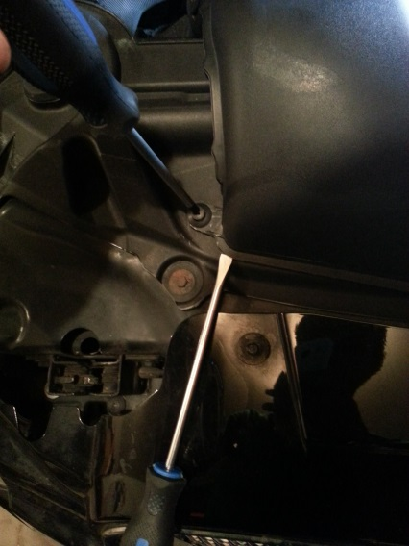

- Remove intake snorkels
- Loosen 4 gear clamps, remove 1 vacuum hose connected to the passenger side snorkel

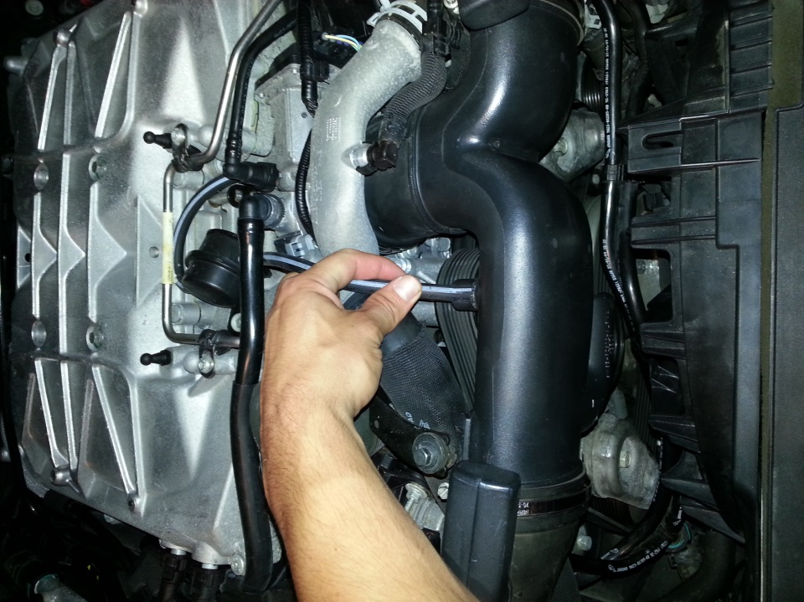
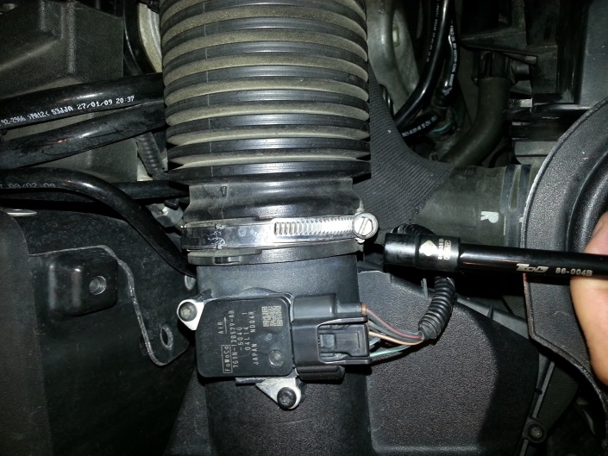
- Gently Pull snorkel off of airbox
- Gently Pull snorkel off of T-pipe

- Remove intake T-pipe
- Loosen 1 gear clamp
- Gently twist and pull towards front of car

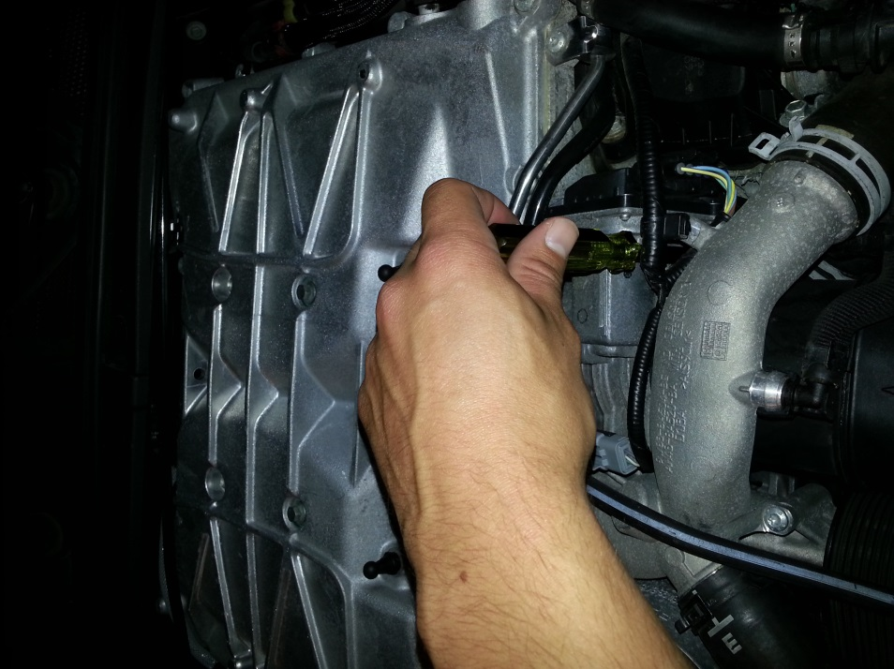
- Remove belly plate
- Remove several torx screws and note their location
  - Two T25 screws secure the rear of the plate to the car
  - Three T25 screws secure the radiator splash guard to the belly plate
  - Several T30 screws connect the belly plate to the nose cone
  - There are two bolts that secure the belly plate to the wheel gaurds
  - There are two more bolts that are located on the outer edges of the plate near the wheels
- Gently push and shimmy plate towards rear of car
- Gather all of the screw clips that fell off and place them back onto the nose cone

- Remove radiator splash guard
- Disengage two plastic clips integrated into the splash guard, pull straight down

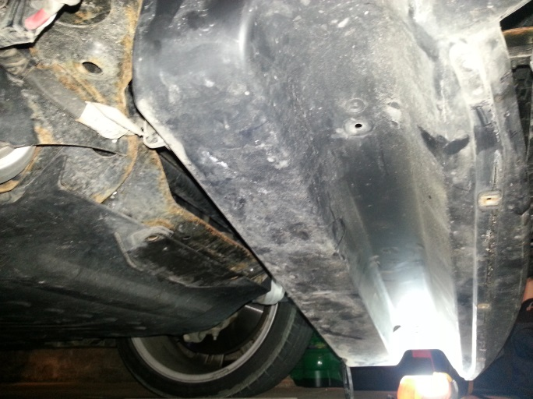

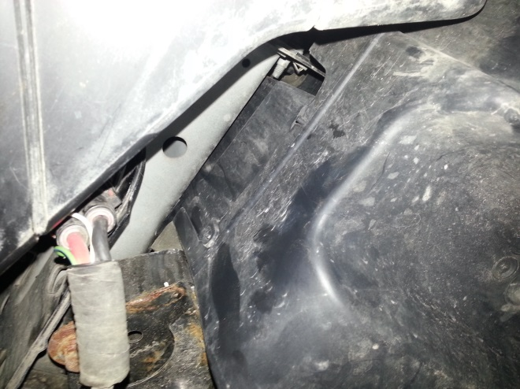

- Unplug cooling fan wiring harness
- Press the clip integrated into the wiring harness and gently pull harness apart. Unfasten strap holding the cooling fan wire to the body
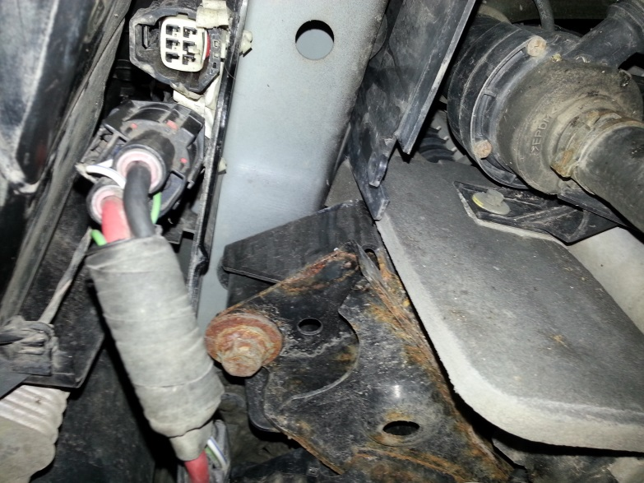

- Remove cooling fan retaining bolt (1) and clip (1) on passenger side of the assembly

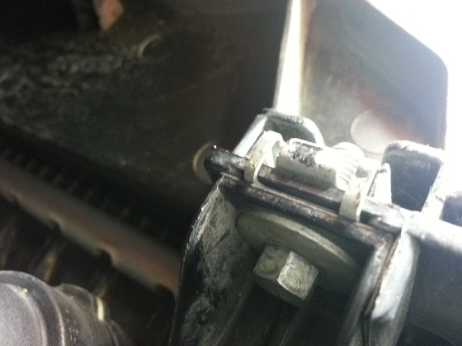

- Unfasten cooling hose straps from cooling fan assembly
Gently pry out the 3 anchor style straps, Gently pry out the clip style straps

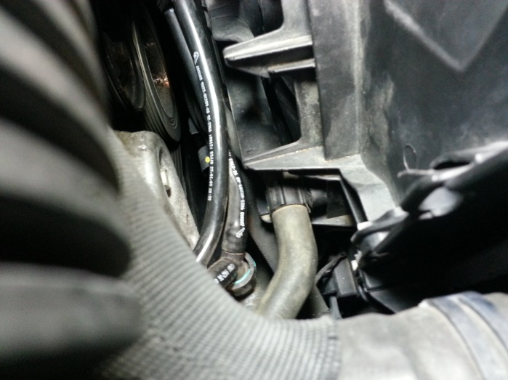
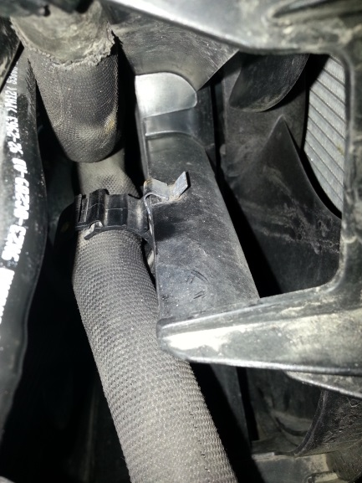

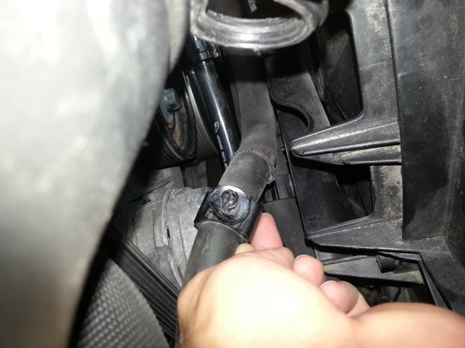

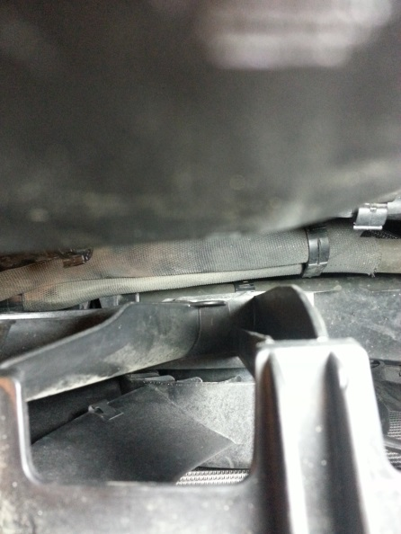

- Remove cooling fan assembly
- Engage the clip integrated into the fan assembly. It’s located on the driver side of the assembly. Slide the fan upwards. Gently move any cooling hoses that are blocking the path of the assembly.

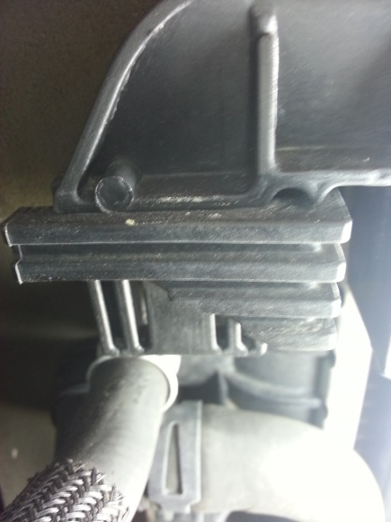

- Repeat steps in reverse for re-assembly with functioning cooling fan assembly

- Test cooling fan assembly
- Engage air conditioner and see if fan engages
- Let car idle while watching engine temperature and see if cooling fan engages when it should. Engine temperature will need to be monitored with an external device. I have a Bluetooth OBD reader and the torque app on my cell phone.

