Replacing Front Bearing 2014 Jaguar XF 3.0 S/C AWD By Kevin
(This is just for the bearing replacement, I added the pdf from Jaguar for the full procedure)
TOOLS
- Bearing Separator Puller Set
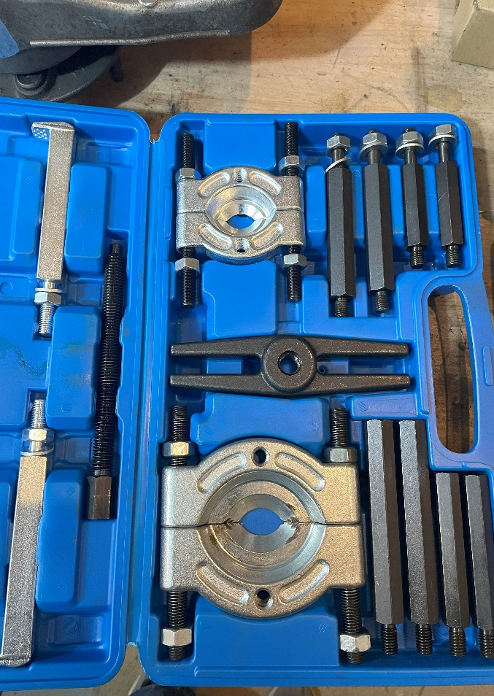
- Wheel Bearing Press Kit and Snap Ring Pliers
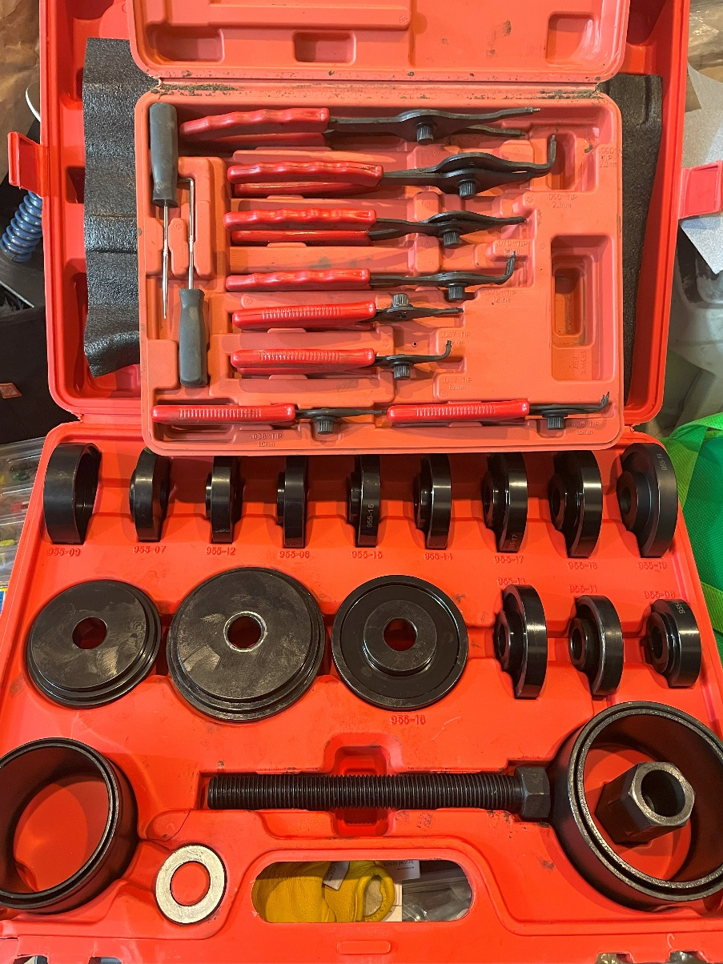
- Pull and Press Sleeve Kit Steel Bush Bearing Removal Installation
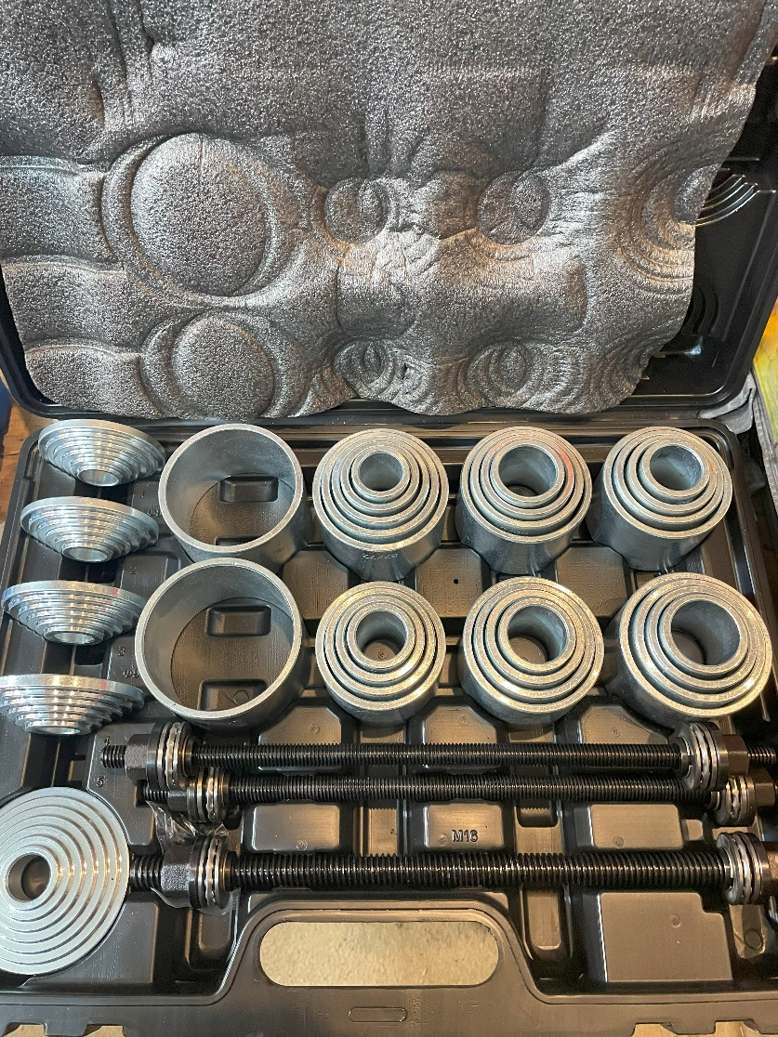
- Magnetic Field Viewing Film
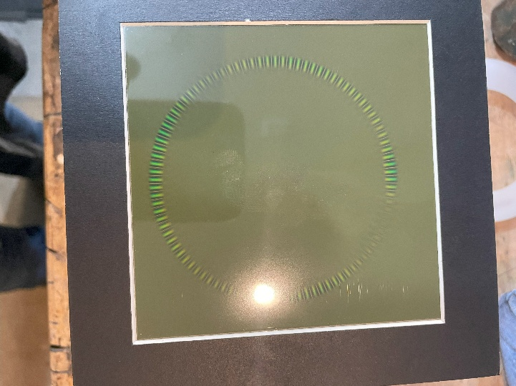
- Hydraulic Press
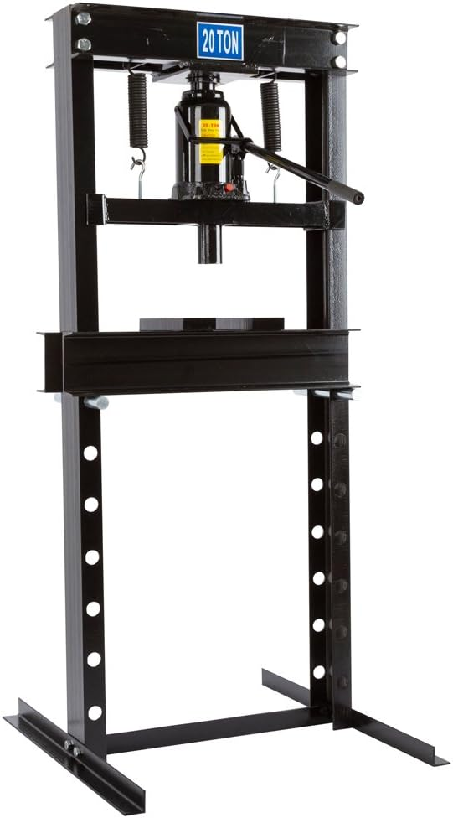
- Punch Set
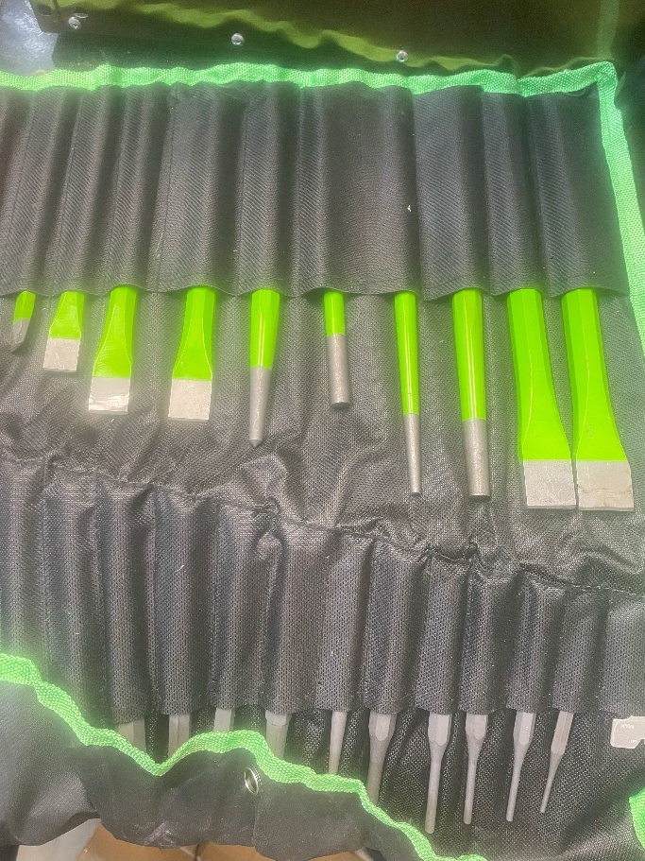
- Bearing
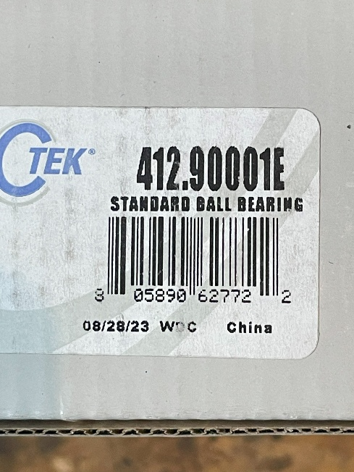
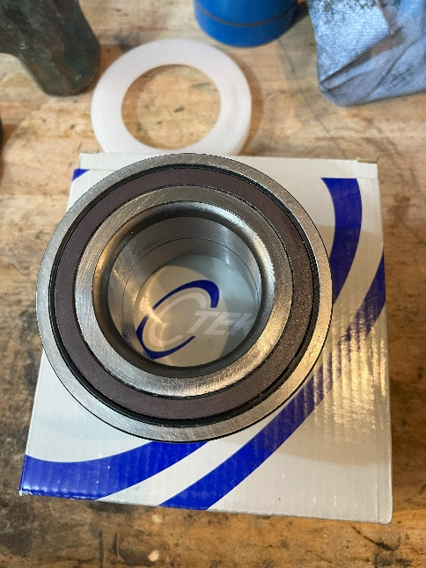
- Torch (Butane will work just fine)
- Grease
- Rags/Paper Towers
- Brake Cleaner
- Wood (2x2/2x4/2x6/small strips of ply) used for leveling and absorption with the press
- Nylon brushes for cleaning and parts cleaner

Note; Although it is very tempting to use a hammer at times during the install process, do not. The reason for the press
is so you can apply even, balanced and level force to the locations designed to take the stress. The slightest misalignment
can cause damage to the bearing assemble creating more loss time and expenses. Presses are not expensive as I purchased
mine a few months back as a 20T for $150 on sale. It is always important to use the correct tool, doesn’t always have to be
the OEM tool but one designed for the task to get the job done properly and safely.

Once Knuckle is removed
- Take the time to clean the surfaces as this will help immensely during the repair procedure.
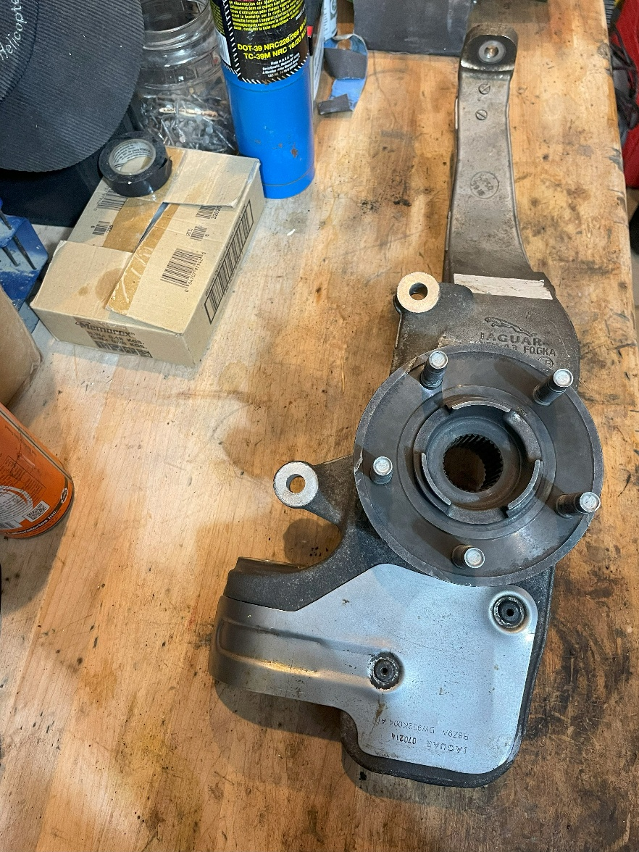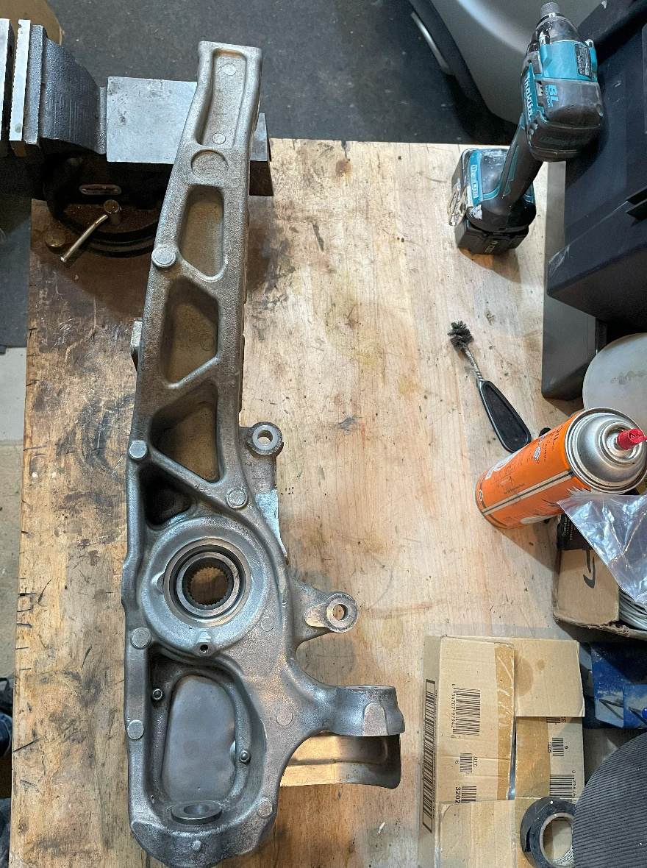
- Prepare to press out the Hub, ensure everything is level and center the pressure solely on the Hub
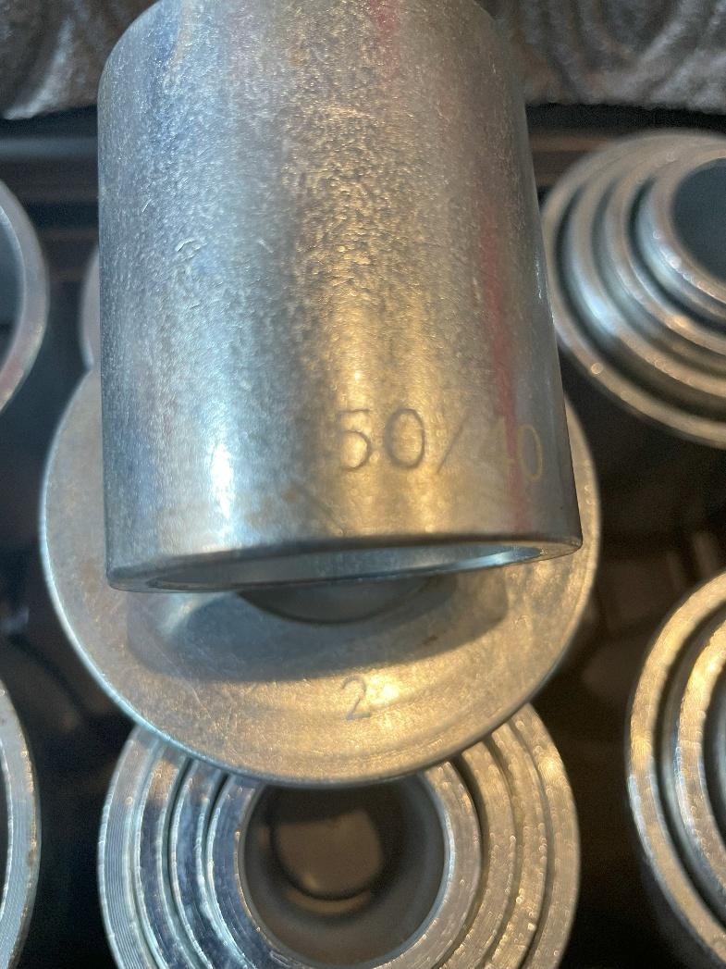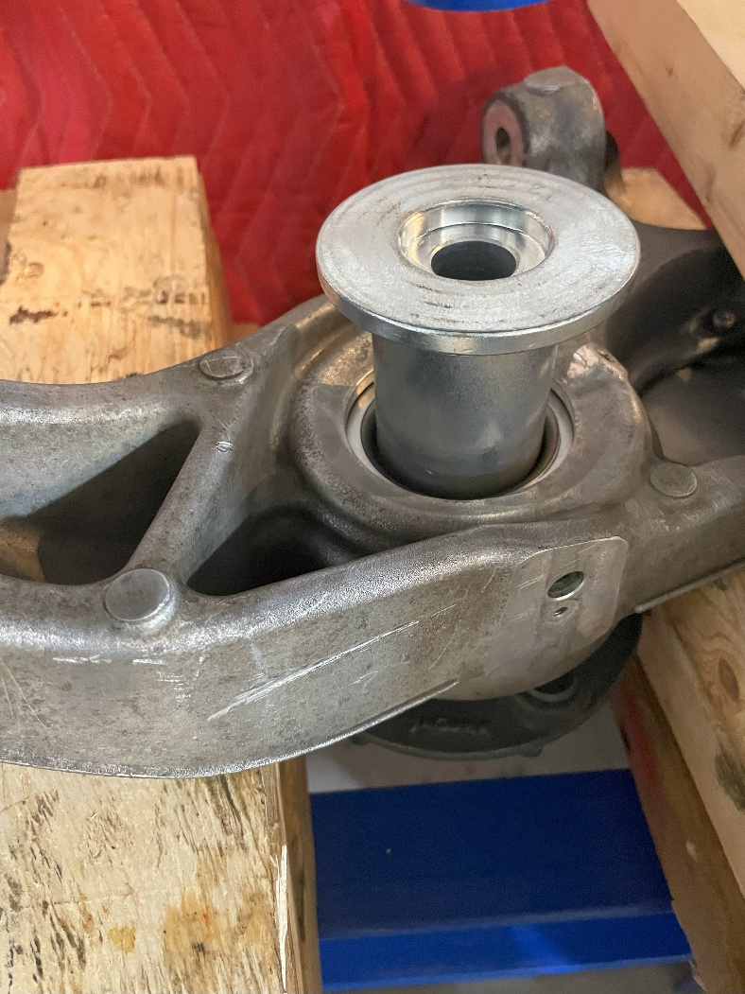
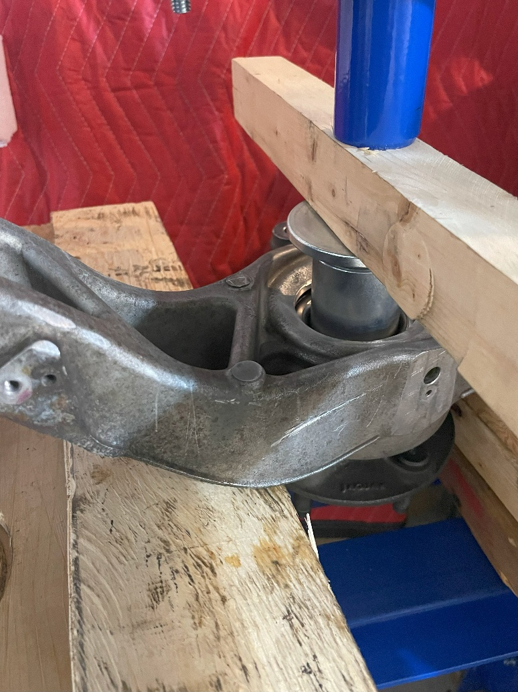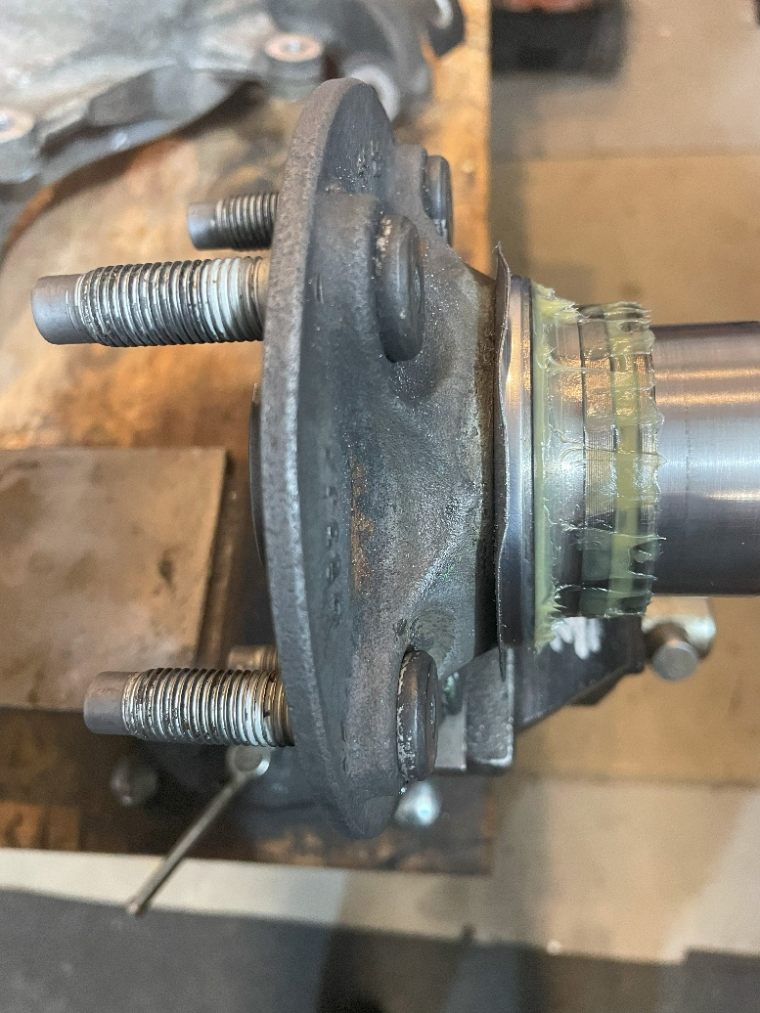
- The race will stay on the hub, you will need to clean the shield off and wipe off the remaining grease
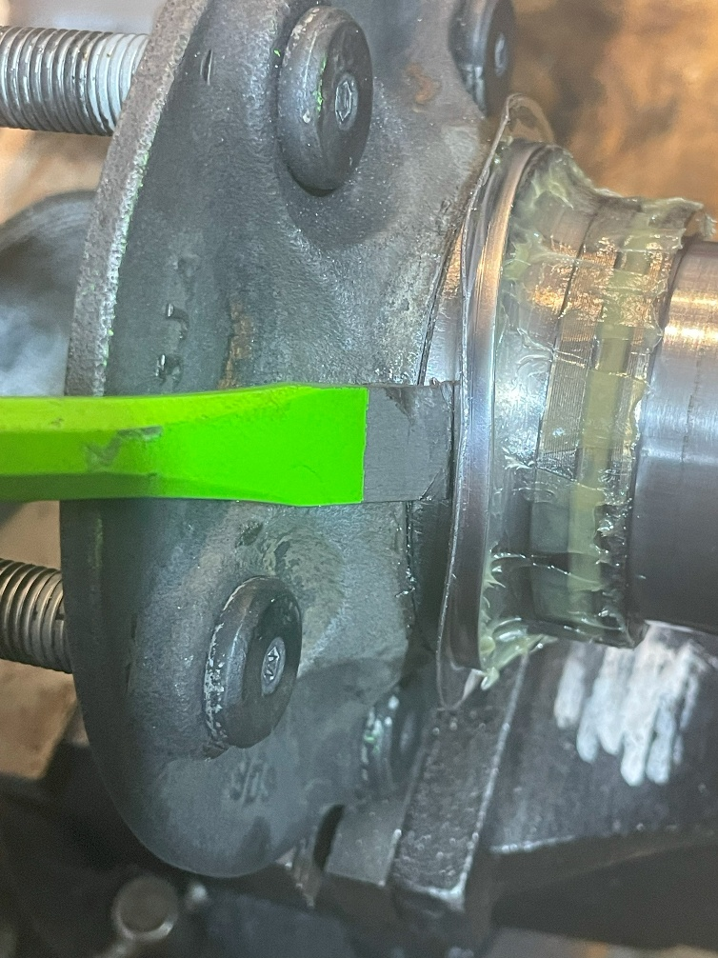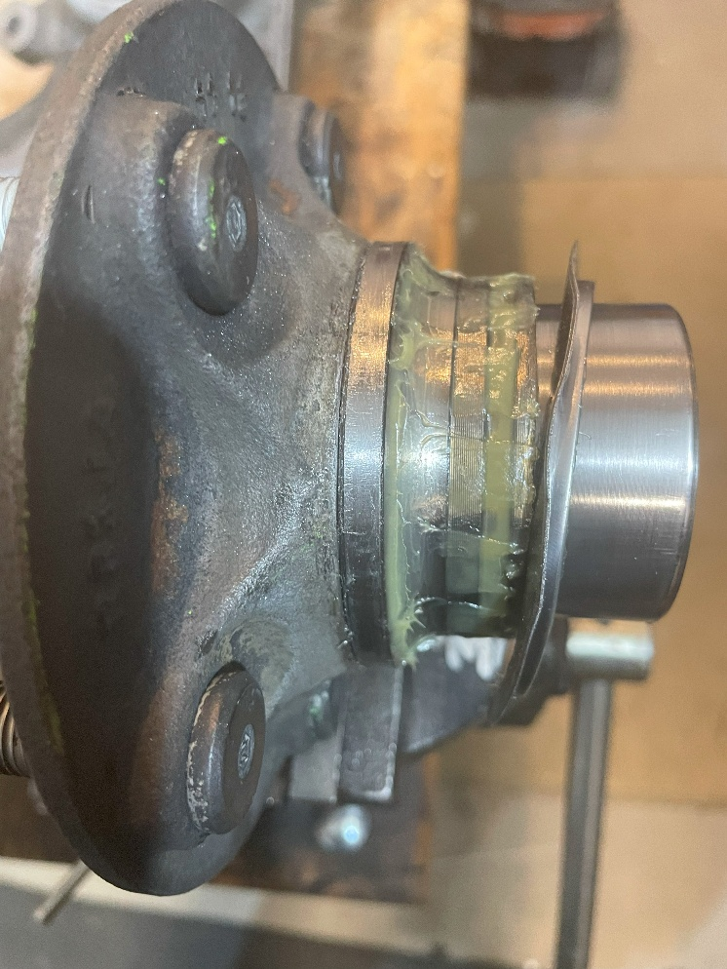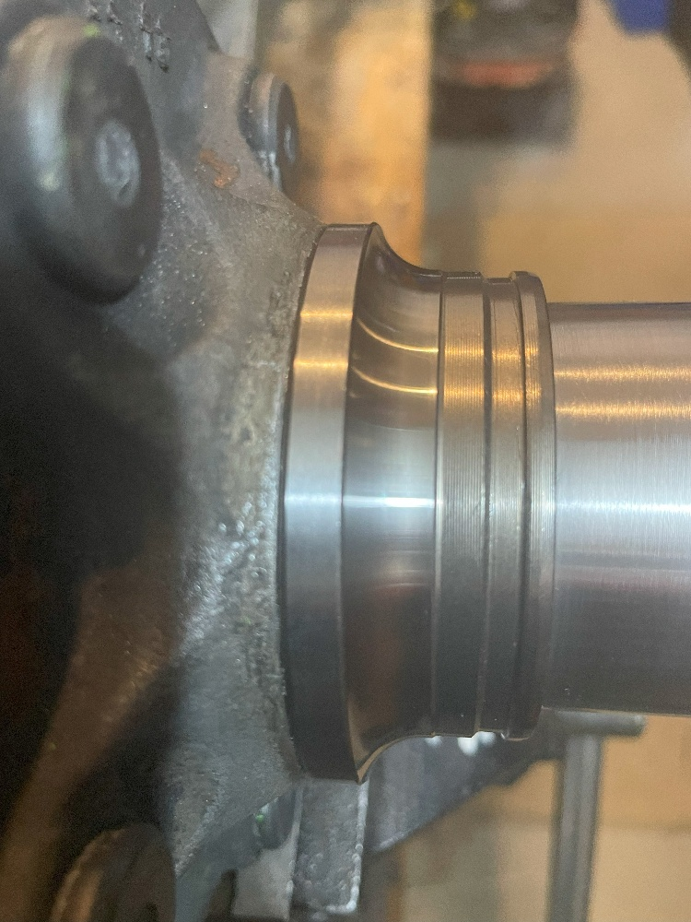
- Now you will need to heat the race to expand, it took me about 3 minutes with a butane torch continuously circling,
this allows you to chisel the edge to gain separation so you can use a separator/puller. I slowly sized up my chisels to avoid damaging the surface.
I used a flat end of a pry bar as a push surface and changed the legs once I was able to add the collar to completely remove the race.
Once removal of the race, clean and place in a freezer for later.
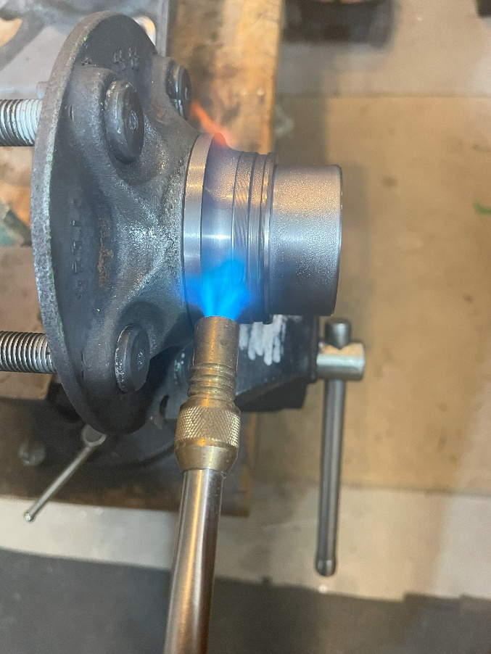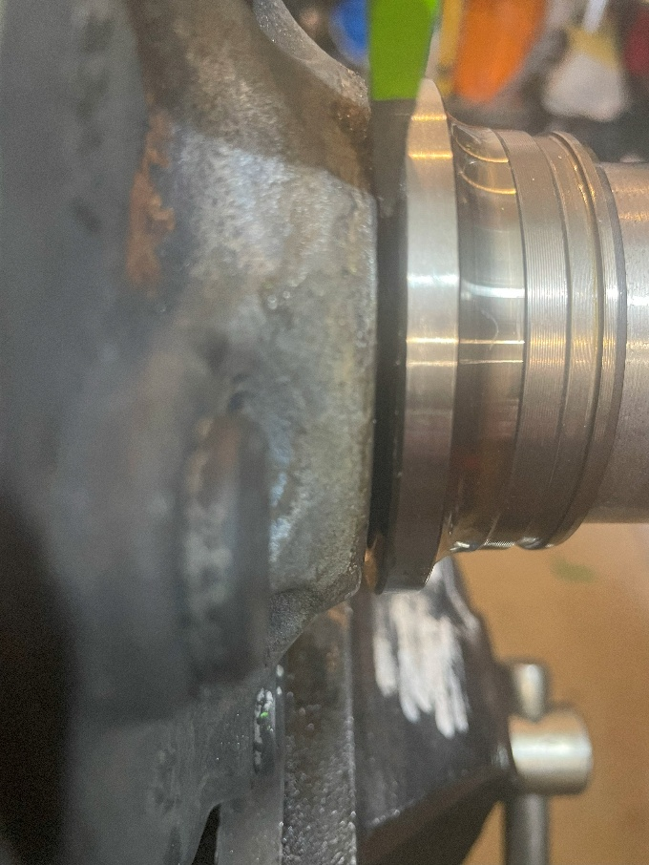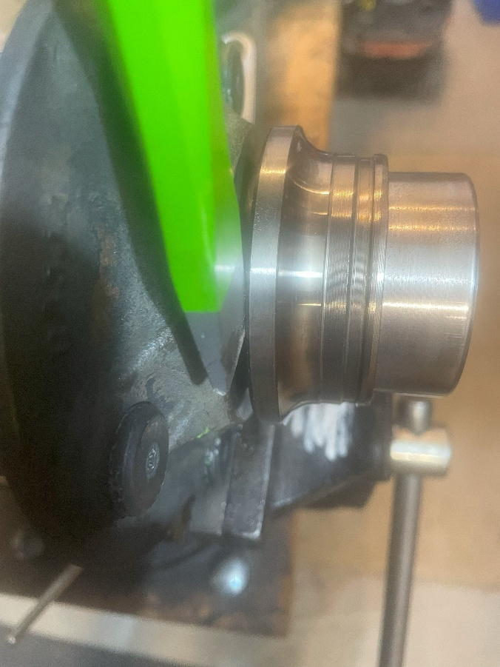
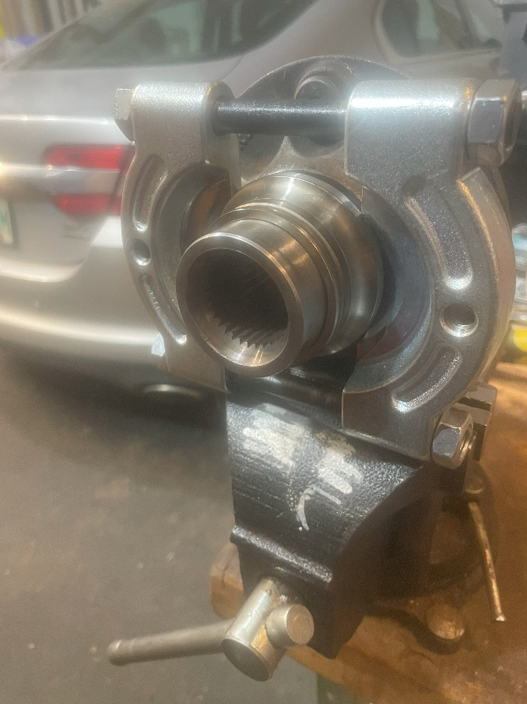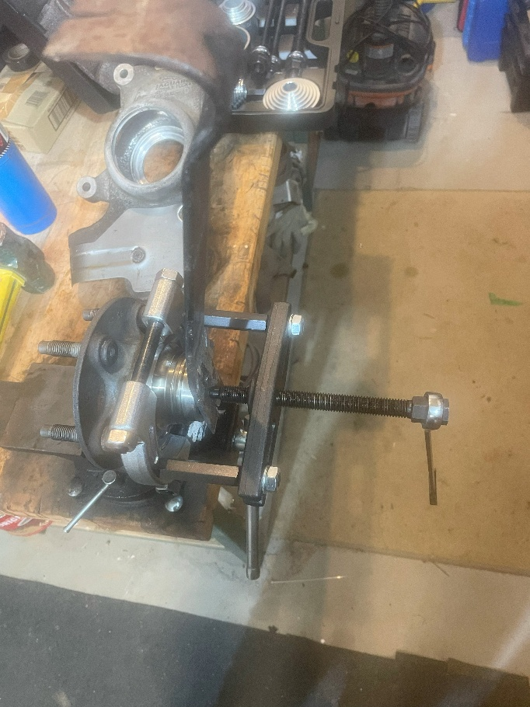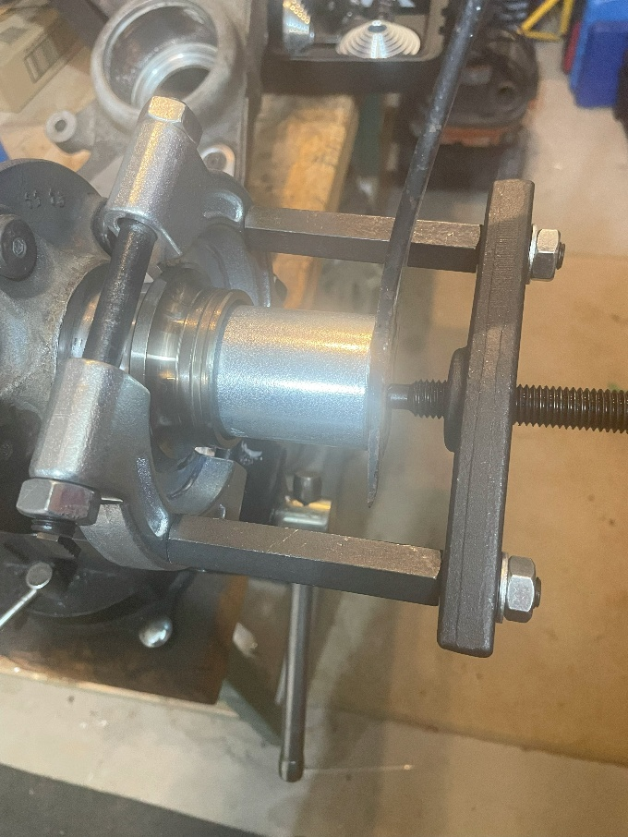
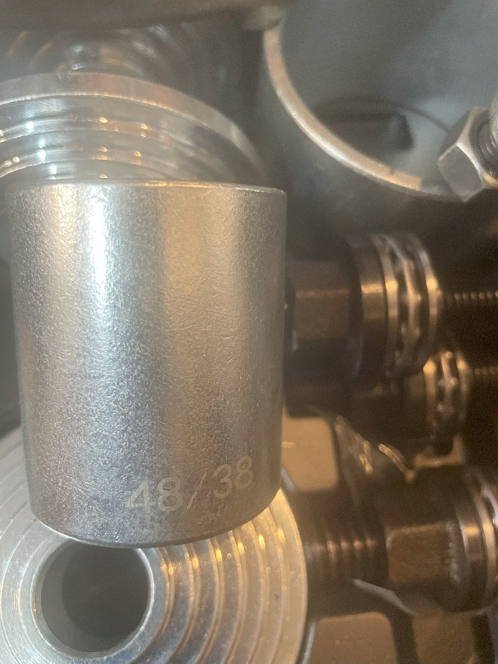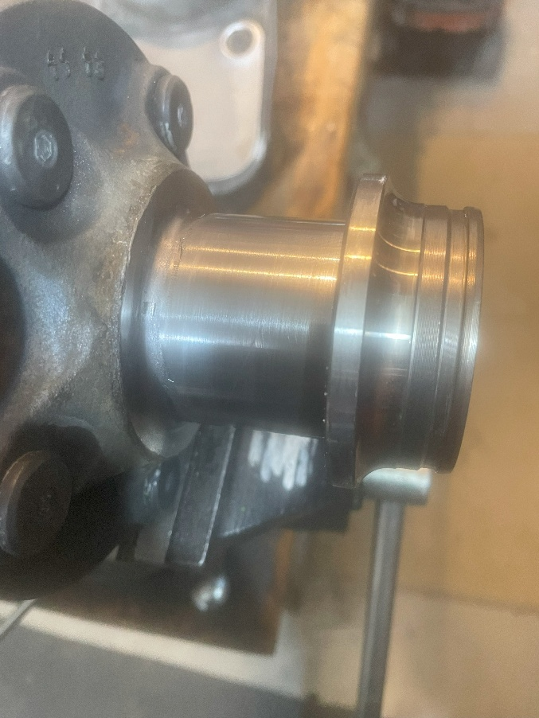
- Remove the Snap Ring so you can remove the rest of the bearing, clean and set aside
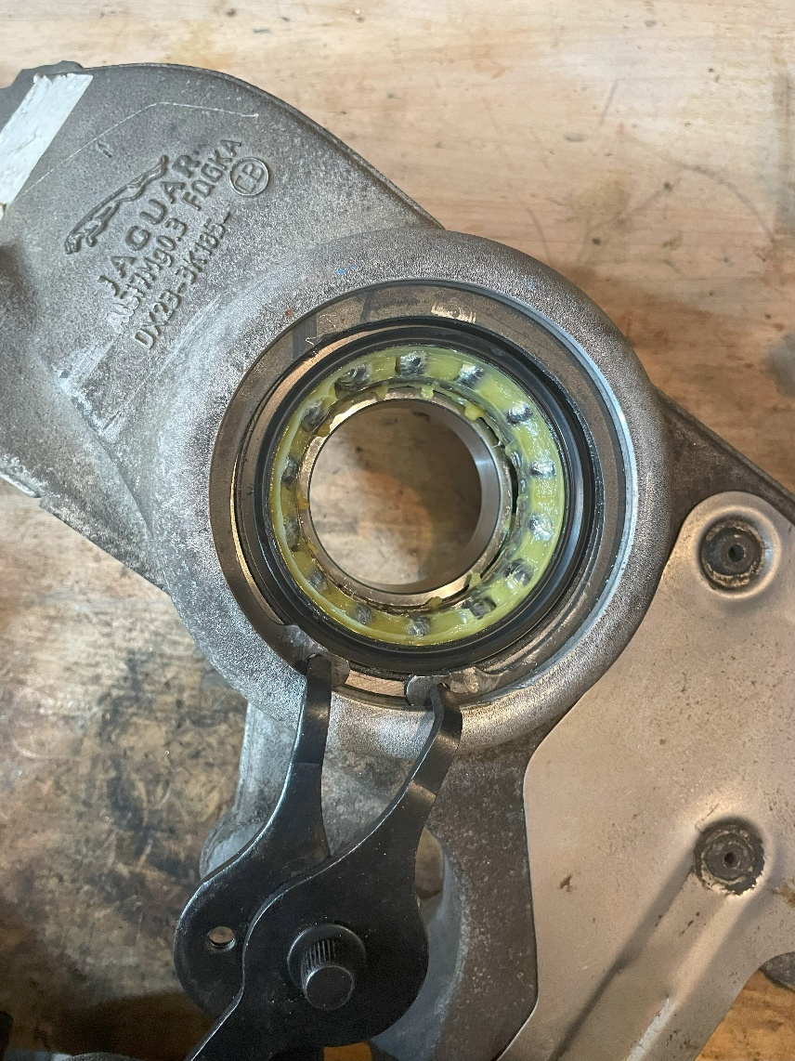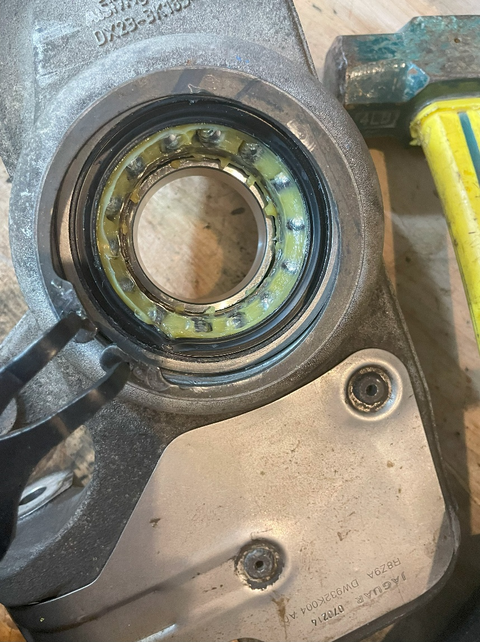
- Push the remains of the bearing out of the knuckle. Clean area but be extremely careful not to scratch,
I like to use rags, nylon brushes and cleaning fluid to flush. Brush a little grease with your fingers once completed.
I like to clean the old bearing and place aside; I would use it to help with the install of the new on later.
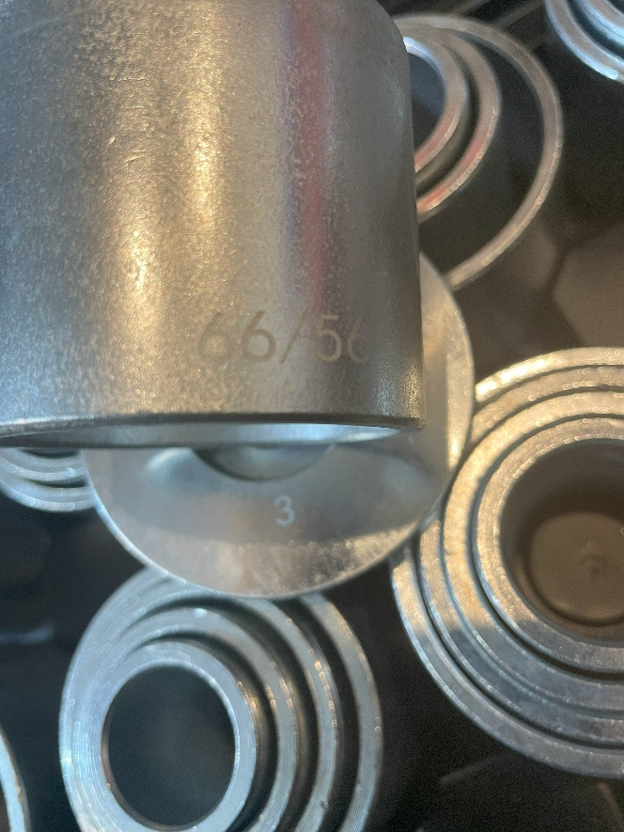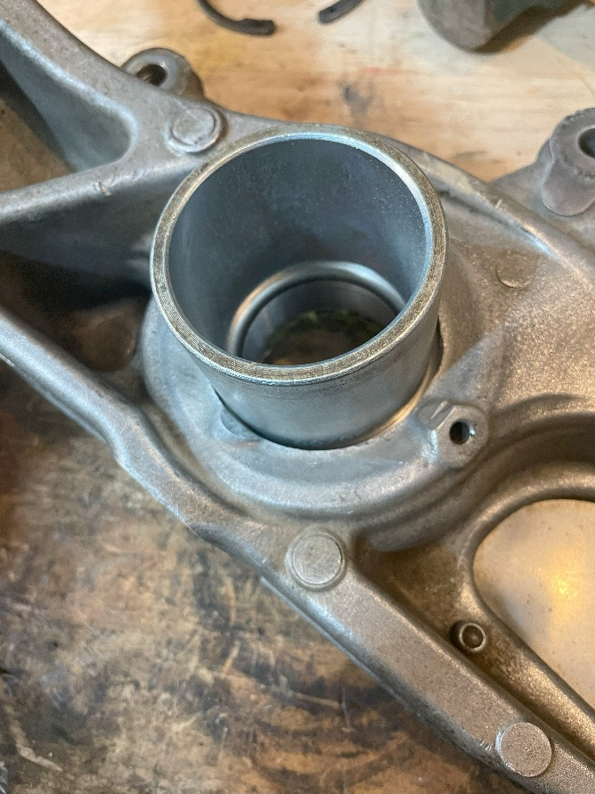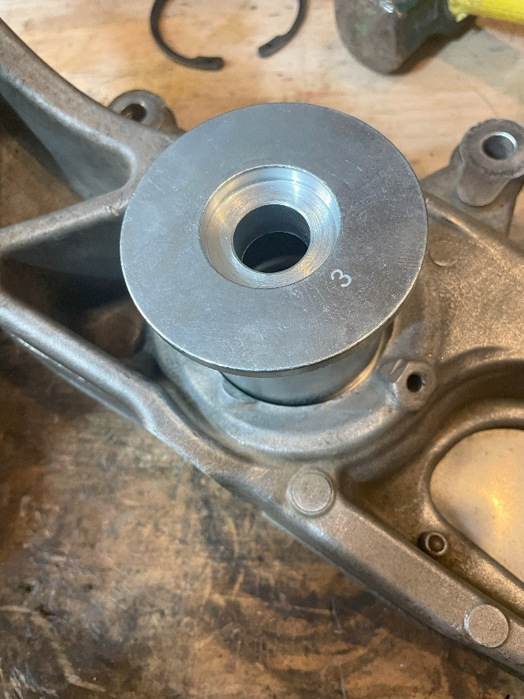
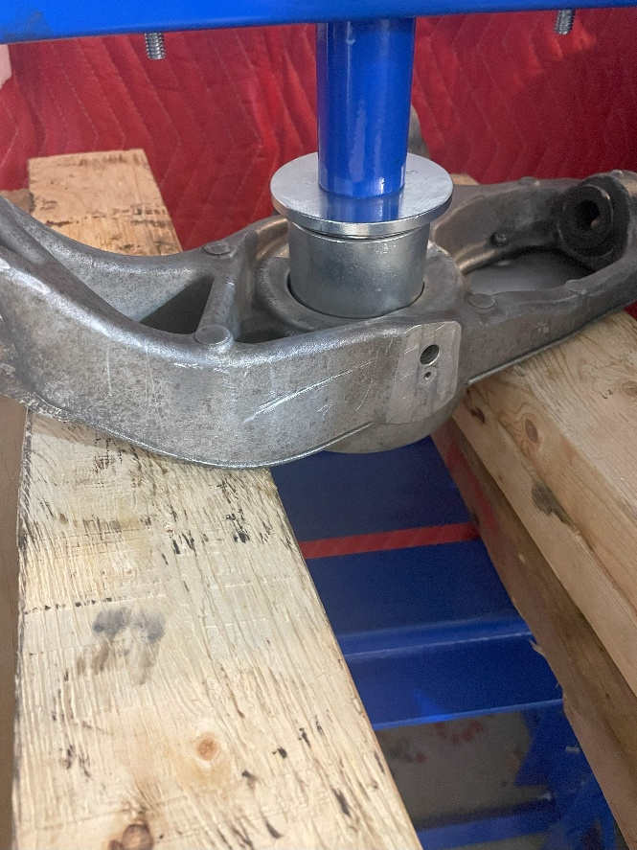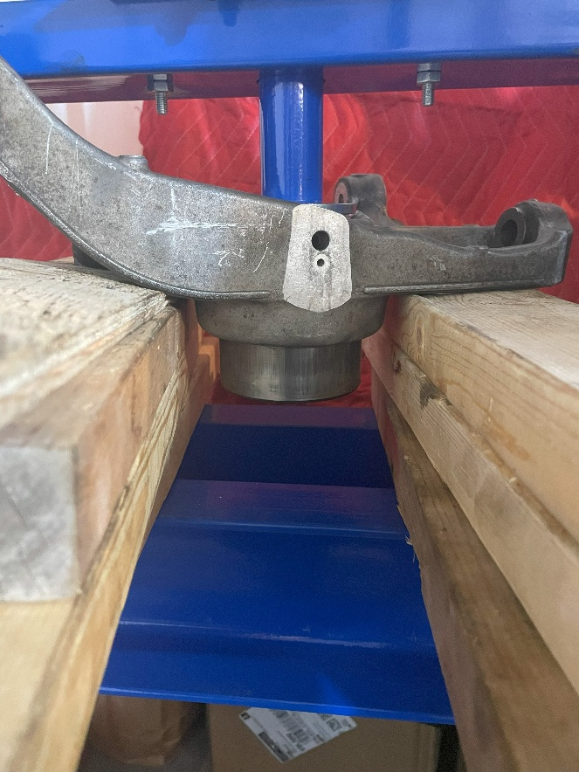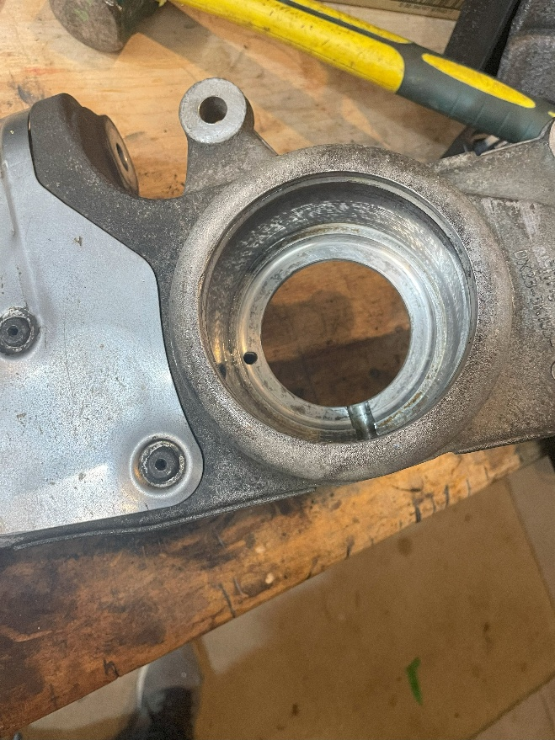

Assembly
- Verify you have the correct bearing and inspect the magnet for the ABS using a Magnetic Field Viewing Film.
This is to ensure that everything will be functional after install. I placed a sleeve on the film to better illustrate
What the magnetic configuration should look like as the film tends to float a bit without proper pressure.
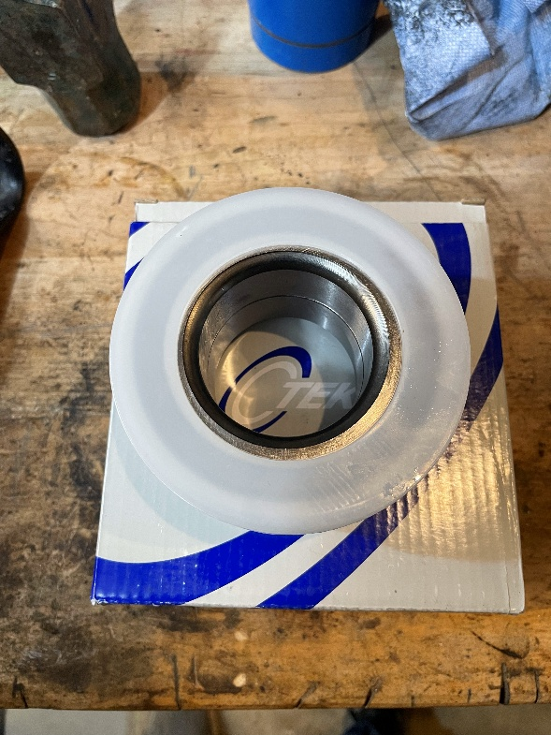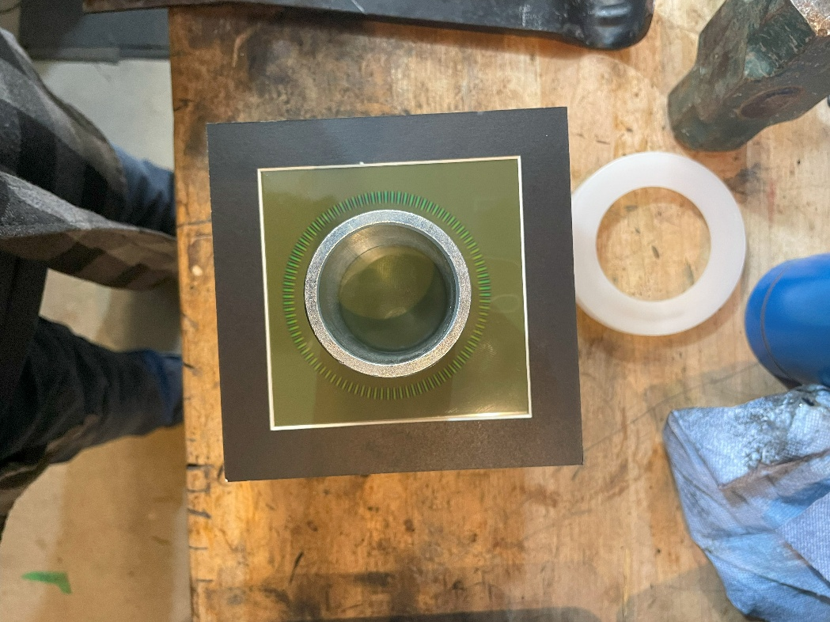
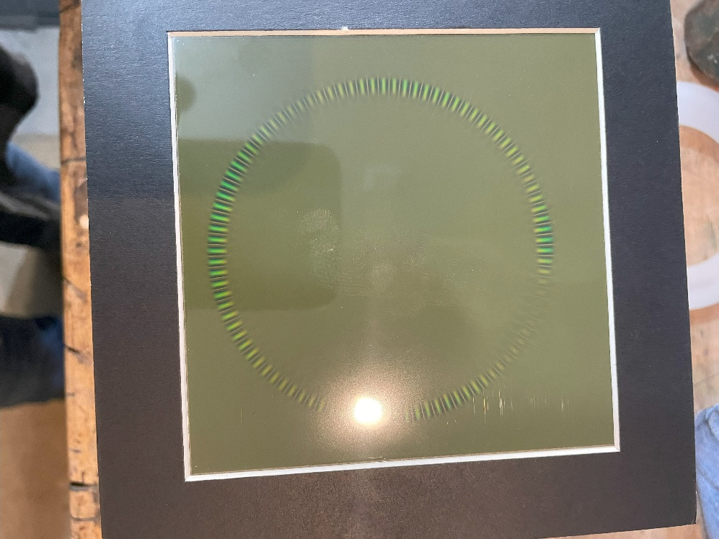
- Ensure you rotate the bearing for proper magnet placement in the knuckle. You will need to press the bearing
past the Snap ring slot in the knuckle, this is where the old bearing comes in handy. As the perfect size, you can place
on the new bearing to allow an even press for the final setting and allowing proper fit of the snap ring.
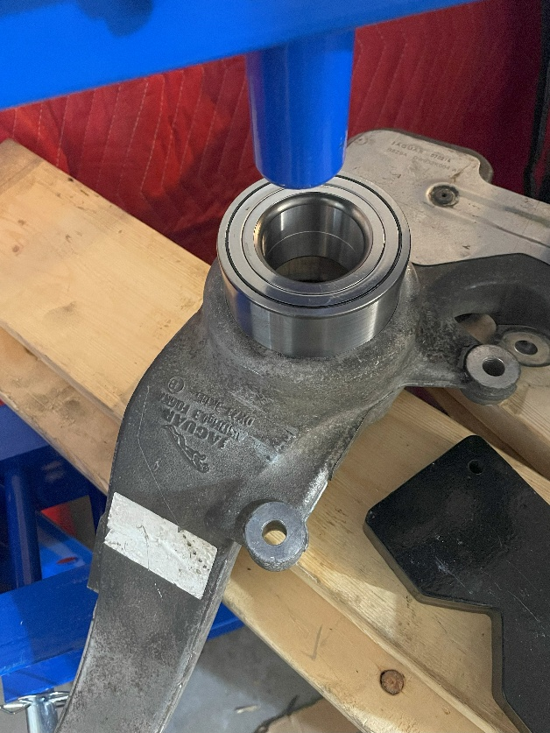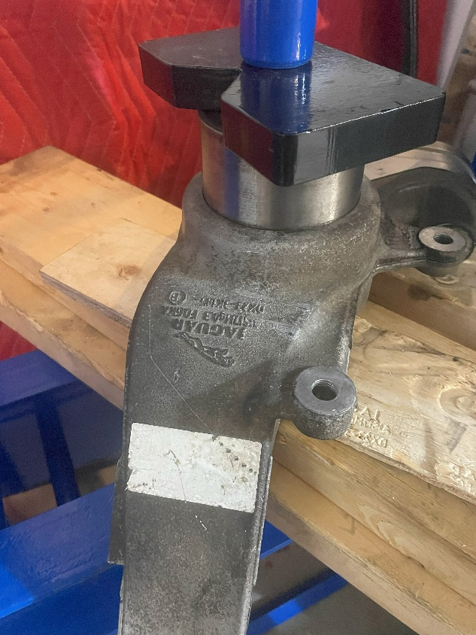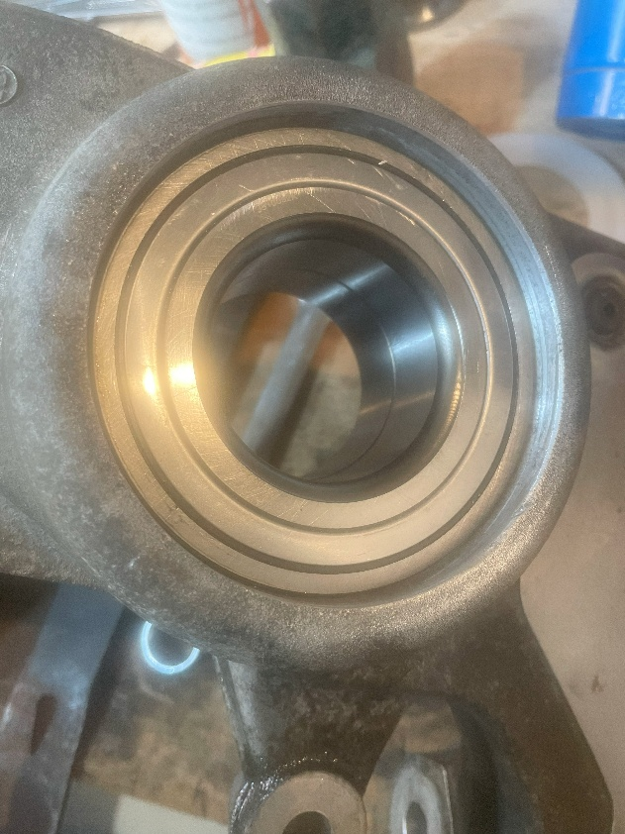
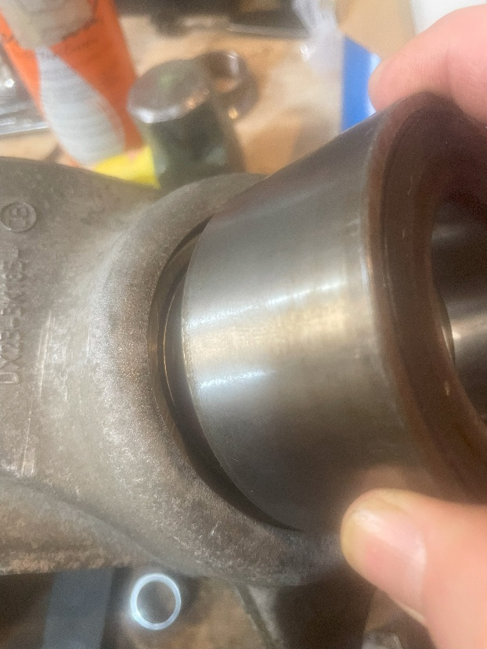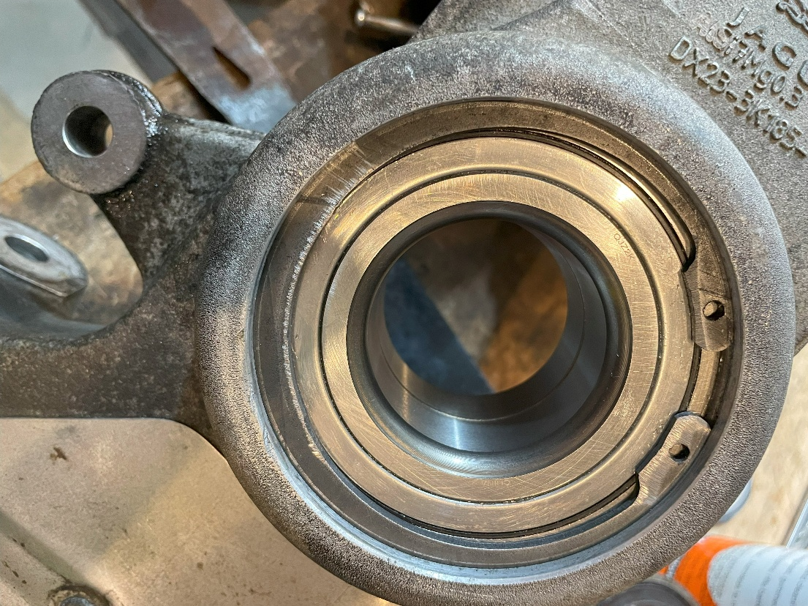
- Installation of the hub is the most sensitive procedure as you are sliding the shaft into a split bearing assembly and if
not perfectly strait, damage can easily occur to the bearing. It is very important to place a sleeve under the bearing that fits
perfectly to the inside race so the pressure can be transferred through the race and not the bearing assembly. This sould also
ensure a level, flat orientation for pressing the hub into the bearing. I like to pre-align before pressing to ensure proper height
and spacing is allowed. By using a hub alignment plate (Included in the press kit) on top and the same sleeve used to originally
press out the hub, placed on the bottom centered on one of the press plates ensures a level, flat alignment for the insert of the hub.
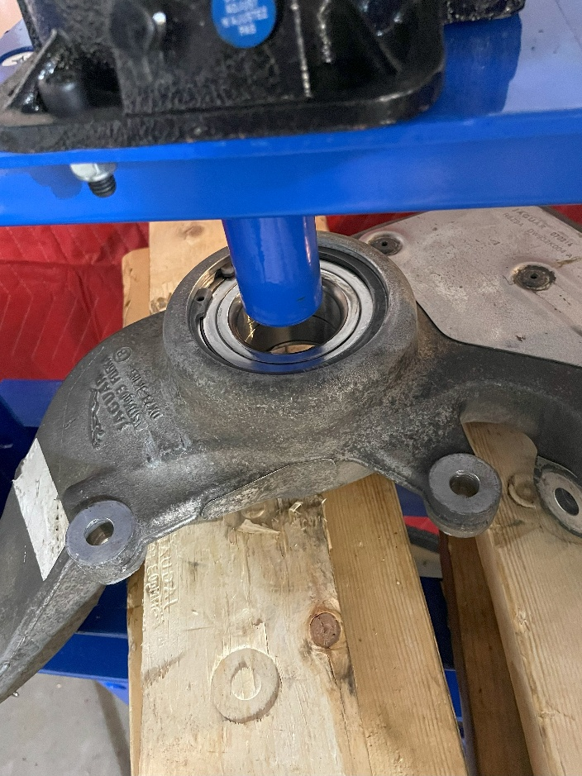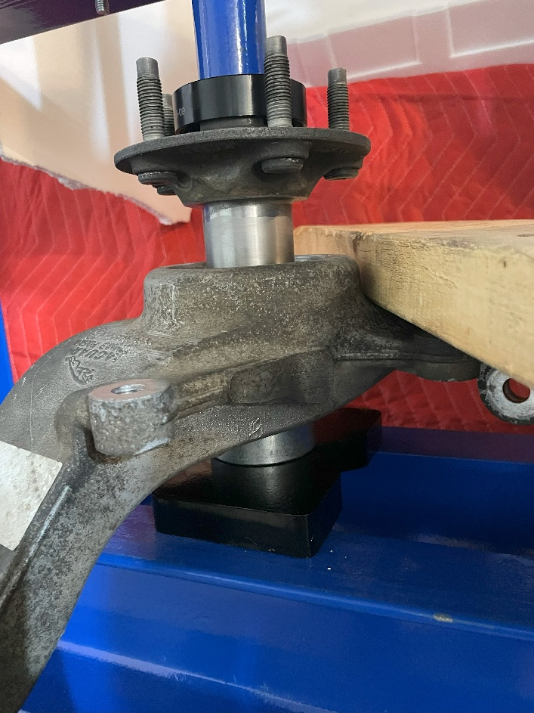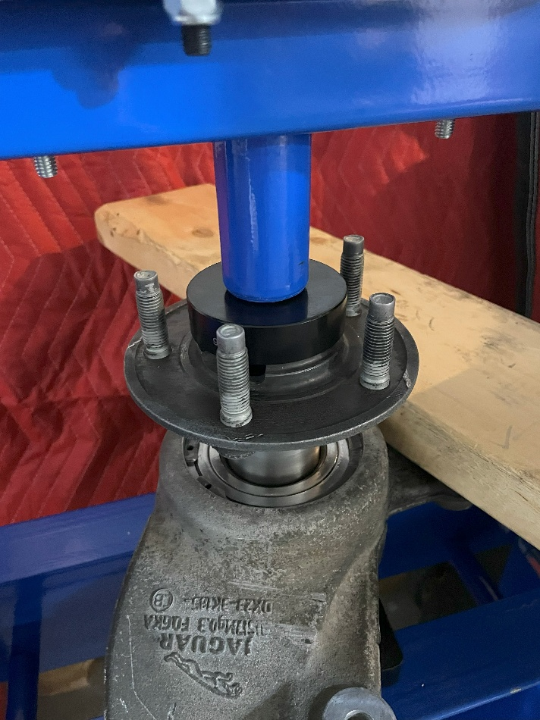
- A final check to see of the bearing is tight, solid but will spin without interference, then cleanup and/or install.
Mine are going on the shelf for future use.

Hope this helps as once again, I also included with this tutorial the OEM guide of full removal, repair and install.

Kevin

