jaghelp.com
Jaguar articles from a Jag specialist.
Wednesday, September 11, 2013
2005 XJ Fuse location and id
Everybody should have this fuse assortment in their cars in case you need fuses: ATD-364120 Piece Car Fuse Assortment
Engine compartment fuse box

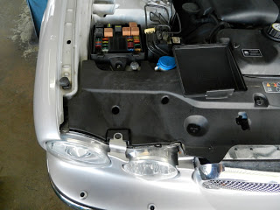

Fuse |  | Fuse |  | Rating | Colour |  | Circuit
No. | Type |  | (amps)

F1 | ATO | 10A | Red | Front ignition, UHEGO, fuel pump, rear ignition relay coils
F2 |  |  |  | Not used
F3 |  |  |  | Not used
F4 | ATO | 30A | Green | Powerwash pump
F5 |  |  |  | Not used
F6 | ATO | 40A | Orange | Air suspension compressor
F7 | ATO | 40A | Orange | Right-hand front screen heater or wiper park zone heater
F8 | ATO | 20A | Yellow | Right-hand dipped beam
F9 | ATO | 20A | Yellow | Left-hand dipped beam
F10 |  |  |  | Not used
F11 |  |  |  | Not used
F12 | ATO | 10A | Red | Engine control module
F13 | ATO | 10A | Red | Fuel injectors
F14 | ATO | 10A | Red | Purge valve, EGR valve, canister close valve (CCV), port deactivation, V6 intake manifold tuning valves (IMTV), MAFS, air filter solenoid, radiator fan controller
F15 |  |  |  | Not used
F16 | ATO | 20A | Yellow | Right-hand main beam, left-hand main beam
F17 | ATO | 10A | Red | Engine control module, transmission control module
F18 | ATO | 15A | Blue | Front fog lights, instrument cluster front fog status
F19 | ATO | 25A | Natural | Starter solenoid
F20 | ATO | 30A | Green | ABS module (pump)
F21 |  |  |  | Not used
F22 | ATO | 30A | Green | ABS module
F23 |  |  |  | Not used
F24 | ATO | 20A | Yellow | Throttle motor
F25 | ATO | 15A | Blue | Horns
F26 | ATO | 40A | Orange | Wiper system, front electronics module (FEM)
F27 |  |  |  | Not used
F28 |  |  |  | Not used
F29 |  |  |  | Not used
F30 | ATO | 10A | Red | Ignition coils
F31 | ATO | 15A | Blue | Intercooler water pump (supercharged engines)
F32 | ATO | 40A | Orange | Left-hand front screen heater
F33 | ATO | 30A | Green | 'A' bank heated oxygen sensors
F34 | ATO | 30A | Green | 'B' bank heated oxygen sensors
F35 | Midi | 80A |  | Radiator cooling fan
Cabin fuse box
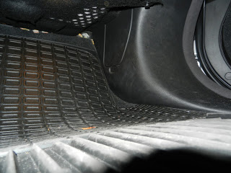

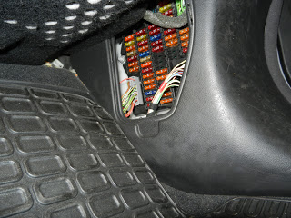

F1 | ATO | 10A | Red | Climate control unit, fan, screen heaters and wiper relay coils, smog sensor
F2 | ATO | 5A | Tan | Radiator fan controller, cruise control switch, adaptive cruise control
F3 | ATO | 5A | Tan | Rear outer seat, electrochromic mirror, driver seat heater, electric parkbrake, left and right-hand HID lamps levelling, left and right-hand seat belt switches
F4 | ATO | 5A | Tan | Instrument cluster
F5 |  |  |  | Not used
F6 |  |  |  | Not used
F7 | ATO | 5A | Tan | Cigar lighter, sunroof module, electric parkbrake switch illumination, accessory relays (trunk fuse box)
F8 | ATO | 5A | Tan | Instrument cluster
F9 | ATO | 10A | Red | Left-hand direction indicator and repeater
F10 | ATO | 5A | Tan | Glove compartment door motor and lamps
F11 | ATO | 5A | Tan | Radio muting (engine start), ignition feed
F12 | ATO | 10A | Red | Front electronic module (FEM), passenger mirror
F13 | ATO | 20A | Yellow | Rear electronic module (REM), door locks
F14 | ATO | 10A | Red | Courtesy light, footwell lamps, rain sensor, FEM
F15 | ATO | 5A | Tan | ECM, FEM, instrument cluster airbag fault lamp, instrument cluster ignition (run/start)
F16 | ATO | 5A | Tan | Diagnostic connector
F17 | ATO | 5A | Tan | ABS module
F18 |  |  |  | Not used
F19 | ATO | 5A | Tan | Ignition relay, ECM, REM, fuel pump relay, start relay
F20 | ATO | 5A | Tan | Telephone transceiver, TV module, VICS (Japan), voice module, rear telematics
F21 |  |  |  | Not used
F22 |  |  |  | Not used
F23 |  |  |  | Not used
F24 | ATO | 10A | Red | PATS transponder
F25 | ATO | 10A | Red | Right-hand direction indicator and repeater, right-hand front lamp, header console map lamp
F26 | ATO | 15A | Blue | Screenwash pump
F27 | ATO | 10A | Red | ACC module
F28 | ATO | 10A | Red | Climate control modules (front and rear), driver's door module (DDM)
F29 | ATO | 10A | Red | Airbag module, occupancy sensing module, passenger weight sensor
F30 | ATO | 10A | Red | Voice, front/rear sound, DVD, telematics, TV
F31 | ATO | 15A | Blue | Sunroof
F32 | ATO | 5A | Tan | Front/rear parking aid, trailer tow module, battery backed sounder, voice module, telephone receiver
F33 | ATO | 5A | Tan | Transmission control, 'J'-gate, generator
F34 | ATO | 5A | Tan | Navigation system
F35 | ATO | 10A | Red | Left-hand seat movement
F36 | ATO | 40A | Orange | Left-hand seat movement
F37 | ATO | 25A | Natural | Driver window
F38 | ATO | 15A | Blue | Radio head unit
F39 | ATO | 5A | Tan | Transit relay (removed before customer delivery)
F40 | ATO | 10A | Red | Security LED, yaw rate sensor
F41 | ATO | 20A | Yellow | Ignition switch
F42 | ATO | 10A | Red | FEM, REM, DDM, clock
F43 | ATO | 5A | Tan | Diagnostic connector
F44 | ATO | 5A | Tan | Brake switch
F45 | ATO | 10A | Red | Right-hand seat movement
F46 | ATO | 25A | Natural | Passenger window
F47 | ATO | 5A | Tan | Instrument pack
F48 | ATO | 20A | Yellow | Instrument pack (steering column tilt and reach)
F49 | ATO | 40A | Orange | Left-hand seat movement
Trunk fuse box

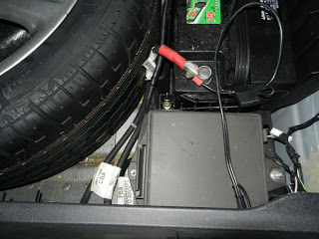

F1 |  |  |  | Not used
F2 |  |  |  | Not used
F3 |  |  |  | Not used
F4 |  |  |  | Not used
F5 | ATO | 40A | Orange | Right-hand front seat
F6 | ATO | 10A | Red | Accessory connector
F7 | ATO | 40A | Orange | Front blower motor
F8 | ATO | 10A | Red | Heater circuit water pump
F9 | ATO | 25A | Natural | Rear seat motors
F10 |  |  |  | Not used
F11 | ATO | 5A | Tan | Rear footwell lamps, grab handle lamps
F12 | ATO | 10A | Red | Air suspension
F13 | ATO | 20A | Yellow | REM, rear seat heaters
F14 |  |  |  | Not used
F15 | ATO | 5A | Tan | Right-hand rear light cluster
F16 | ATO | 10A | Red | Trunk lights, driver seat switch pack, rear switch seat pack
F17 | ATO | 10A | Red | Left-hand rear fog and reversing lamps
F18 | ATO | 10A | Red | Number plate lamps, side marker lamps
F19 | ATO | 30A | Green | Heated rear window
F20 | ATO | 10A | Red | Heated door mirrors
F21 | ATO | 25A | Natural | Rear seat motors
F22 | ATO | 10A | Red | Accessory connector
F23 |  |  |  | Not used
F24 | ATO | 20A | Yellow | Fuel pump driver module
F25 | ATO | 15A | Blue | Front accessory socket
F26 | ATO | 15A | Blue | Rear accessory socket
F27 | ATO | 10A | Red | Rear CD
F28 | ATO | 25A | Natural | Left-hand rear window
F29 |  |  |  | Not used
F30 | ATO | 10A | Red | Generator, battery backed sounder, transit relay
F31 | ATO | 40A | Orange | Right-hand front seat
F32 | ATO | 30A | Green | Electric parkbrake actuator
F33 | ATO | 20A | Yellow | Rear electronic module (fuel pump)
F34 | ATO | 30A | Green | Power amplifier
F35 |  |  |  | Not used
F36 |  |  |  | Not used
F37 |  |  |  | Not used
F38 |  |  |  | Not used
F39 |  |  |  | Not used
F40 | ATO | 25A | Natural | Right-hand rear window
F41 |  |  |  | Not used
F42 |  |  |  | Not used
F43 | ATO | 15A | Blue | Rear cigar lighter
F44 | ATO | 15A | Blue | Front cigar lighter
F45 |  |  |  | Not used
F46 | ATO | 10A | Red | Right-hand rear reverse and fog lights
F47 | ATO | 20A | Yellow | FEM, front seat heater
F48 | ATO | 5A | Tan | High mounted stop lamps
F49 | ATO | 5A | Tan | Left-hand rear light cluster
F50 |  |  |  | Not used
F51 | ATO | 10A | Red | Navigation system
F52 | ATO | 20A | Yellow | Air suspension
F53 | ATO | 20A | Yellow | Rear fan motor
F54 | ATO | 15A | Blue | Heated steering wheel
F55 |  |  |  | Not used

