jaghelp.com
Jaguar articles from a Jag specialist.

Friday, January 3, 2014

2006 S-type supercharger removal
The title says it all! I removed the supercharger on a 2006 S-type R to fix a coolant hose. Here are the pics and how I did it:
- Here we go!
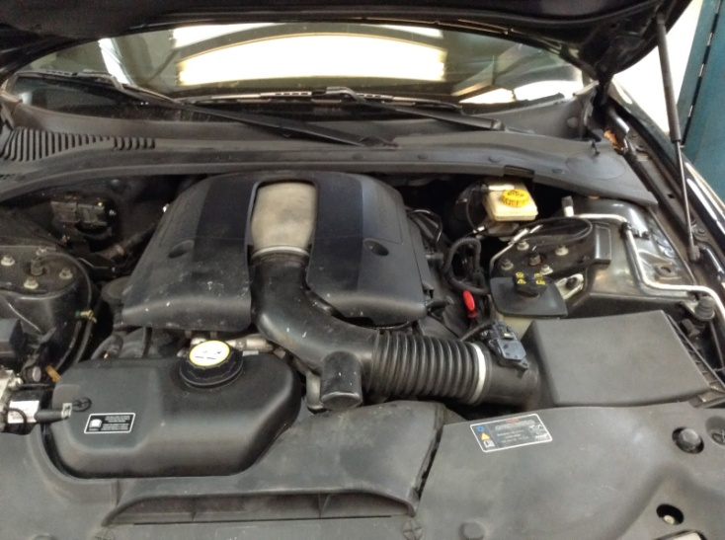
- First off I removed the top engine cover, the wipers, the cowling, and the intake boot. That should be pretty straight forward, notice that I marked the position of the wipers with blue tape.

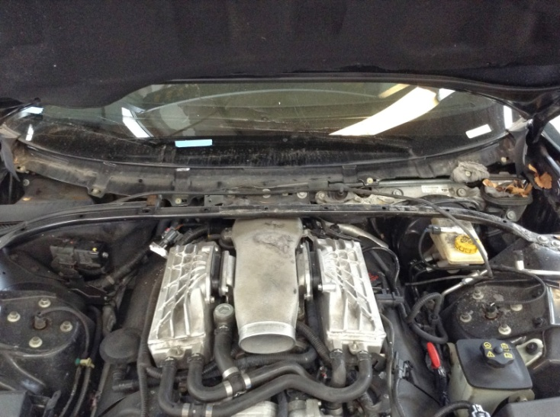

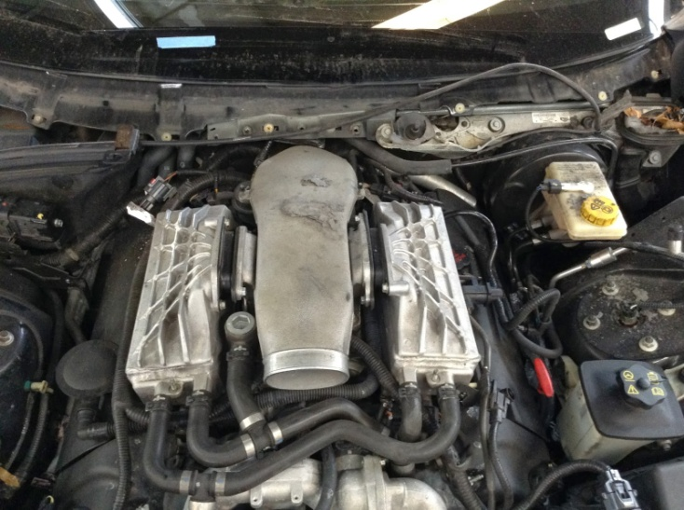
- It might be a good idea to blow the engine so no debris falls inside since we are taking the intake system apart. There is a clamp that holds the main intake tube in place, loosen it and remove it carefully so as not to rip the rubber apart.
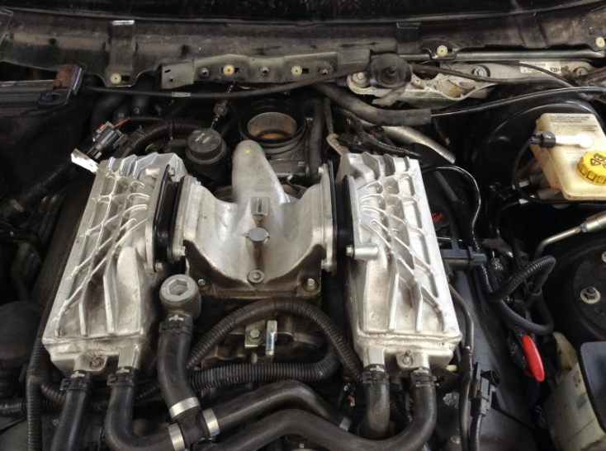

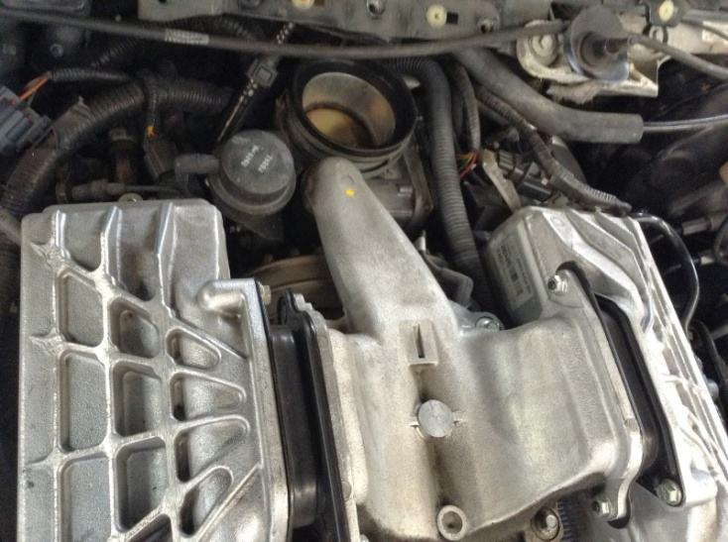
- Remove the expansion tank and the front cover.
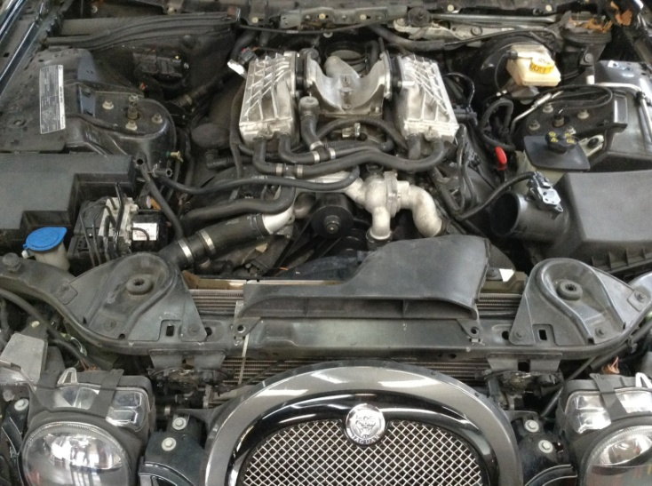

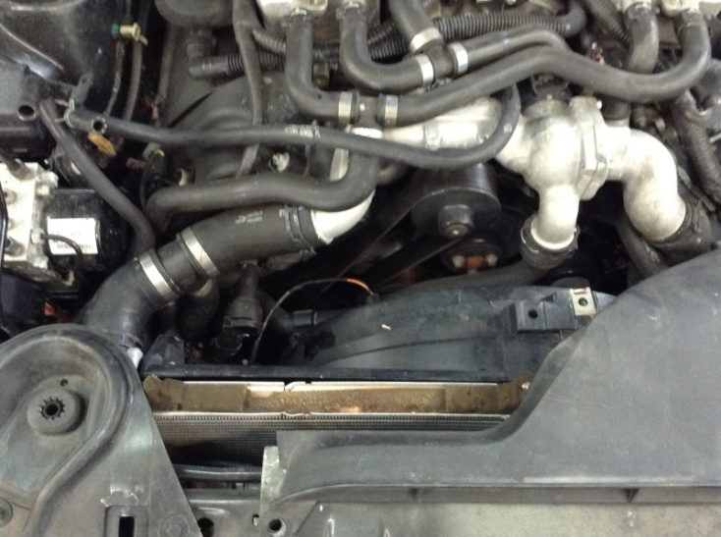
- Undo the two hoses on the pic, and move it to the right out of the way.
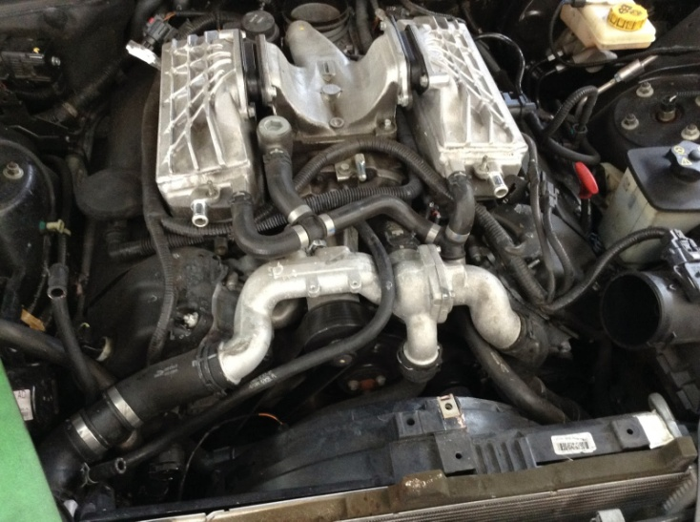
- Remove the thermostat housing which is held in place by four bolts and four hoses, two on each side, one below and a big one behind it. You also need to unplug the temperature sensor.
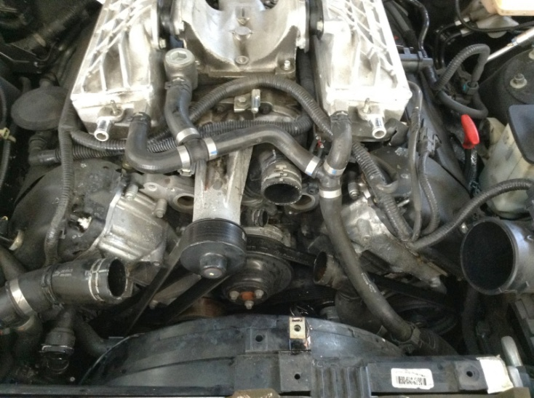

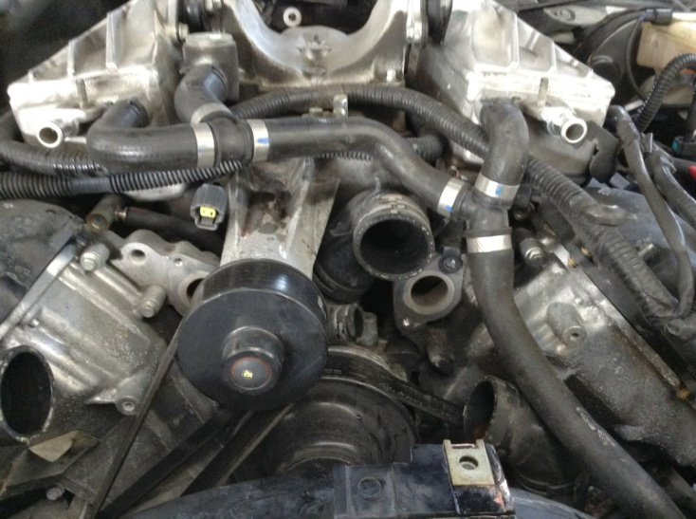
- Remove the three part hose in the pic, and move it our of the way. Then loosen the supercharger belt with a half inch drive ratchet. Just remove the belt from the supercharger, you don't need to take it completely out. Then push it aside.
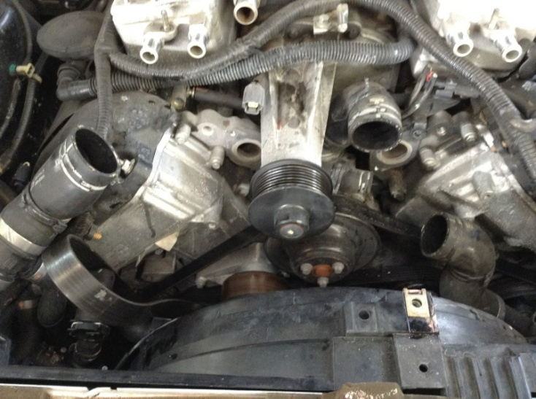

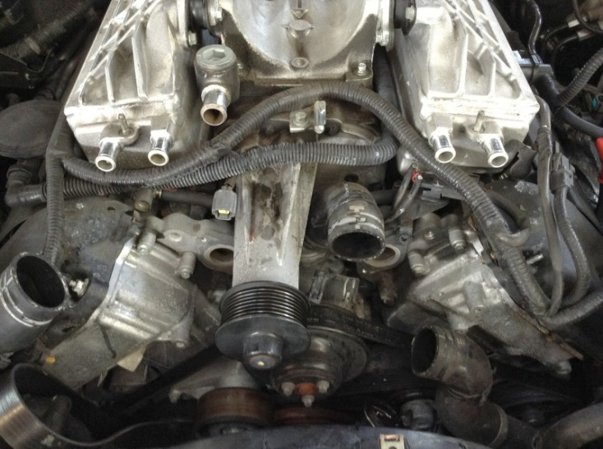
- Now it's time to remove the top cover of the supercharger, just 4 bolts and a clamp hold it in place. Your main concern is the hose, you don't want to mess it up unless you have a new one. You might notice that sometimes my pics repeat, usually I take two to make sure they are OK, but I put them both because you can never have too many pics.
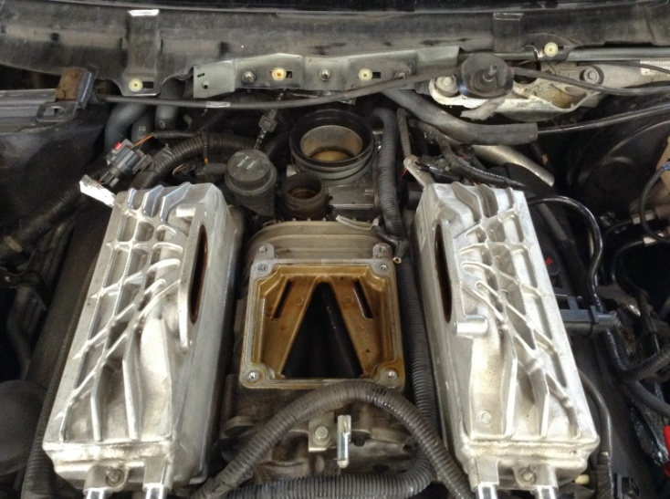

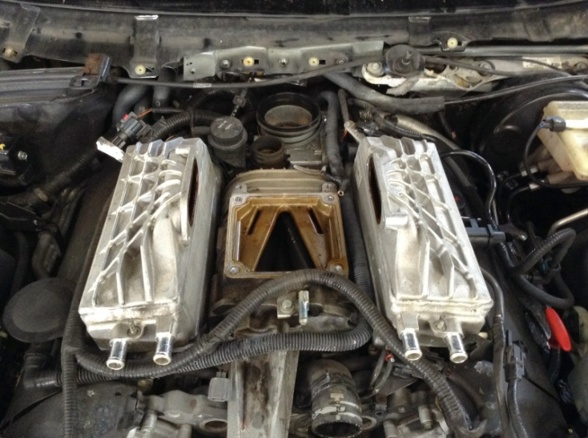
- Removing the throttle body wasn't as hard as I thought, just remove the four bolts, and the connector. Removing the boot (carefully) helps.
- Now comes the real fun!!! The EGR valve needs to come out, makes everything else much easier. Your main concern here (in this whole procedure this is what you wanna do right!) is DO NOT ROUND OFF THE EGR BOLTS. You want to make sure that when you are taking these out your socket is straight, and spraying it with Rust-off is a good idea.
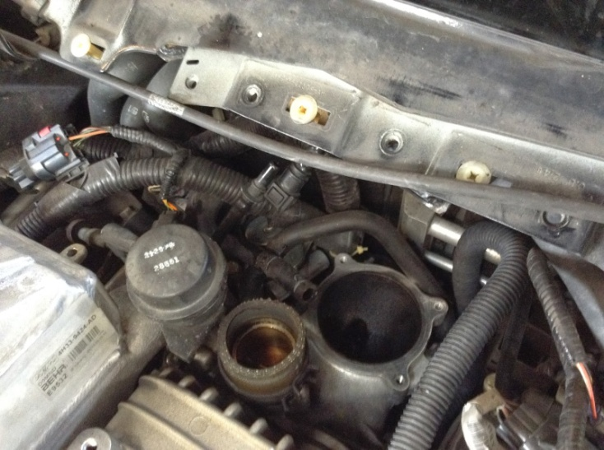
- To go at these (after trying and failing miserably I admit it) I realized it becomes much easier if you remove the A/C Cabin Filter and the housing as in the pic.
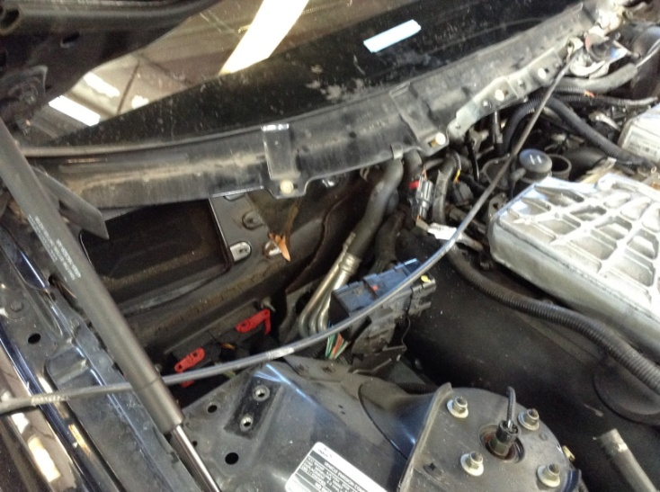
- The you have to remove the heater hoses, there is two 10 mm bolts that hold the heater hoses brackets, you want to take those off to allow them to move out of the way (they won't be out off the way they will still annoy you. Just position them where they bother you the least)
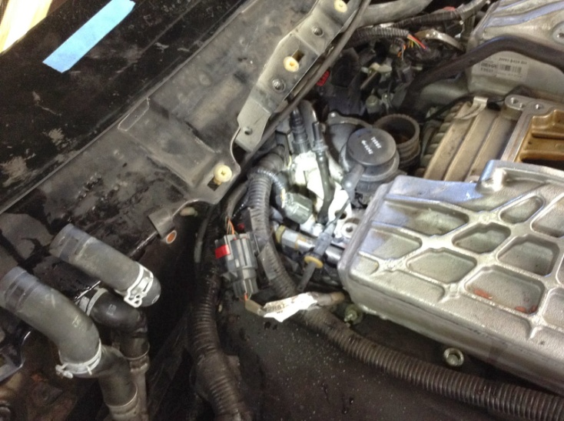

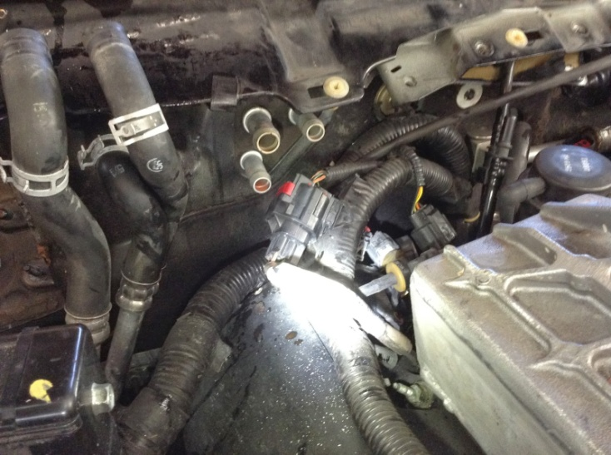
- To take out the EGR valve (shown below), remove the two 13 mm nuts at the bottom of the exhaust pipe. Then there is two 8 mm bolts that hold the valve to the supercharger. I loosened the two nuts with a deep 13 mm socket, a 3/8 swivel extension and a ratchet from the top. The two 8 mm I loosened with an 8 mm socket, a 3/8 to 1/4 inch adapter, and a long non-swivel extension with a 3/8 drive ratchet. MAKE SURE IS STRAIGHT you don't want to round those bolts... One of the hoses as you can see I disconnected at the opposite end. The other hose I took off the EGR, but to get to that one I "fished" the EGR out so it was easy to get my tool to it.
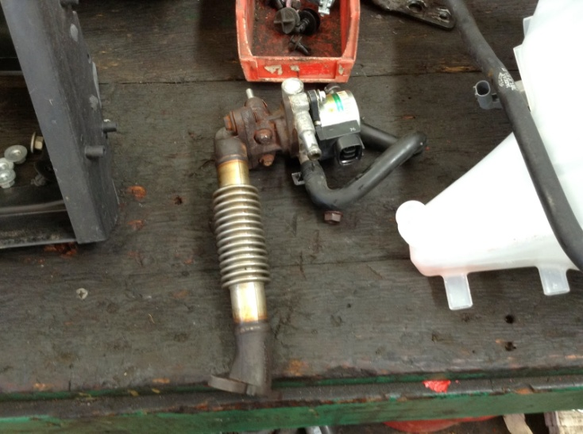
- You also need to look and remove anything that needs to be removed to the best of your common sense (I couldn't be stopping to take a pic to every single thing I did) but it's not too bad. Of the top of my head I remember moving the harness out of the way, the vacuum tube, a couple of vacuum hoses in the back.
- So how do you finally take the supercharger out? There is five 10 mm bolts holding the supercharger in place. Look at the next pic of the supercharger already out so you see where they are at. There is two at the back that go to the sides, two super easy at the front, but there is one (one S.O.B. I might add) that is right below it (again look at the pic of the supercharger pic). And there are the pain in the ass hoses!
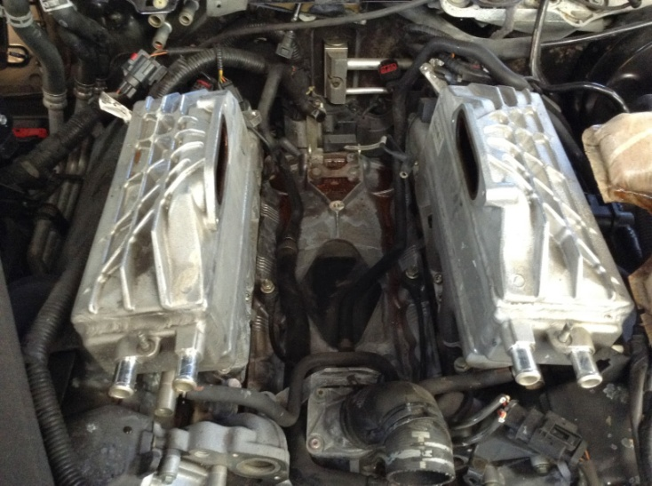

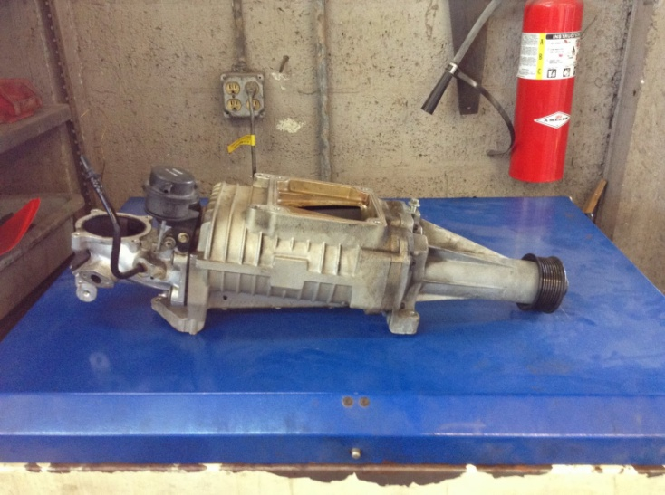

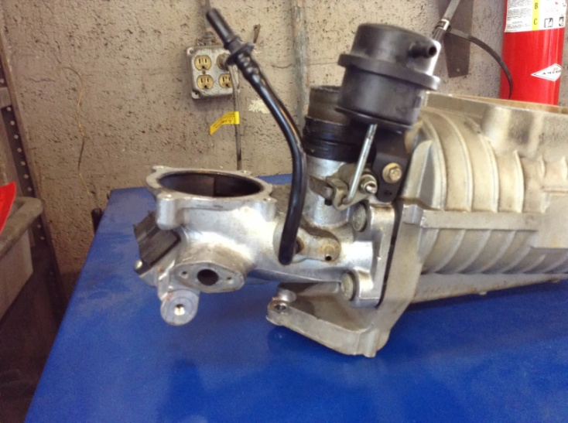

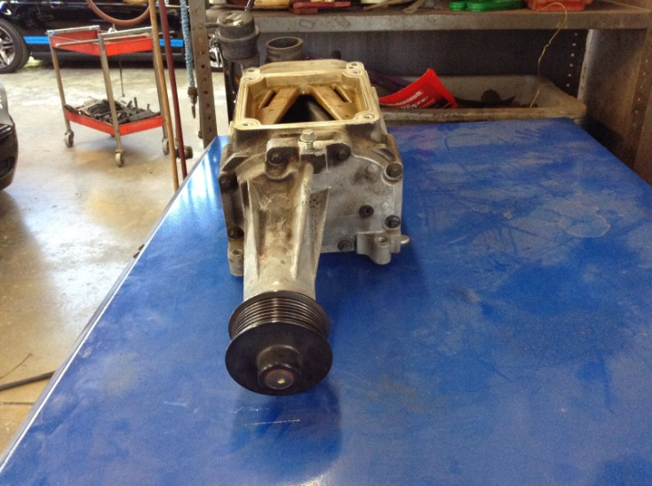
- Check back for when I'll post how I put it back together!

Posted by Daxter Bels at 5:06 PM
Email ThisBlogThis!Share to TwitterShare to FacebookShare to Pinterest
Labels: S-type, Supercharger

30 comments:
V400TCJanuary 3, 2014 at 11:47 PM
Superb write up many thanks for taking the time to do this.
Reply
Replies
  - 
Daxter BelsJanuary 4, 2014 at 12:03 AM
Thanx!
UnknownMarch 9, 2014 at 5:03 AM
Great article. Would have been lost without it. One thing I did different. By removing the plenum (4 bolts on the rear of the sc) it makes the 5th bolt on sc super easy. Thanks for making this available to all who are in a bind.
Daxter BelsMarch 24, 2014 at 9:46 AM
good to know, will try it next time!
AnonymousAugust 1, 2014 at 10:22 AM
Really helps to slot the back attachment bolt hole. Makes reinstalling the blower much easier!
AnonymousMarch 13, 2018 at 2:43 PM
mine did not need to remove the egr did the job in 4 hrs this really really helped preform the job of replacing the heater hose assy
rr could have run a brass or stainless steel pipe under the super charger but it is what it is thanks for the pic and write up
Reply
tonnytranApril 3, 2015 at 6:59 AM
In the event that your dividers are a standard tallness, its anything but difficult to make basic repairs like fixing openings or sanding. It's likewise genuinely simple to prime and paint your dividers, which can in a split second update the look of any room.
Reply
MrtomJune 21, 2015 at 12:53 PM
many thanks for taking the time to do this
Reply
Replies
Daxter BelsJune 21, 2015 at 10:05 PM
no prob!
Reply
HenryJune 21, 2015 at 12:54 PM
Thanks for making this available to all who are in a bind
Reply
Replies
Daxter BelsJune 21, 2015 at 10:05 PM
any questions ask!
Reply
ZennyJuly 12, 2015 at 12:43 AM
When your partitioning undoubtedly are a standard tallness, its not difficult to generate simple fixes similar to mending open positions or sanding. It really is likewise genuinely all to easy to perfect and also colour your partitioning, which will inside a minute up-date the style regarding virtually any bedroom.
Reply
DannyJuly 12, 2015 at 12:44 AM
If perhaps your current dividers undoubtedly are a common tallness, it's not difficult to make standard fixes including correcting opportunities or maybe sanding. It really is moreover honestly an easy task to leading and colour your current dividers, that may in a moment update the look connected with virtually any room.
Reply
KallySeptember 21, 2015 at 8:48 AM
If you look closely at the dash pic you’ll see just enough of the air filter to know the nationality of the engine underneath.It absolutely is additionally absolutely all to accessible to absolute and additionally colour your partitioning, which will central a minute up-date the appearance apropos around any bedroom.
Reply
Daxter BelsSeptember 22, 2015 at 6:52 PM
That fuc* the last three comments said?
Reply
sarahSeptember 22, 2015 at 7:58 PM
In the event that you take a gander at the dash pic you'll see sufficiently only of the air channel to know the motor's nationality underneath.It completely is also totally all to open to outright and moreover shading you're apportioning, which will focal a moment up-date the appearance pertinent around any room.
Reply
Joan P. BrooksFebruary 18, 2016 at 6:33 PM
Thanks, very useful.
Reply
BenjaminApril 2, 2016 at 10:07 AM
Thanks, very useful. The pictures to go along with the step by step instructions are great.
Reply
StagniteApril 8, 2016 at 7:11 AM
Excellent report. I need to change my EGR valve on a 2006 STR. Is yours a LHD? I ask because my EGR connects to bank 2 (RHS standing in front of the car looking towards it). Yours seems to have a short exhaust connector pipe.
Reply
StagniteApril 8, 2016 at 3:21 PM
Re above comment. Of course it is LHD. Just realised where the brake master cylinder and servo are located!
Reply
StagniteMay 9, 2016 at 4:33 AM
My bad mistake. EGR valve connects to Bank 1 so that is not my problem after all.
Having inspected the spark plugs on Bank 2 it is suggested that there is a leaking inlet manifold gasket so will need to do all the above to change the inlet manifold gasket.
Reply
Robert SmithJune 1, 2016 at 5:15 AM
Thanks for sharing us this informative idea. It will help us to know details about our car engines.
Reply
AnonymousNovember 1, 2016 at 7:08 PM
Hi I followed your steps to remove the supercharger but when I try and start it turns on for bout 3 seconds then turns off any ideas
Reply
Replies
Jagstr03November 1, 2016 at 7:09 PM
Oh yea I forgot to mention when I installed it
Reply
Elizabeth J. NealJune 7, 2018 at 5:20 AM
I can set up my new idea from this post. It gives in depth information. Thanks for this valuable information for all,.. supercharger rebuild porting
Reply
UnknownMarch 12, 2019 at 9:53 PM
For some reason I can't see lots of your pictures is there any other way? So far I understand but I cant see what bolts your talking about that hold the supercharger down same with egr valve.
Reply
Nick SAugust 15, 2019 at 7:05 PM
Wondering how the button knobs come off the engine cover at beginning. Turn, depress or pop out?
Reply
Replies
StagniteSeptember 4, 2019 at 10:58 PM
They just pull off. Lift the engine cover with a slight tug.
Reply
StagniteSeptember 4, 2019 at 10:57 PM
Superb write up. I still haven't changed mine despite having all the required parts in a bag! STR on 66,000 miles now, 2006. Would it be easier/possible to remove the four bolts holding the throttle elbow to the s/c thereby leaving the throttle body and EGR behind?
Reply
JimSeptember 11, 2020 at 11:59 AM
Hi... resurrecting this thread to ask... looking at photos 7 and 8 above, which show the thermostat housing, does anyone have a name, or better yet a part number, for the hose attached to the bottom of the housing? Hope you can help! Many thanks.
Reply
Newer PostOlder PostHome
Subscribe to: Post Comments (Atom)

Search this blog



Jags and more
- New Posts
- XF
- XJ(2010-)
- XK(2007-2015)
- XJ(2003-2009)
- S-Type
- X-Type
- XK8(1996-2006)
- XJ(1997-2003)
- XJ X300 (95-97)
- XJS ( - 1994)
- Land Rover Articles
- Videos
- Tools
- Jokes
- F-type

Follow me on Instagram!

Total Pageviews
0 | 45
1 | 46
2 | 67
3 | 78
4 | 69
5 | 57
6 | 65
7 | 94
8 | 51
9 | 59
10 | 53
11 | 99
12 | 58
13 | 39
14 | 39
15 | 96
16 | 61
17 | 56
18 | 72
19 | 75
20 | 42
21 | 94
22 | 55
23 | 43
24 | 54
25 | 54
26 | 46
27 | 54
28 | 54
29 | 20
1,018,585

Followers

About Me
Daxter Bels
I've been an automotive technician since 2007. I graduated Robert Morgan Educational Center in 2008 and I am ASE certified. I specialize in Jaguar, Volvo and Land Rover cars and work for Gables Cats Automotive in Coral Gables. (http://www.gablescats.com)
View my complete profile

Forum links
JaguarForums
JaguarForum UK Foro de Jaguar
Simple theme. Powered by Blogger.

