Instrument Cluster Removal
Removing the Instrument Cluster is fairly straight forward and requires no special tools or experience and the most frequently requested reason is due to a blown lamp.
Repair Open Time is less than an hour and would cost you here in the UK:
£89.00 at an appointed dealer plus parts
WARNING: Always disconnect the battery when working with electrics ensuring first that you have the radio code at hand.  Remove the two screws from the left hand side of the lower scuttle panel. Note that the lower one is a tad difficult to see in the picture as it points upward and if you forget it, it may end in tears! | 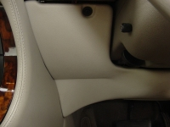
Remove the two screws from the Right hand side of the lower scuttle panel.  Lower the panel and remove any electrical plugs by applying pressure to the locking clips.  Set the Scuttle panel to one side out of the work area. | 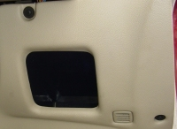
Laying on your back in the foot well look up and locate the Cluster mounting screws 2 on each side. The rear-most are self tappers and in the example here one was missing. Note that on XJ40s and some early x300s these are all Pozidrive bolts. | 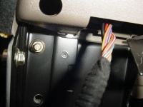
The forward two are accessible through the holes in the plastic moulding and are actually Pozidrive bolts. | 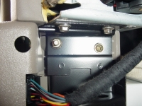
Sitting in the driver’s seat, carefully pull the top of the cluster forward to disengage a metal locating tongue at the rear top of the cluster. Lowering the steering wheel helps access. Reach behind the cluster and unplug the two connectors by pressing down the two clips (top and bottom) and extracting them rearward. | 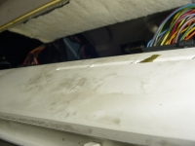
There are two clips at the bottom of the cluster (just visible in the picture) that allow access to the lamps that illuminate the dials (held by the white lamp holders), the lower warning lamps and Odometer. The brown ones ether side do not require the cluster to be removed from the car for access, nor do they require you to open the cluster out. | 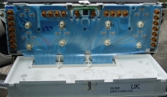
This picture is for reference only and shows the mounts with the unit completely removed and is for reference only.  Reassembly is the reverse of these instructions. | 