Front Spring Compressor.

I made a spring compressor when working on my front suspension a few years ago and I did this by using a large threaded rod and drilled a hole through one end and used a long bolt shaft as the cross piece. At the other end a suitable nut and a number of thick washers. All this was well greased.
I used a 3/4" threaded rod 22” long and the cross piece was a 5/16" bolt shaft 1 & 7/16" long.

The cross piece has to be short enough to pass through the hole in the spring pan and the top spring mount and long enough to fit securely into the notches in the top mount.

The large diameter of the threaded rod will prevent it moving sideways enough to dislodge and cause grief.

The compressor has to be passed up through the spring pan and top mount with the cross piece aligned across the car and then turned 90 deg to engage in the top spring mount.

When reassembling the lot I used a bolt shaft with the head removed screwed into the lower suspension arm to guide the spring pan onto it.

With the load off the suspension the spring pan only has to be lowered a couple of inches before the spring load is zero. In the pic below, with the spring compressor installed, the nut is only finger tight.

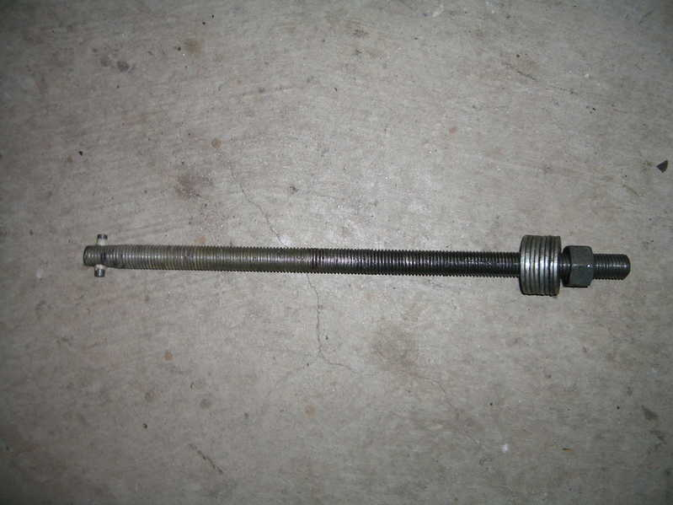
Spring Compressor as described above.

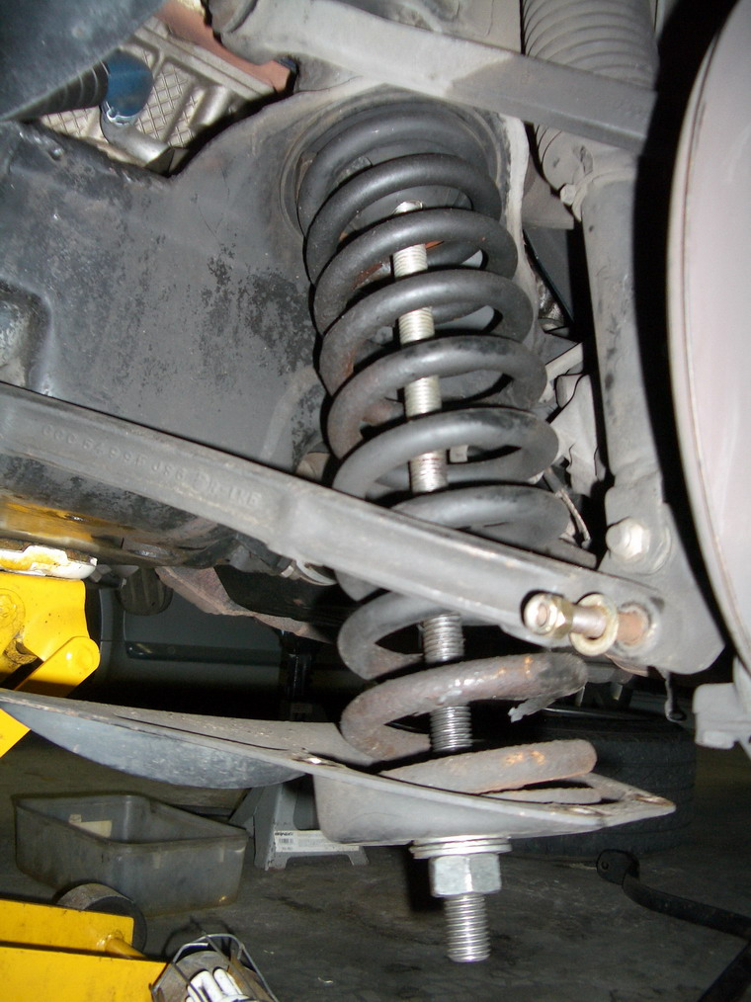
Spring compressor installed with spring at full extension.

