XJ6 S-3 Cylinder Head prep notes
Clean Stud holes in Cylinder Head Run a reamer or correct sized drill through each of 14-cylinder head holes. Ensure all corrosion is removed.
Install Tappet Guide Hold-Down Kit on exhaust side.
Which end of Stud is up?
The short studs have a 1/16” wider band at one end; This side goes down.
The long studs are threaded at both ends, but one end has an un-threaded tip; This end goes down.

Stud Placement (Series 3 and some Series 2 engines.)
There fourteen studs, four short and Ten long: Three of the Ten long studs are three 3/16” longer than the remaining seven (different part numbers). The longest studs hold the two Engine lift brackets.

The four short studs are easy to place as they go is the four corners. With the dowl stud placed in forward exhaust side of block. Three longest studs are placed on intake side in number 2, number 5 and number 6 positions for the two Engine Lift Brackets.
Length of 14 studs:
(3 ea C2269) = 6 7/16”
(1 ea C42355) = 6 5/8” Dowl stud
(3 ea C38073) = 12 15/16” Longest
(7 ea C29033) = 12 11/16”
Dowel stud has band at the top (below threads) where the head slides on, to “locate” the head on the block.

Ready the Block
Read the shop manual thoroughly on positioning crankshaft, camshafts and distributor drive alignment, before placing cylinder head on the block. Valve to valve interference, valve to piston interference and distributor being 180 degrees out of alignment are all possibilities.

Lower stud threads: apply a thin layer of hi-temp grease; screw into block at 27 - ft-lb. (double-nut method)

Remove all oil and grease from the mating surfaces by means of a cloth dampened with gas or other volatile grease solvent, wiping dry with a clean cloth. Gaskets come with sealing compounds around holes, so no additional sealant req’d on block.
The head gasket is stamped with the word “ Top” to ensure that it is fitted with the correct side facing upwards. The timing chains have to be raised up through the hole in the gasket which, in turn, has to be lowered evenly over the studs.

Fitting the Head
First, remove any bolts from the camshaft flanges and place the timing chain sprocket assemblies in the top loops of the chains. Rest the sprockets in the supporting brackets and tie them together with a length of wire or plastic strap so that the head can be lowered over them.
Wrap the threads at the top of the 14 studs with a thin turn or two of electrical tape, to protect the surface of the head. Make it into the shape of a cone at the tip. Remove tape once head is on block.
Apply a thin layer of Copper Coat on top surfaces of the timing chain case, then install cylinder head gasket.
Apply a thin layer of Hi-temp grease on upper portions (3”) of all 14 studs. Makes it easier for head to slide on studs.

The easiest way to fit the head is to have two people lowering and a third person aligning the head evenly on the block; (otherwise, it may bind on the studs). Beware when lowering the head, not to contact an open valve with the top
of a stud. The valve stems will bend very easily.
Drop the head down soon after gasket is in place, seal studs (squeeze a bead of GE Silicone II around each of the 14 studs at the cylinder head), then add thick washers, engine lifting brackets and high-tension lead brackets to the studs.
The washers are part of the sealing system that keeps the water in the block. The thicker washers should be on all studs, with the except the lifting brackets studs; washers are between the bracket and dome nut).
If re-using washers, polish with very-fine sandpaper.
If re-using dome nuts, internal threads should be cleaned with a bottoming tap and solvent.

Preparation for torquing
Apply a thin layer of Hi-Temp grease on top of the cylinder head washers before installing the dome nuts. It helps give a more accurate reading when torquing the nuts. The lifting brackets are against the head, a washer is on top of bracket, under the dome nut. If you have correct amount of thread showing, you should not need two washers per stud, but is ok, if too much thread is showing. You do not want dome nut to bottomed on stud. If you add a commercial washer, it should be
Grade 8-10…. If you don’t have a few extra Jaguar washers in advance, it is not a good time to be running to the hardware store!!

Torque the Dome head nuts in stages (start at 20 ft/lb.), ½ turn at a time, to 54 ft/lb. working from the center of the head towards both ends. Tighten the six nuts at the front of the cylinder head.

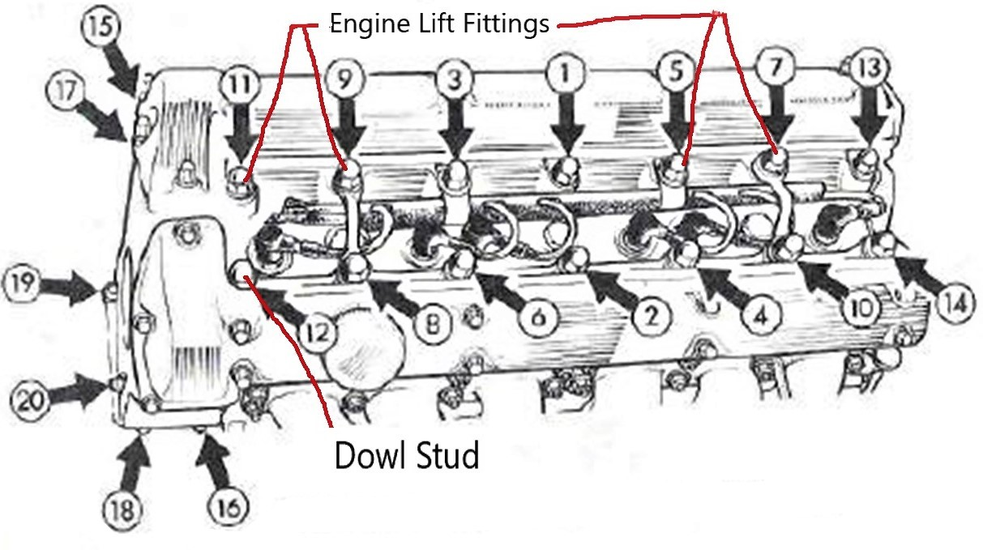 (Note: picture shows aluminum Engine Lifting Fittings from early cylinder head on the 2nd and 6th studs {RH & LH})
After initial torquing of dome nuts, wait overnight and then re-torque; (one at a time, back off dome nut ¼ to 1/3 turn then re-torque in the correct order). The studs stretch a significant amount. Modern gaskets do not recommend re-torquing after several weeks of engine running.
On 4.2-liter models fitted with air c0nditioning equipment, mount the alternator and the compressor brackets to nuts 16 and 18.

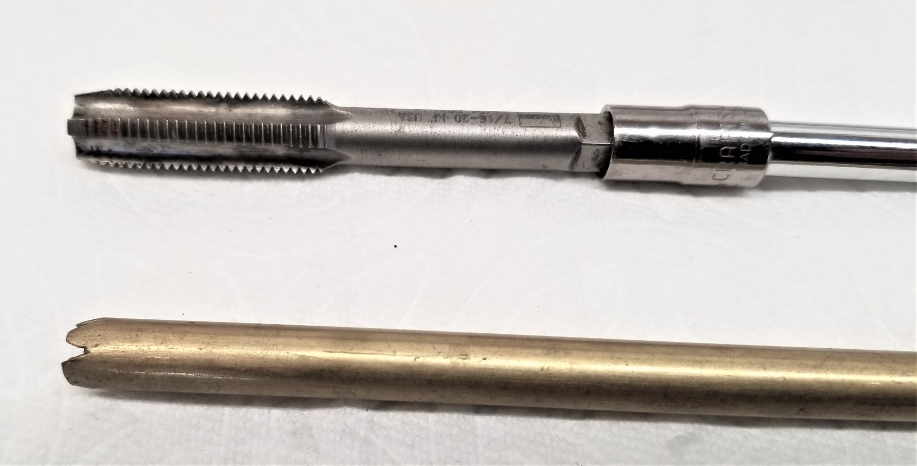

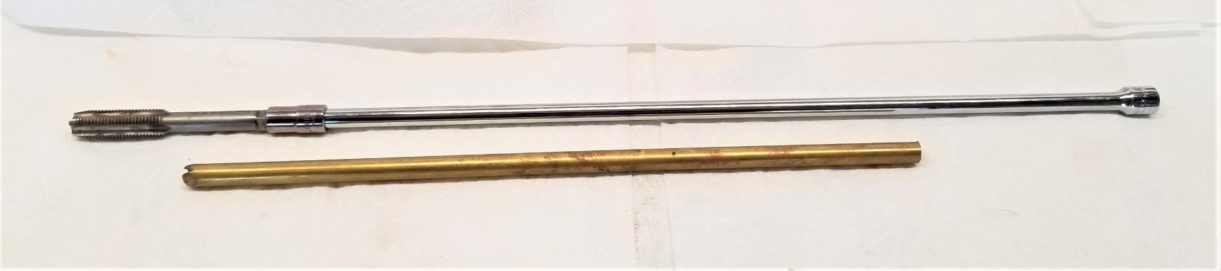
14” long ¼” socket extension, 7/16-20 tap, forced into 9/32 socket. Started with regular Tap, finish with bottom. Had to make sure socket and tap did not fall off inside engine (Supper glue gel).
To clean holes and get rid of any fluids in hole I used 5/16" brass tube (Ace Hardware) with slots cut in one end to allow airflow, hooked up to shop vacuum cleaner with 3/8” plastic tubing (Ace Hardware) and a cut-up small funnel, duct taped to the shop vac hose.

