XJ6 S3 Stud installation Ready the Block:

Apply a light application of hi-temp grease on the block stud threads, and screw studs in at 27- ft-lb (use double nut method).

Remove all oil and grease from the mating surfaces by means of a cloth dampened with gas or other volatile grease solvent, wiping dry with a clean cloth.
The head gasket is stamped with the word “Top ”to ensure that it is fitted with the correct side facing upwards. The timing chains have to be raised up through the hole in the gasket which, in turn, has to be lowered evenly over the studs.

Fitting the Head Beware when lowering the head onto the studs, NOT to contact that one open valve with the top of the studs. The valves WILL BEND very easily.

Wrap the 14 studs’ top threads with a thin turn or two of electrical tape to protect the surface of the head. Make it into the shape of a cone at the tip, above the stud.
Remove any bolts from the camshaft flanges and place the timing chain sprocket assemblies in the top loops of the chains. Rest the sprockets in the supporting brackets and tie them together with a length of wire or plastic strap so that the head can be lowered over them.
Apply thin coat of hi-temp grease on upper portions of all 14 studs. Makes it easier for the head to slide on studs.
Apply a thin layer of Copper Coat on aluminum surfaces around timing chain cavity, block & cylinder head. Install Head Gasket, “Top Up.”
Apply a small bead of GE Silicone II around each of 10 interior studs at interface with Head Gasket.

The easiest way to fit the head is to have two people lowering and a third aligning it evenly on to the block, (otherwise cylinder head may bind on the studs).

Drop the head down quickly after the grease and copper coat, adding washers, engine lifting brackets and high-tension lead support bracket to the studs.

Apply a small bead of GE Silicone II around each of 14 studs at the top of cylinder head under the washers and lifting lugs.

Fit the spark plug lead carrier to some of the studs on the right-hand side and the ‘0’ washers to the remaining ones. The washers are part of the sealing system that keeps the water in the block. The thicker washers should be on all, but the lifting eye studs. (If re-using washers, polish with very fine sandpaper) (Re-used dome nut threads should be cleaned with tap and solvent)

Apply a thin layer of oil to stud threads, and on top of the cylinder head washers (under the dome nuts). It helps give a more accurate reading when torquing the nuts. Put the lifting lug against the head, and a washer under the nut, but not a washer under the lifting lug. If you have correct thread length exposed, you shouldn’t need two washers per stud. (If one stud is not fully seated in block, you may need second washer to keep the dome nut from torquing down on stud, not the cylinder head,)

Torque the 14 Domed head nuts in stages (start at 20 ft/lb.), ½ turn at a time, to 54 ft/lb. (slightly lubricated stud threads) working from the center of the head towards both ends. See FIGURE 1.
Tighten the six nuts at the front of the cylinder head ½ turn at a time to 20 ft/lb. (slightly lubricated stud threads)

FIGURE 1.
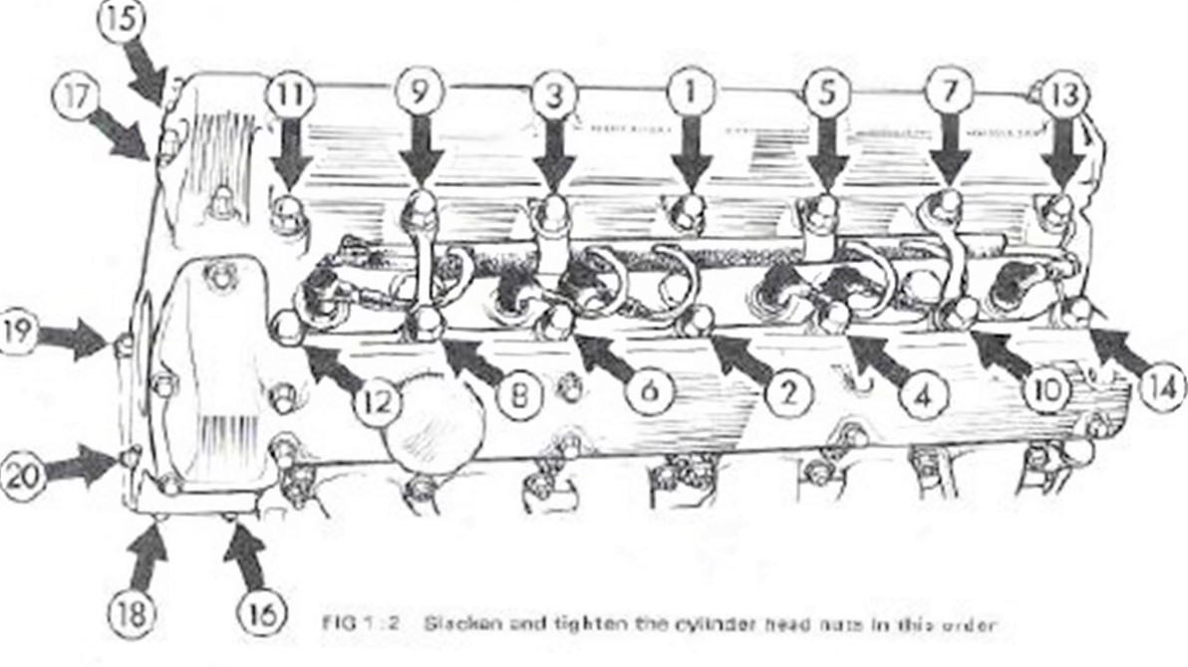
Figure 1 is an XKE head, XJ6 S3 head has different lifting brackets on intake side only.
After torquing the dome nuts, wait 12 hours, then re-torque one-at-a-time, in the original order. (Loosen nuts ¼ turn with breaker bar, not with the torque wrench).

The studs stretch a significant amount. (Newer gaskets designs may state not to retorque in the instruction sheet).

On 4.2-liter models fitted with air c0nditioning equipment, mount the alternator and compressor brackets to access nuts 16 and 18 before installing nuts, and torquing.

