SU HS8 Tuning and setting up, including fuel level.
Written by: Grant Francis (Grant Francis), Veteran member & Ken Hill (cat_as_trophy), Senior member
Pictures and car by: Clarke Bryant (o1xjr), Senior member.(and very small bits of text)
First, a quick background:
Each SU has a butterfly spindle whose sole function is to regulate air volume passed to the engine inlet - it has no direct impact on fuel metering, jets etc - and to regulate that air at idle, it is fitted with a finely adjustable idle adjustment screw.
The round alloy cylinder that is a feature of SU contains a piston with passages to allow induction vacuum to transfer into the carby cylinder, thus drawing up the piston under the restraint of its own weight + internal spring + internal oil damper. The lower piston face contains a long tapered needle, which regulates fuel delivery from an attached fuel bowl via a hollow stem into which the needle protrudes. The greater the air volume and velocity passing through the carb, the higher the piston, the thinner the cross-section of needle remaining in the single hollow jet - therefore, the greater the fuel delivery. Generally, manual chokes consisted of cable device which produced richer starting mixture by mechanically lowering the single hollow jet of each carb relative to the carb needle
Best advice I received is to ensure, before you start anywhere near the carbys. Is that all other engine issues are fully sorted. This should be seen as a final stage of engine tuning

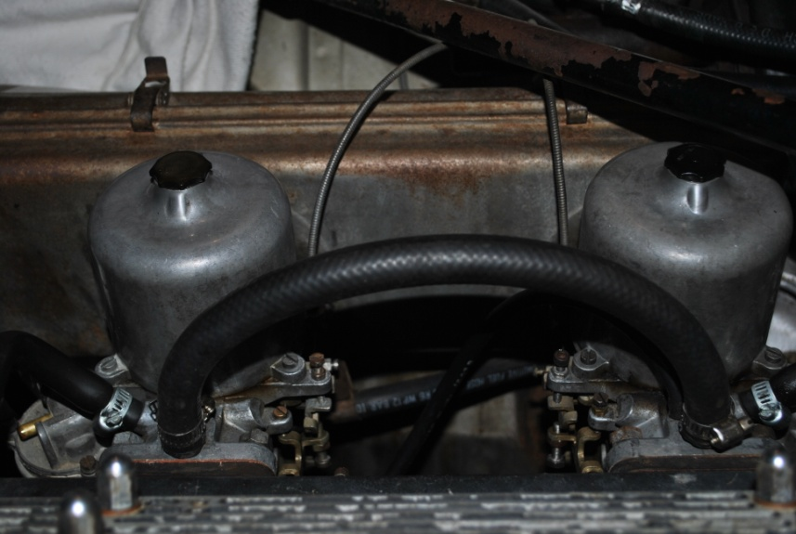

This is a write up from memory of how I have done this for a good many years.

On the Jaguar 4.2 with 2 of these carbys, the following Pre-adjustment work should be followed prior to removing any items related to the carbys.

Ensure the spark plugs are good and gapped correctly. Points gap, timing and dwell are correct and check the HT leads for simple “old age” issues. Check your fuel pumps, hoses, and clamps.

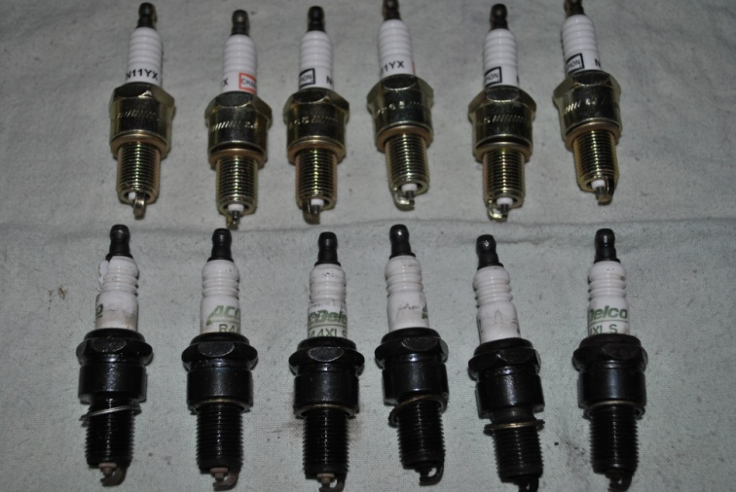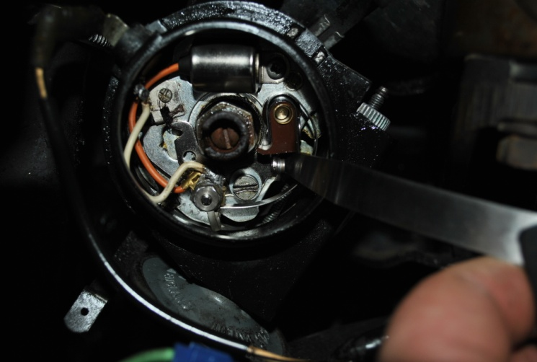

Remove the air cleaner cover, AND the backing plate. Undo cross stay at from inner gaurd,and loosen bolt at firewall and swing it to other side of motor to sit on the other cross stay. This will allow easy access to rear carby.

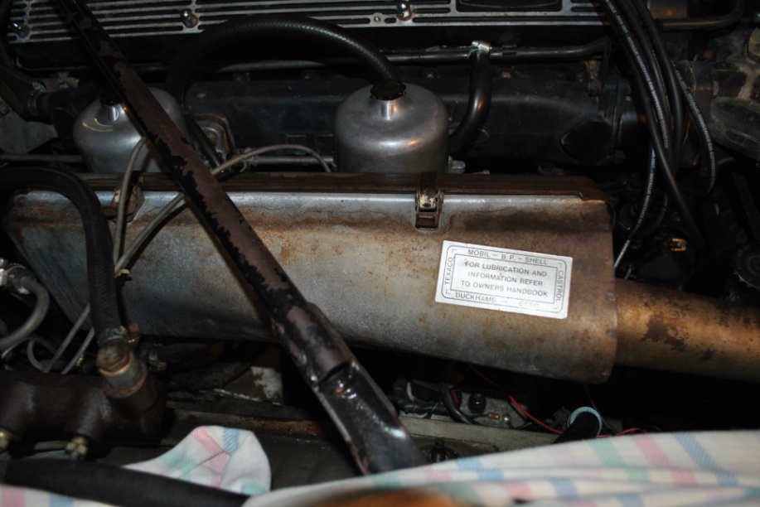
Cross stay

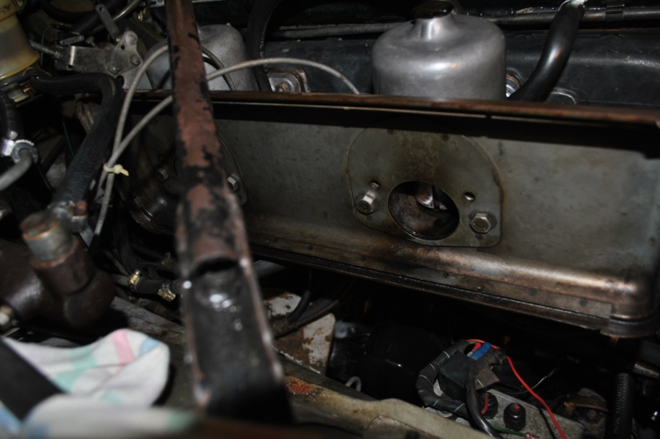

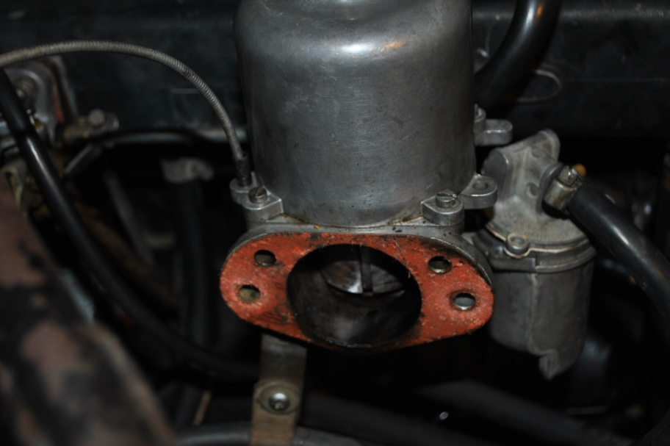

Ensure the throttle cable has “some” slack in it, coz if it is too tight the whole next procedure is a total waste of time. I generally disconnect it totally and sort the refitting after the work is done.

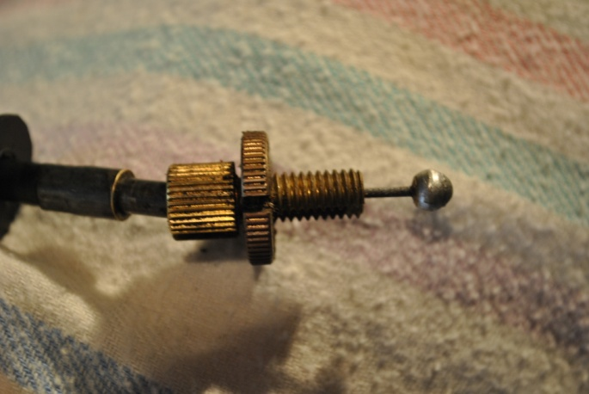

Check and ensure the choke cable is fully extended, that means pushed all the way in at the inner control, and the “fast idle” cam is NOT in contact with the “fast idle” setscrew.

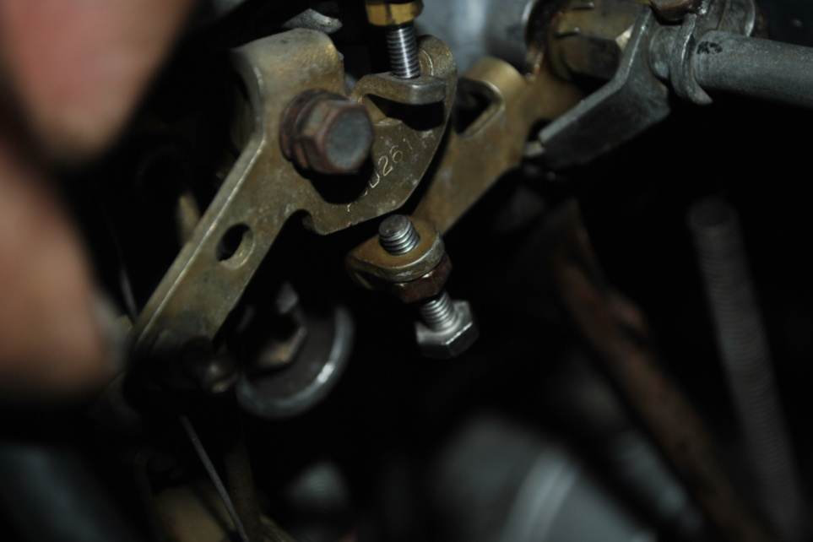

Note the “Z” clamps securing the throttle rod joining the 2 carbies (the rod closest to the manifold, as the outer one is the choke shaft joiner, if fitted). Loosen the small bolts (just loosen will do), enough so that the front carby shaft moves without the rear carby shaft moving at all. You need both carbies to be separated to get the adjustments correct.

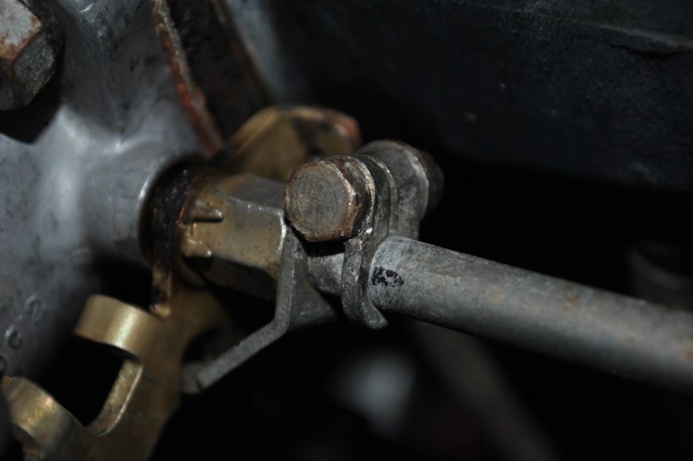
Remove the carby bell chambers (the top dome thingy), lift off the long spring, then CAREFULLY lift out the piston. When lifting the piston, lift it straight up until clear of the carby, as the brass needle is easily damaged.

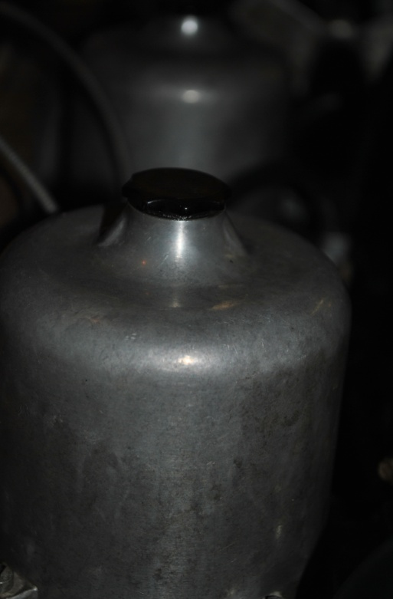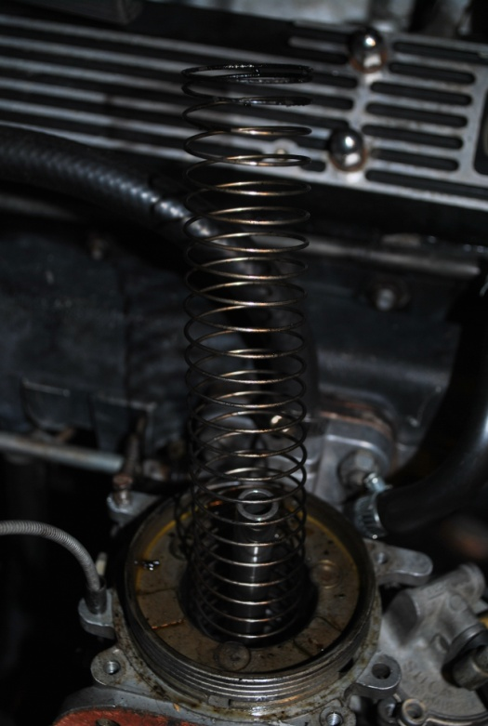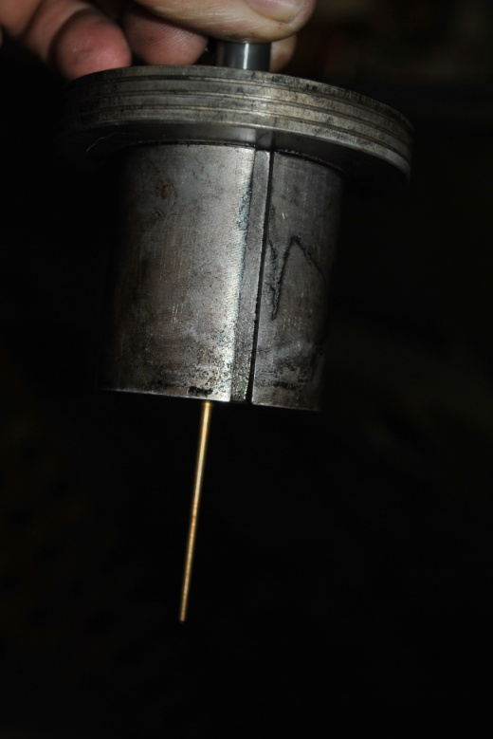

Note: All parts removed must be kept separate so that they can be re-installed into their correct carby. Multiple plastic ice-cream containers are useful.

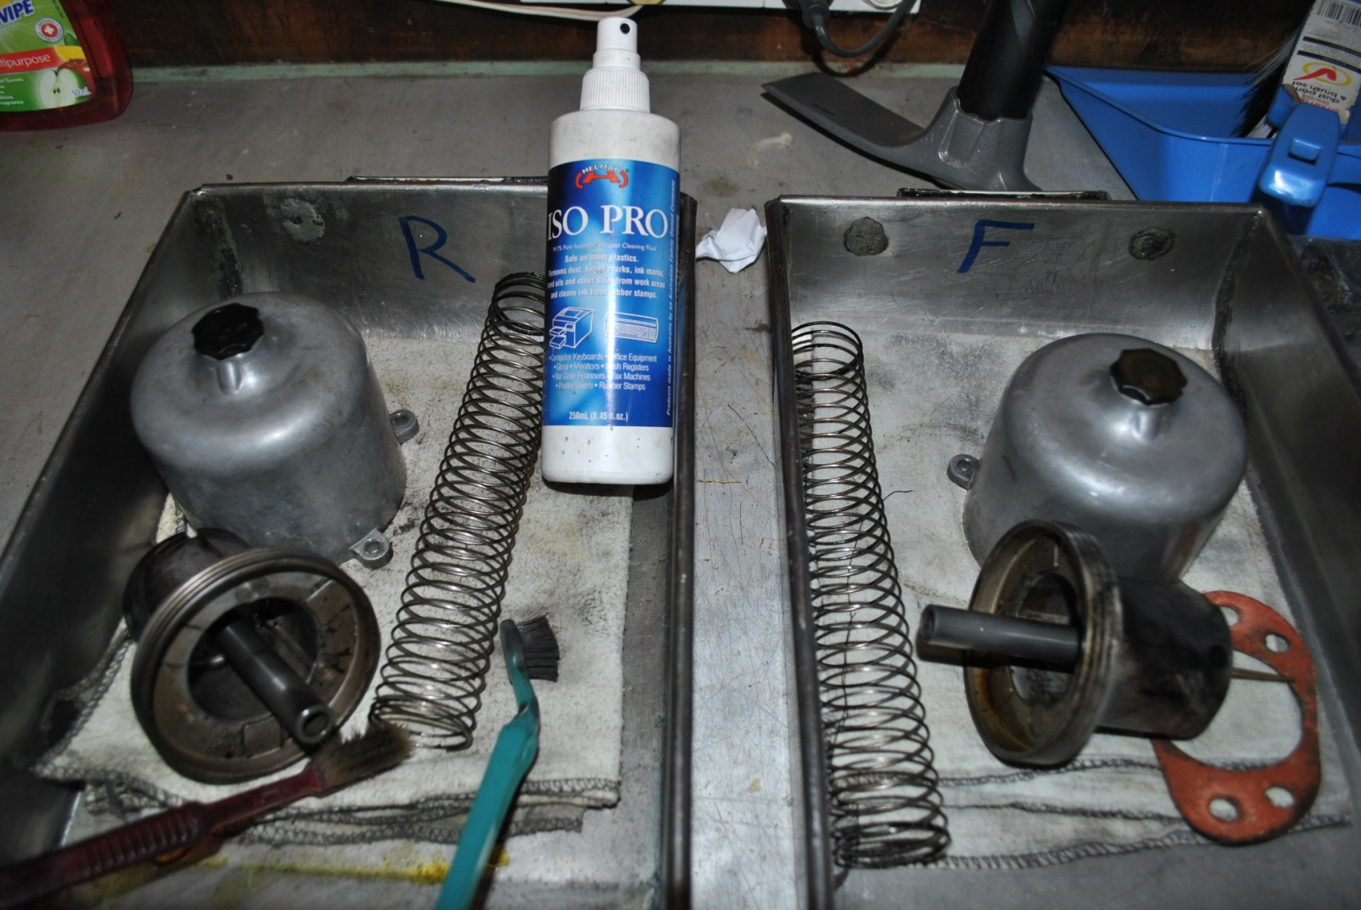

Fuel level setting.

NOTE: I usually do this step as part of the carby set up, and BEFORE balancing etc. The pistons are removed so I can actually see the fuel in the jet, as MY guide to correct float level. I have learnt over the too many years that the fuel sits in the jet at a specific height if fuel level in the bowl is correct, or very, very close. You too will understand this much clearer as you progress with the carby set up and tune, and that dreaded fear factor slips away.

Correct fuel level in the bowls is CRITICAL, due to its relationship to the fuel height IN the jet. Too low, and a lean mixture will haunt you. Too high and fuel will flow out the jet and flood the engine.

The fuel float is hinged to the bowl top (lid), and is usually nitril (plastic stuff) in composition. Some are clear/white, some are black, matters not. Check each float carefully for fuel “inside” the float. This is common, so, again, take your time and check it properly.

Some lids have the “needle and seat” with a washer under the seat, some do not. I have had both, but mainly no washer. New needle and seats are preferred, but its your car. 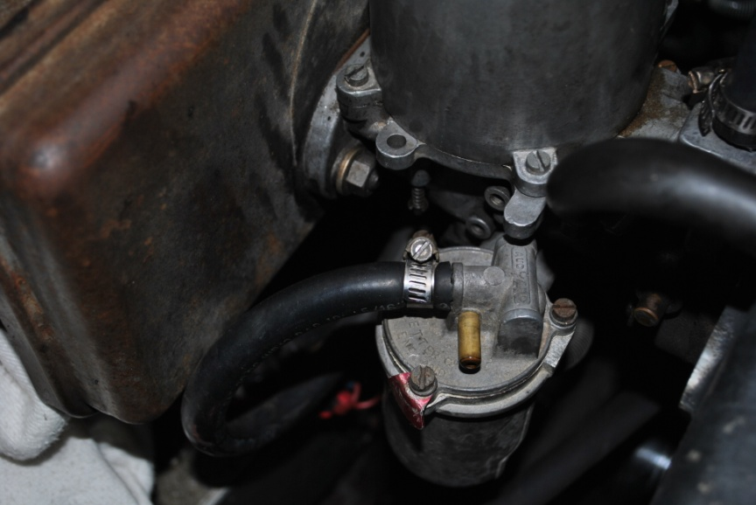
Float Bowl
Invert the lid (float upward) and place your mouth over the fuel inlet pipe and SUCK, and ensure you CANNOT suck air. If air is sucked, FAIL. Once vacuum is achieved, turn the lid over (float downward) and blow through that pipe, and carefully raise the float, thus closing the needle, and ensure your “puff” is closed off.

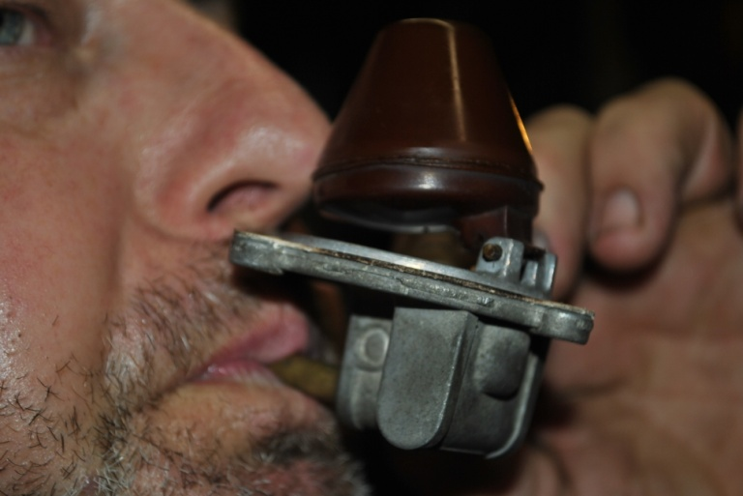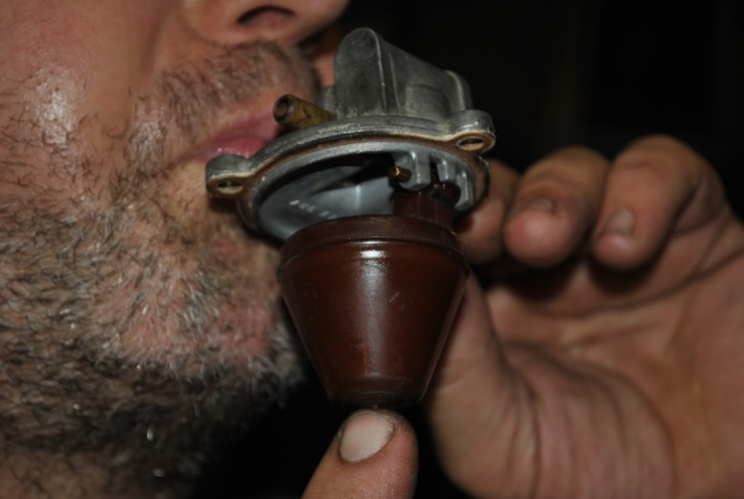
Once satisfied, refit the bowl lids with a new gasket.

Turn ON the ignition, pump runs, and ensure the fuel is NOT flowing out of the jet, indicating a needle seat issue that’s need your further attention.

NB: Reconnect fuel lines to the float bowls before turning on ignition (I got fuel all over the engine bay)
Clean Carby inside and out

At this point I cleaned around top of carby body and inside air intake and around the bridge with the jet in the centre. Using 100% IPA (Isopropyl alcohol), As it is fast evaporating and leaves no residue.
Scrub all gunk and build up with an old toothbrush, then blow out with compressed air if available.

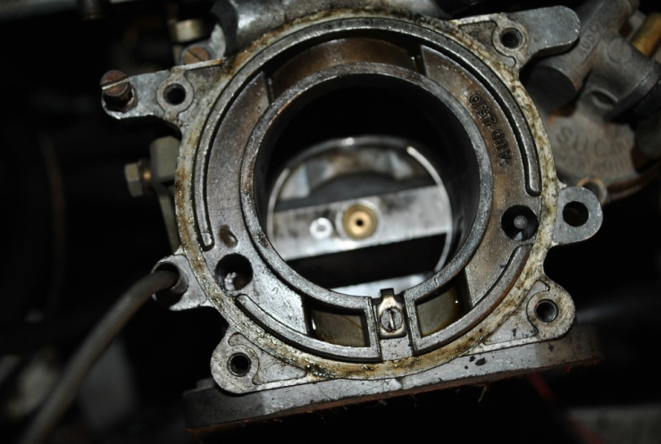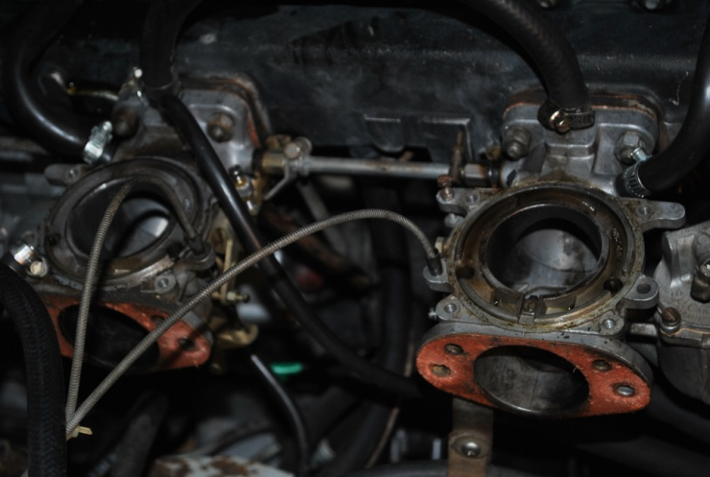

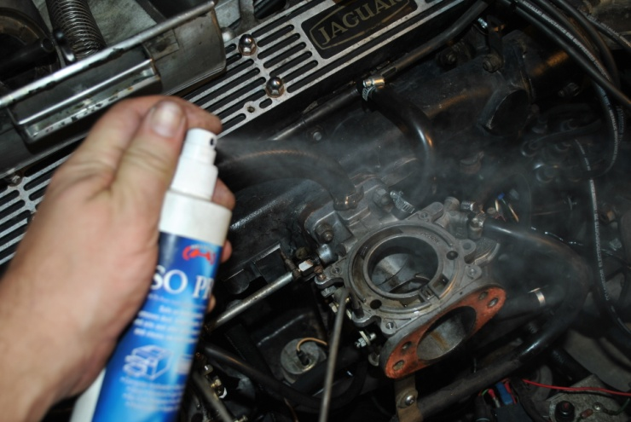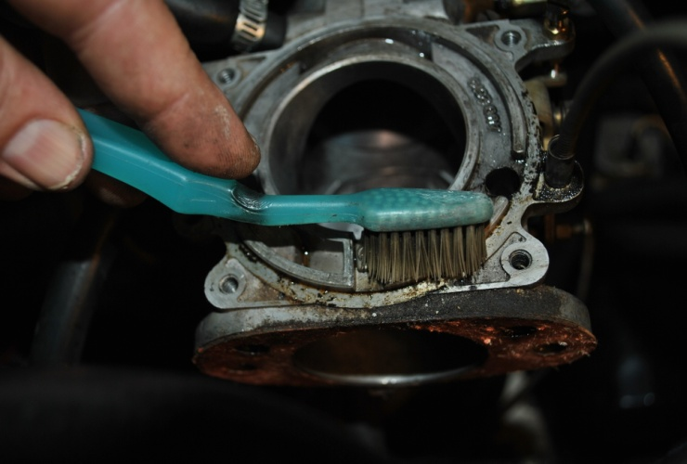

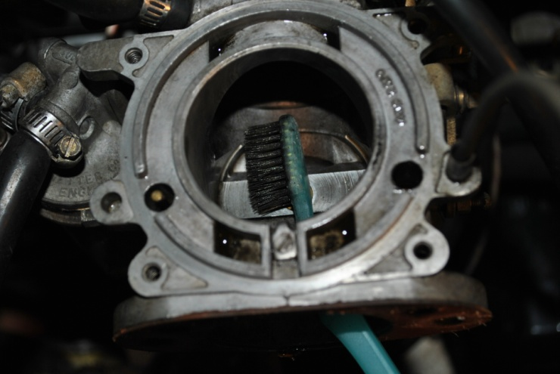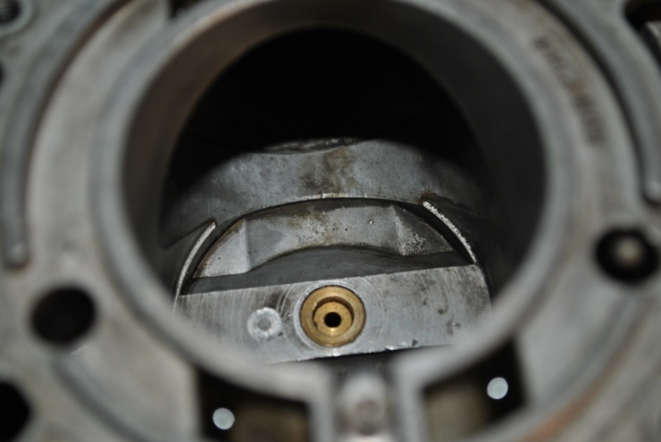

While I had Bell chambers off it was a good time to replace a miss-matched set of idle and mixture screws.
Idle screws are 4 BA x ¾” SS cheese head, Mixture screws are 4 BA x 1” SS cheese head. Lock nuts are
4 BA Brass nuts. You can try to source these locally but in Brisbane I found only two 4 BA bolts and they were the wrong length, 5/8” . SU Midel in Sydney had them at a premium price.
I sourced them online for 10 of each idle & mixture screws + 20 locknuts for less than I could get 2 scews the wrong length in Brisbane. Link below, and paid with Paypal.

http://www.ba-bolts.co.uk/

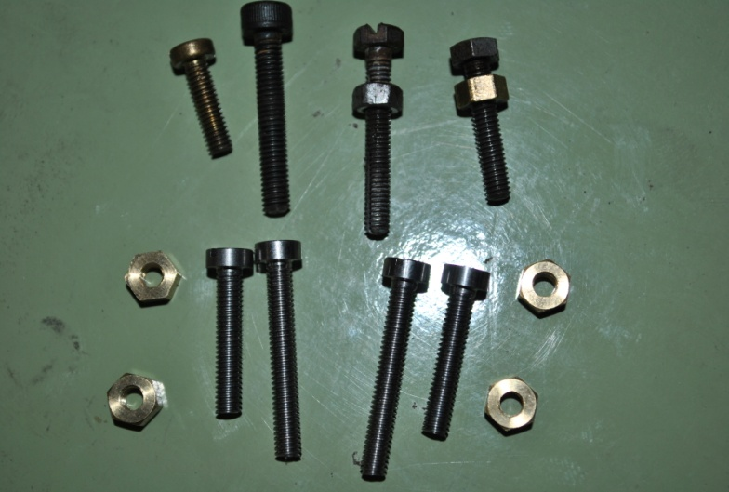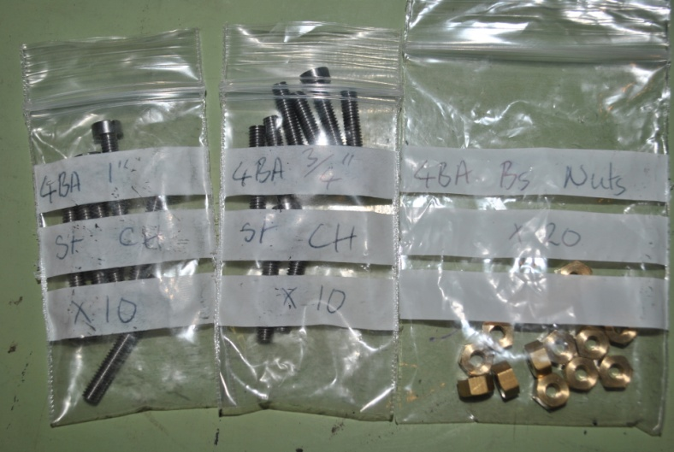

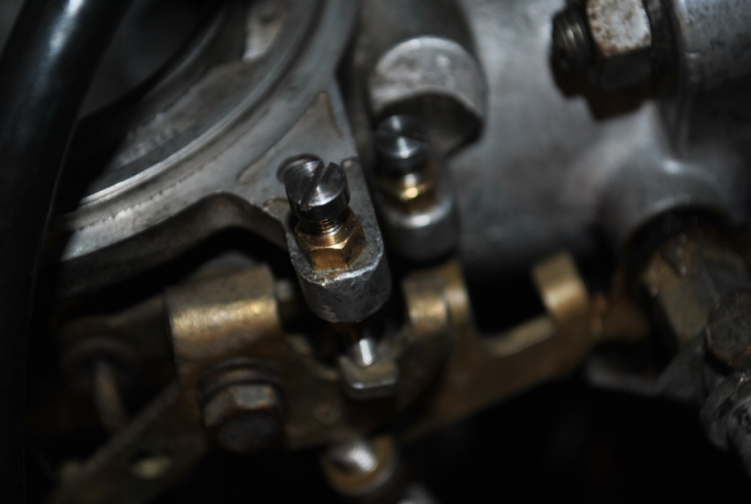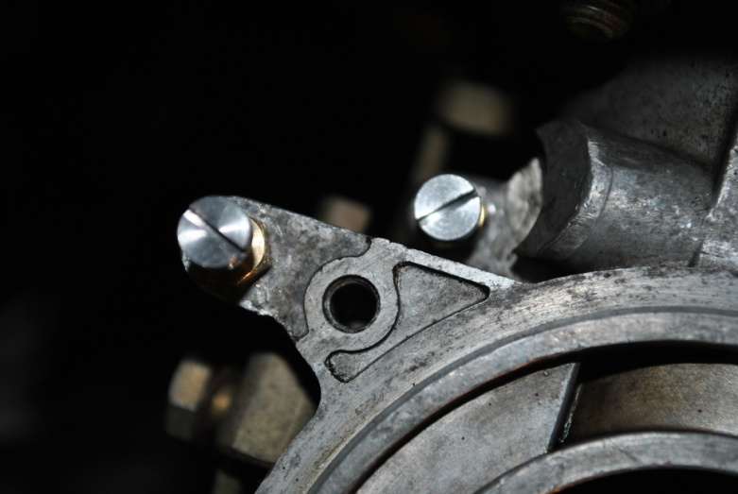

I STRONGLY SUGGEST DOING ONE CARBY AT A TIME.

Wash the bell chamber, paying particular attention to the inside bore. It must be CLEAN, and NO scores, scratches, etc are permissible. If it has deep gouges, a replacement will be needed. Light scratched/wear marks can be removed by using 1000W&D paper, with kero lubricant, and carefully polishing the surface. DO NOT rub in one spot, rotate the chamber so a good even rub is achieved on the whole surface. DO NOT rub hard, smooth long rotational rubs are required. You really do not want to actually remove any metal here, just polish it SMOOTH.

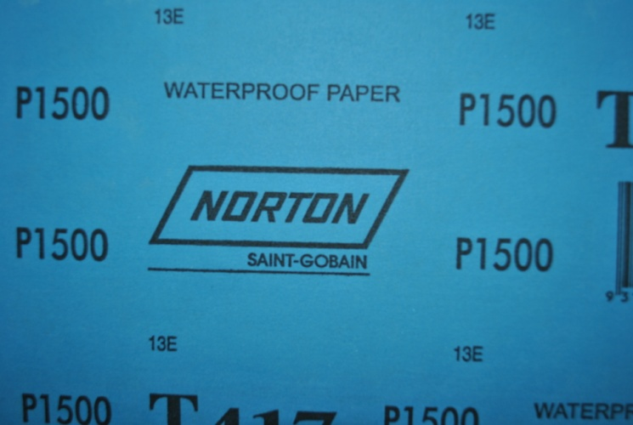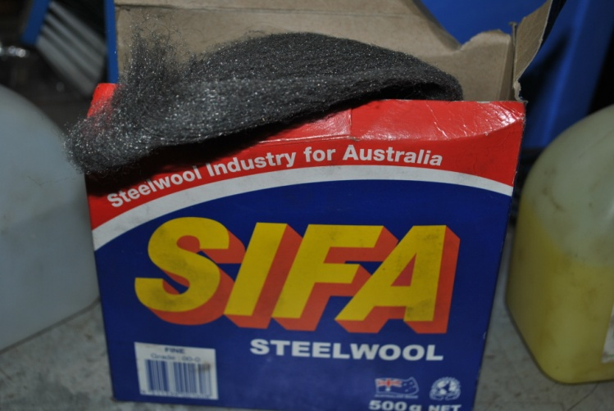

I had 1500 wet & dry on hand so used that on the inside, fine steel wool on the outside. And a glass of red for me.

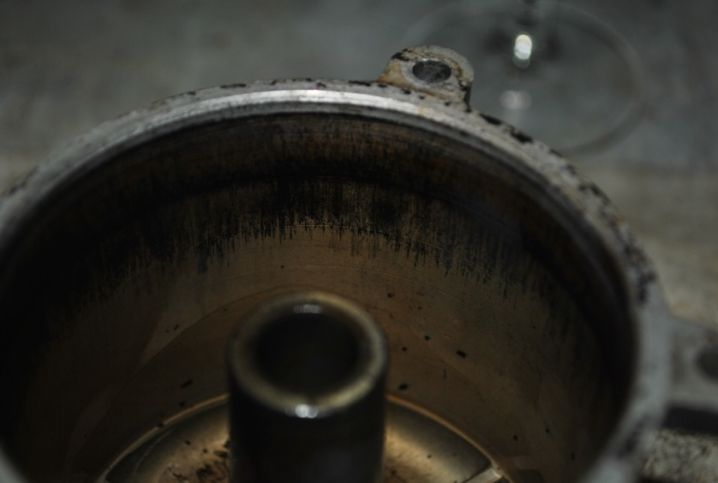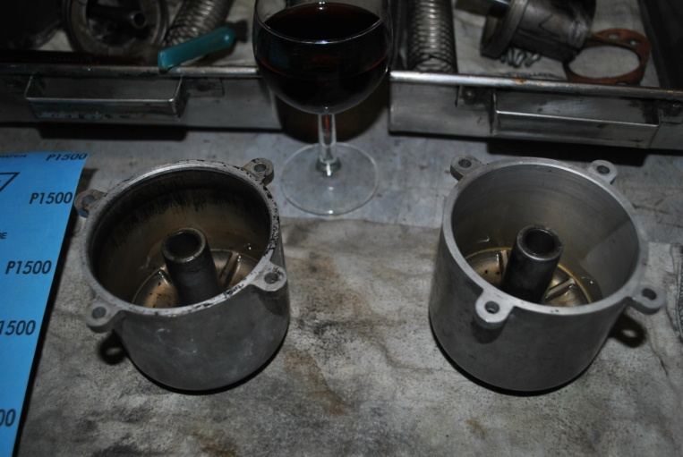

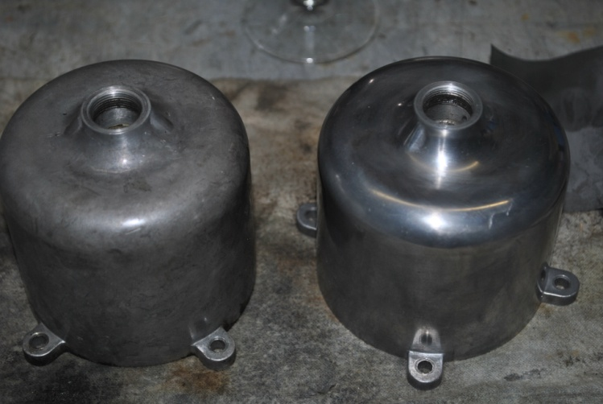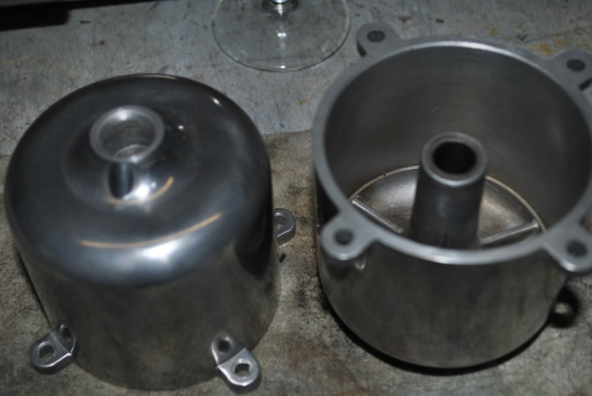

Now check the piston outer circumference, paying particular attention to the 2 grooves. Use a nylon brush with kero to clean this up as good as the bell chamber.

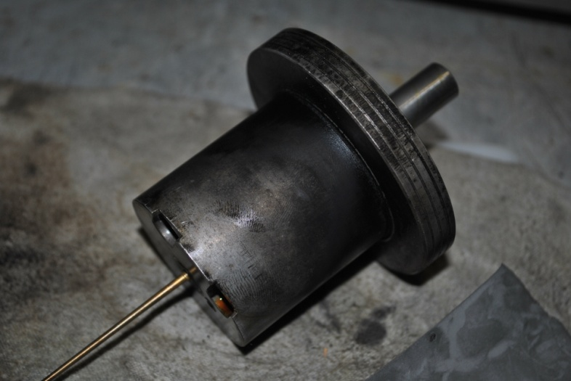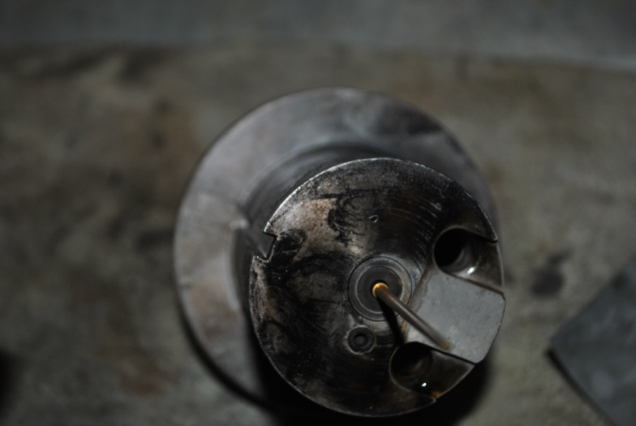

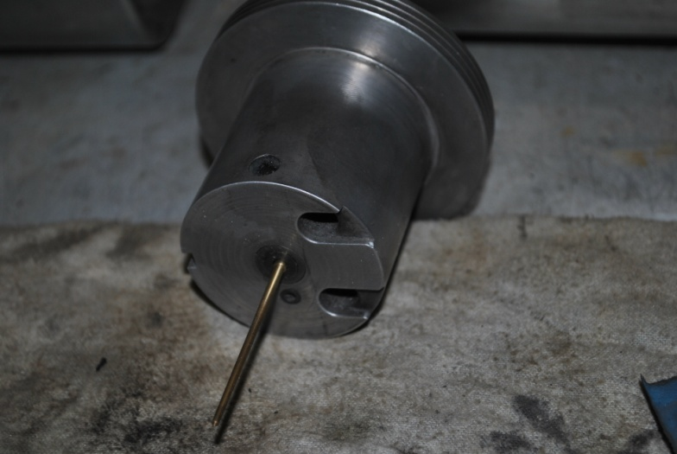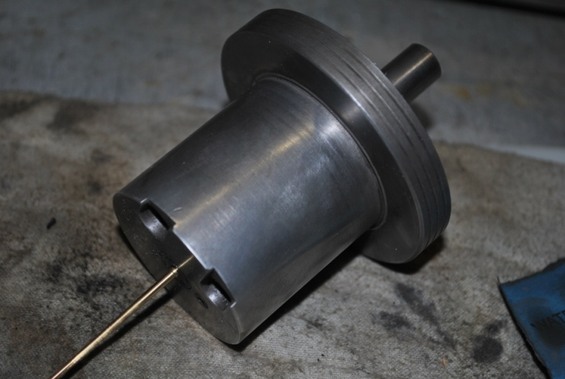

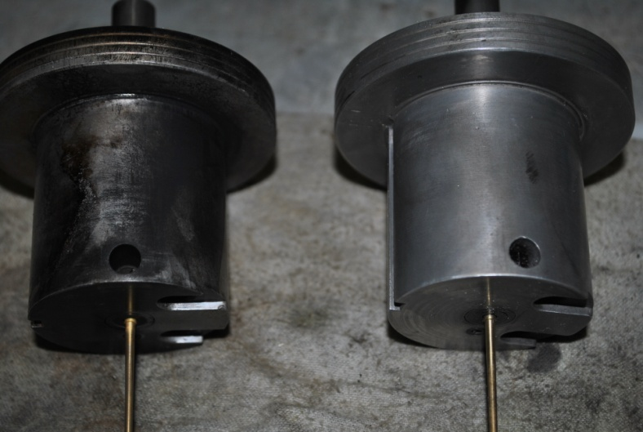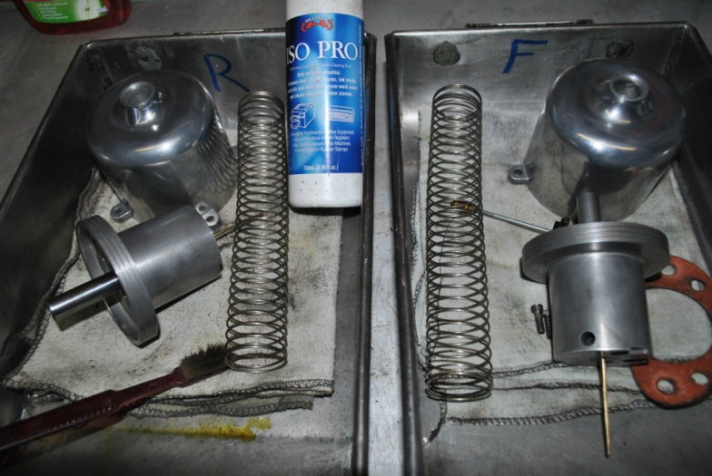

Once satisfied, rinse both items with P/Pack Carby cleaner, and set aside to dry.

