SU HS8 Removing,servicing and refitting
Some text taken from an earlier post in this thread By: Grant Francis (Grant Francis), Veteran member
& Ken Hill (cat_as_trophy), Senior member
Pictures and car by (and some text): Clarke Bryant (o1xjr), Senior member

This is a quick rundown on removing carbys to replace jets, gaskets, mixture needle and float bowl needle and seat. Butterfly and spindle can be changed if needed. I did consider trying this operation with carbys still in car, but good advice from this forum changed my mind.

Take lots of photos before and during the complete process, if you don’t do this type of work regularly or you have to wait until next weekend to re-assemble it is easy to forget what goes where.

Remove the air cleaner cover, AND the backing plate. Undo cross stay at from inner gaurd, and loosen bolt at firewall and swing it to other side of motor to sit on the other cross stay. This will allow easy access to rear carby.

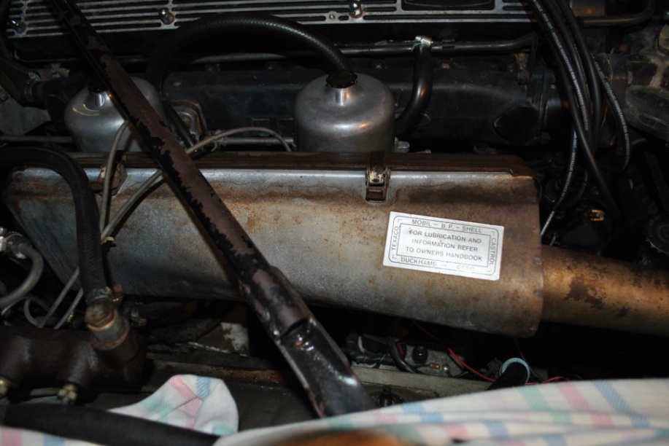
Cross stay

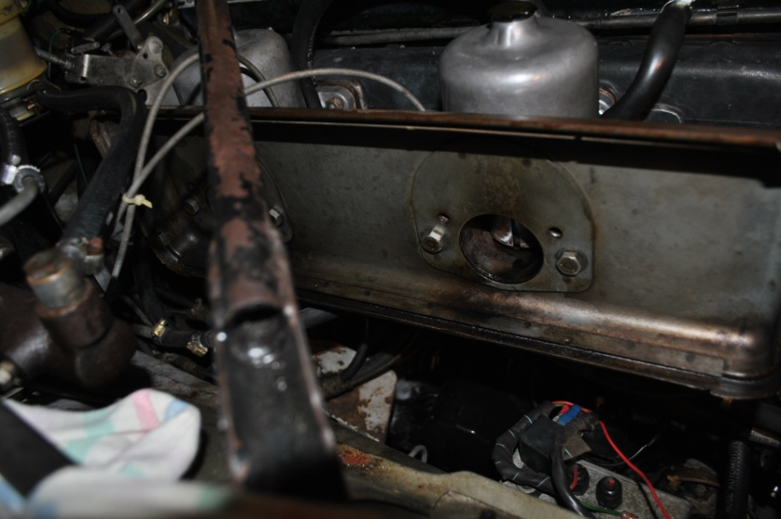

Disconnect choke cables, label them front and rear. Remove vacuum hoses and fuel lines, plugging fuel lines with a bolt or similar. Taking note of where to replace hoses etc.

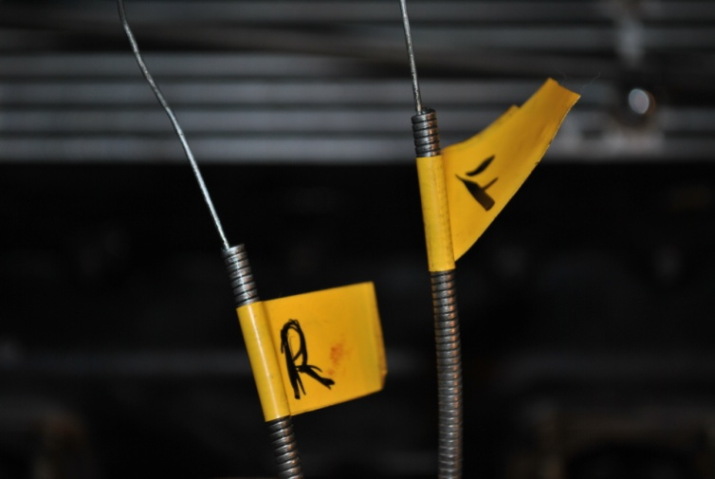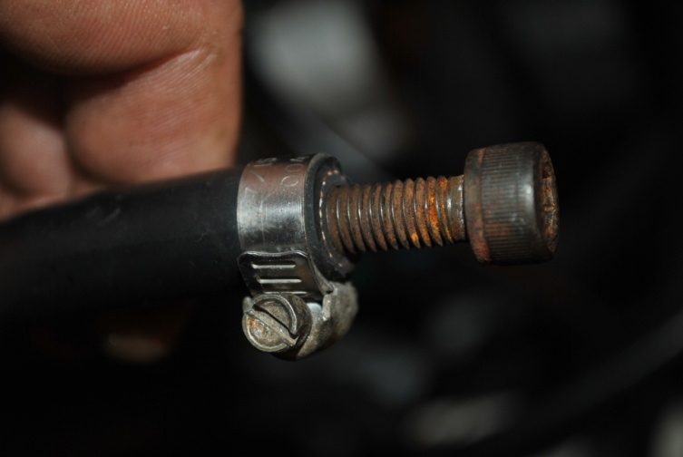

Remove circlip from shaft near cable (out of picture). Disconnect throttle linkage at rear of the rear carby.

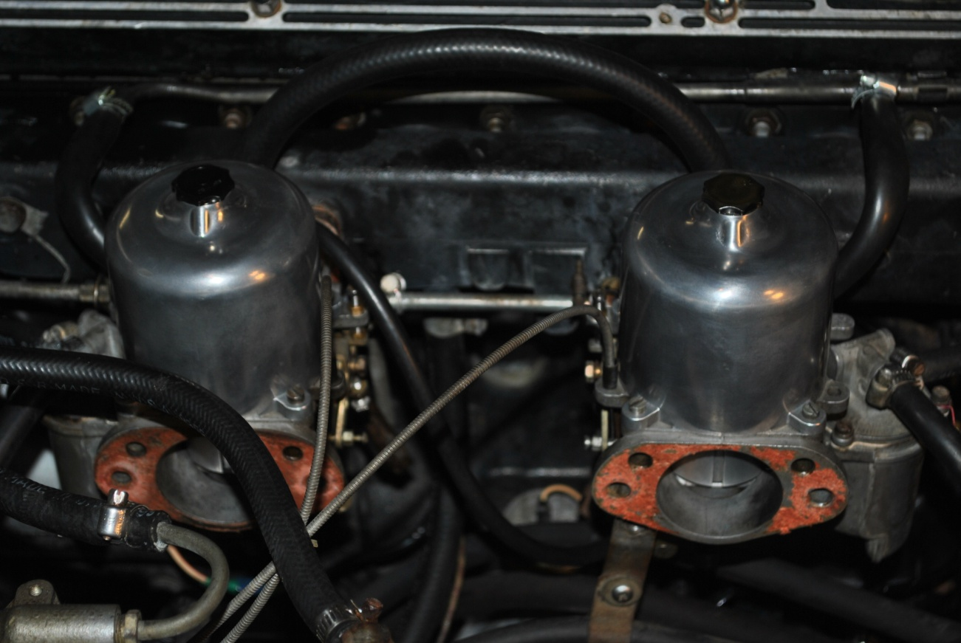
Circlip

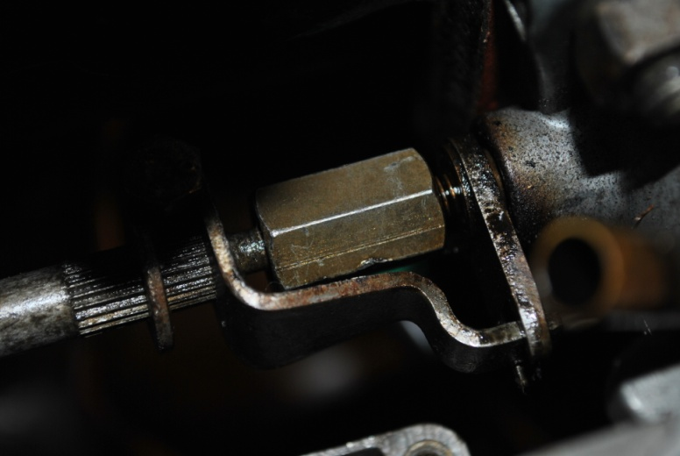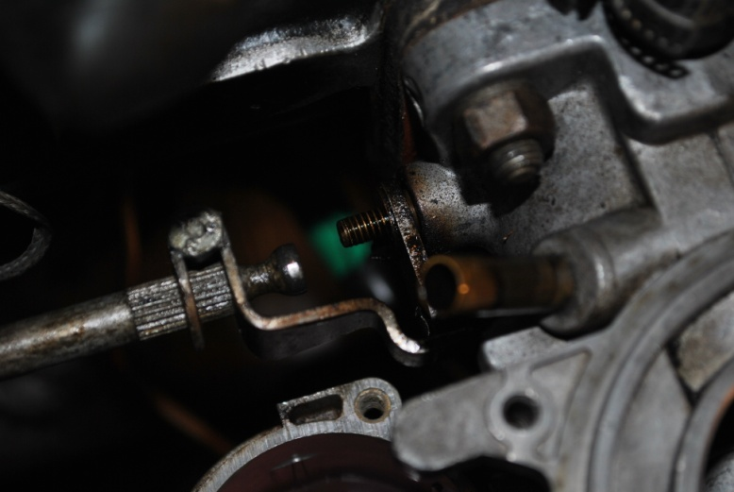
At this point it is best to remove as many parts as possible while carbys are still bolted solid to the manifold. Reducing the risk of slip and damage to screws, fingers etc trying to work on a bench with carby not fixed to motor

Remove the carby bell chambers (the top dome thingy), lift off the long spring, then CAREFULLY lift out the piston. When lifting the piston, lift it straight up until clear of the carby, as the brass needle is easily damaged.

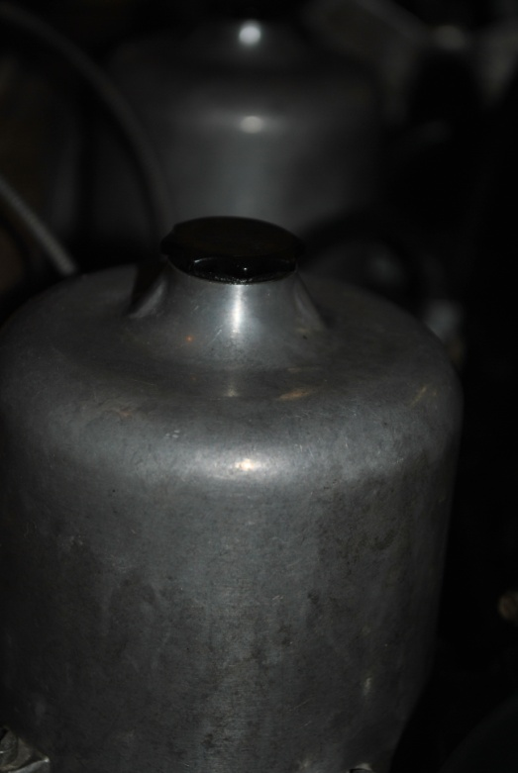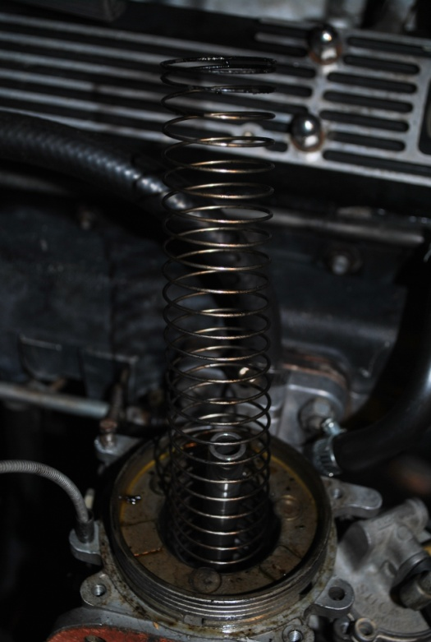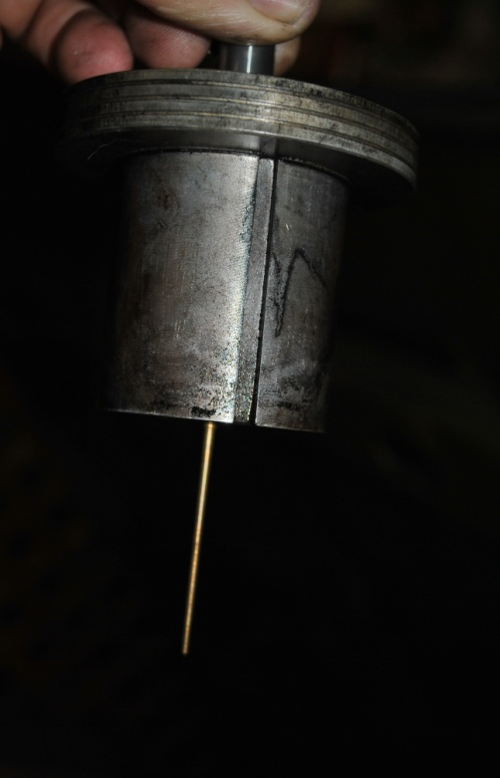

Note: All parts removed must be kept separate so that they can be re-installed into their correct carby. Multiple plastic ice-cream containers are useful.

Remove the float bowl lids at this point as well

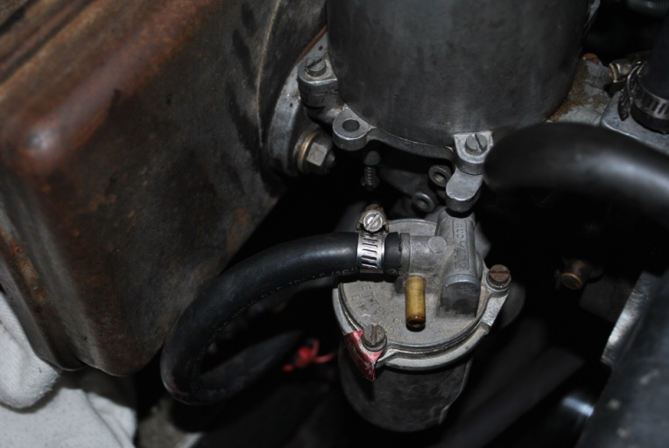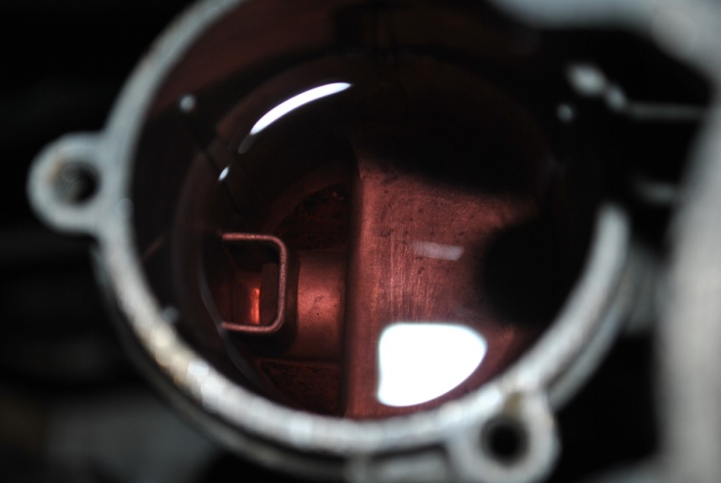

The next step is to remove the 4 x ½” nuts on each carby which fix them to the manifold. Lower nuts are out of sight below throttle linkages.

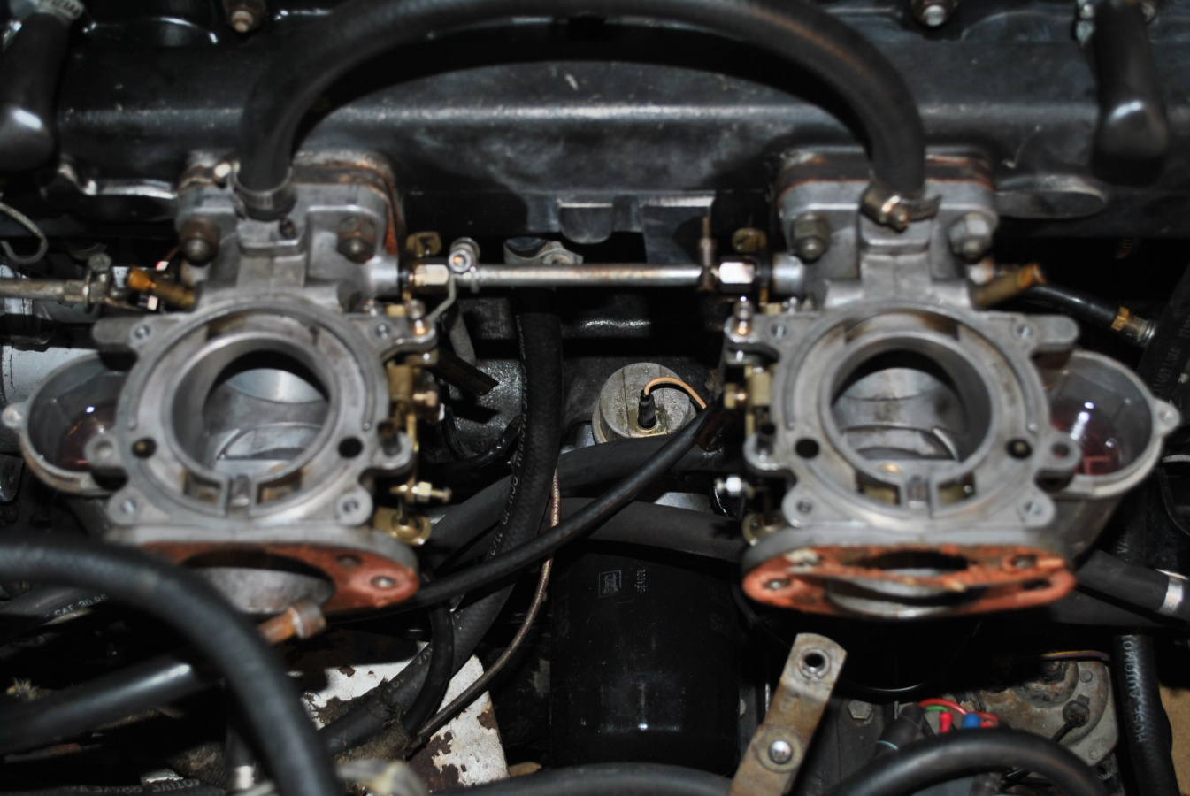

Lower nuts are here (see red arrows)

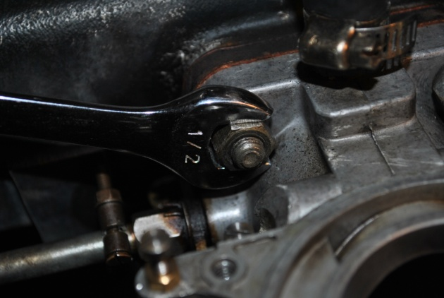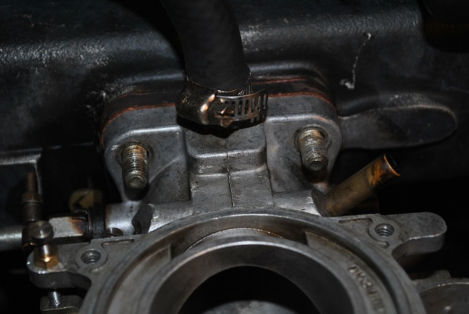

Throttle return springs and brackets come off with lower nuts to the manifold studs

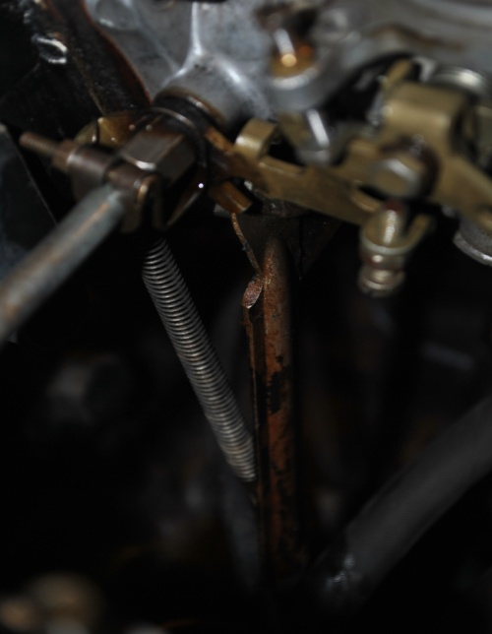
Bracket

Return spring
You won’t be able to reassemble and drive after this point, until you have the new parts.

You will need 4 x base gaskets
2 x backing plate/ intake gaskets
2 x float bowl gaskets
2 x needle and seat kits for float bowl
2 X Jet assemblys
2 x mixture Needles(with the right code stamped on them)
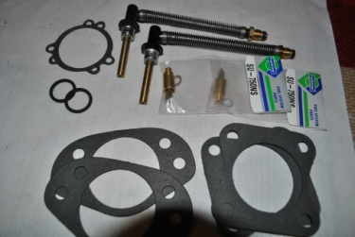

Gently wriggle carbys off manifold

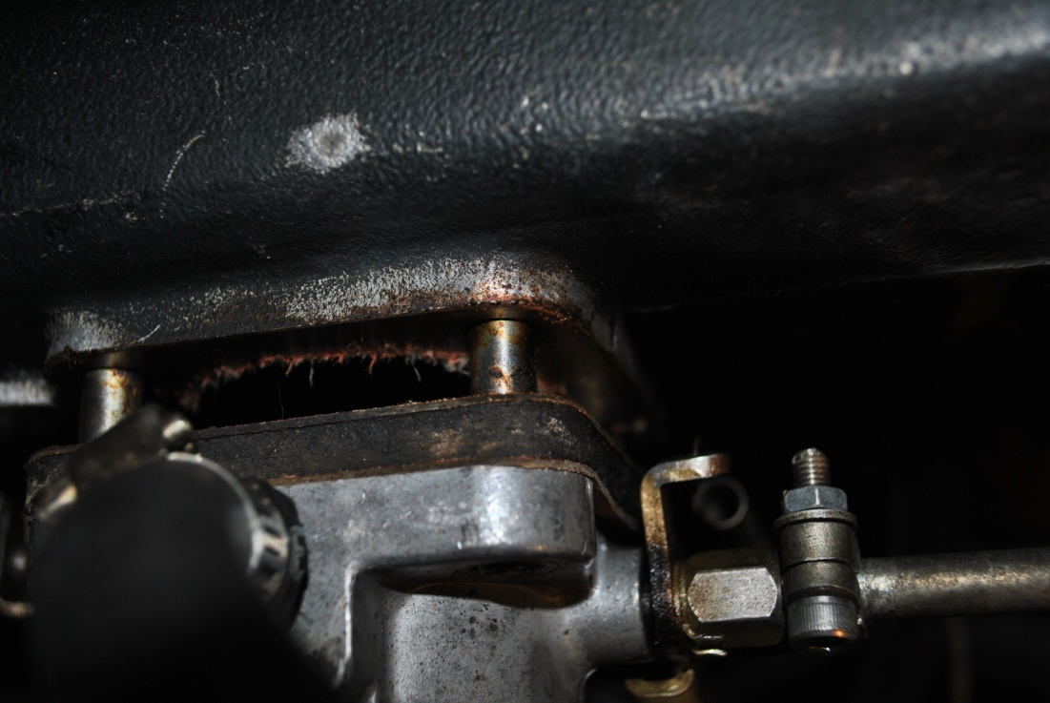

Take pictures before separating carbys so you know where linkages go back together.

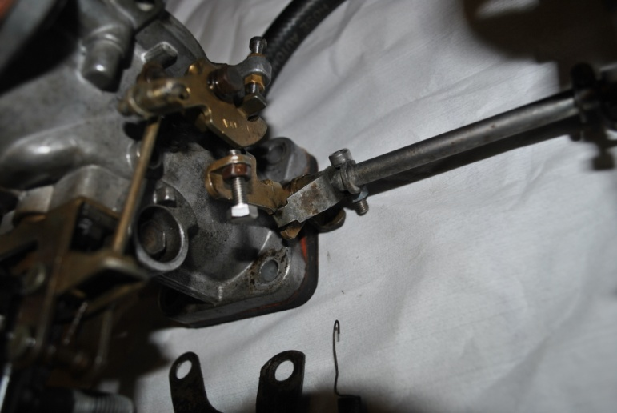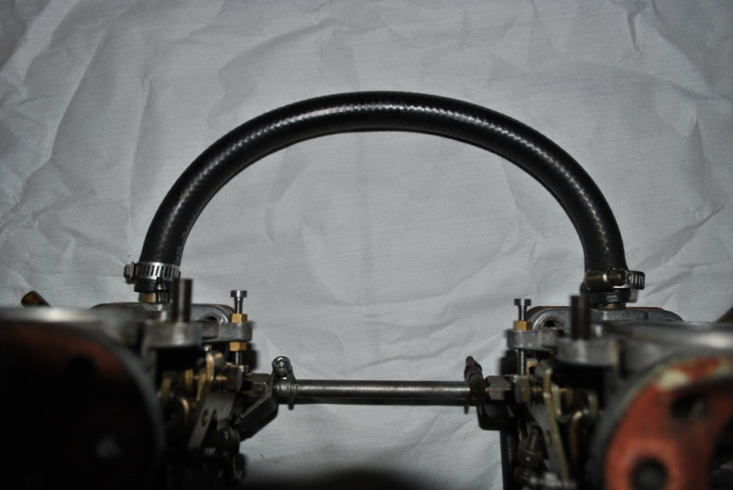
Position of return springs and brackets for reassembly

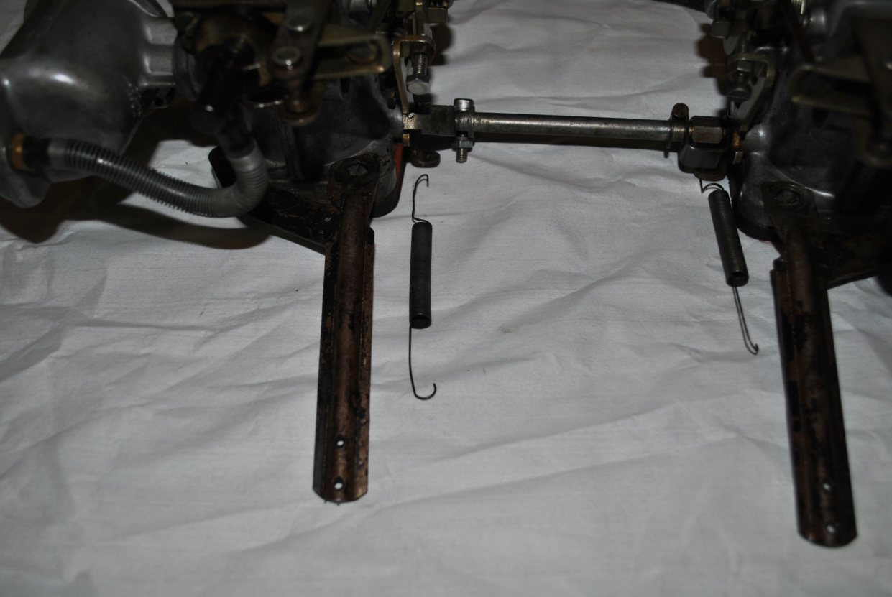

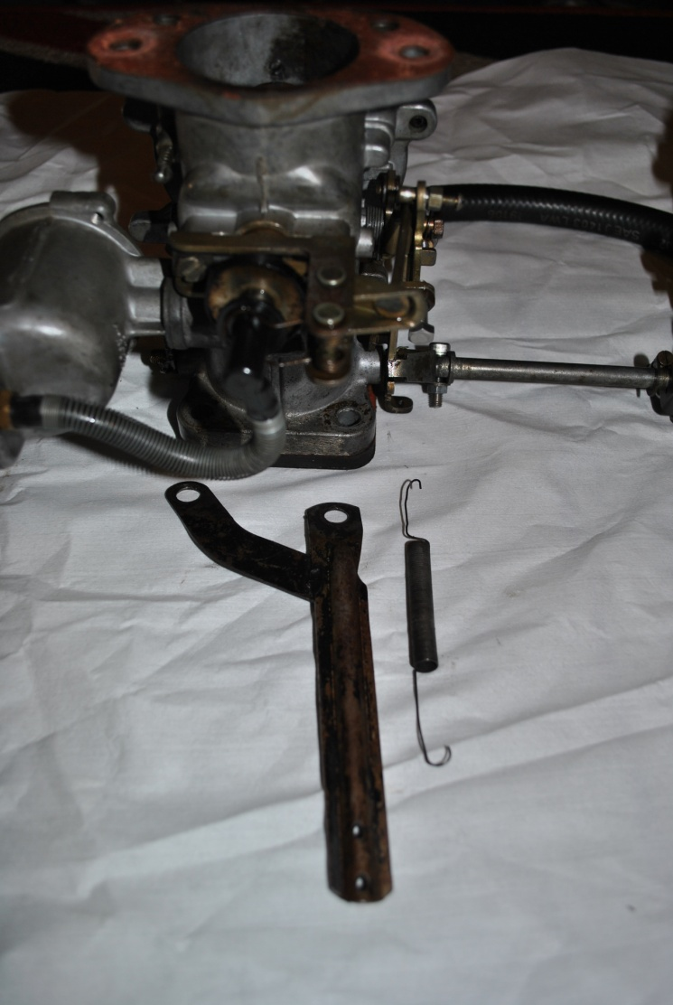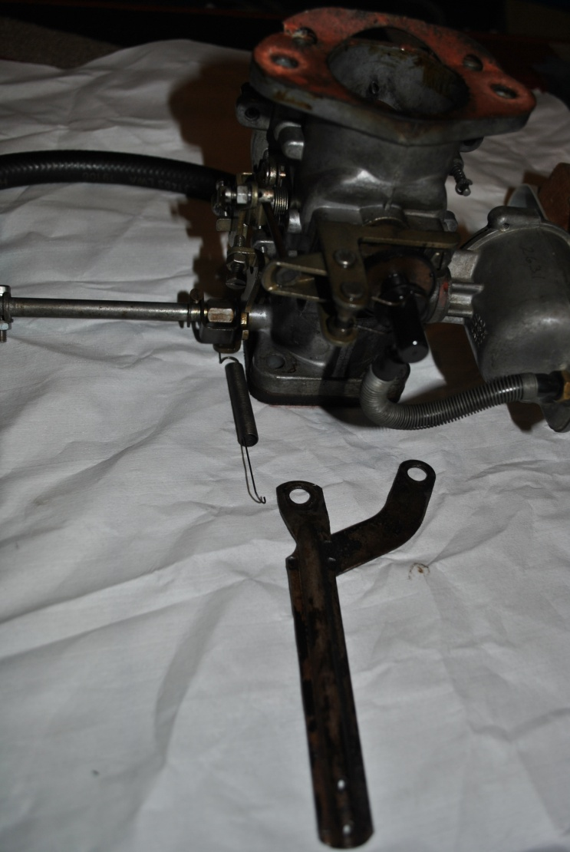

You will have to remove pistons before getting your parts to get the code off your old mixture needles. I was lucky, a previous owner had made a note on the cover of the air filter with paint pen.

Remember the importance of keeping each carby separated

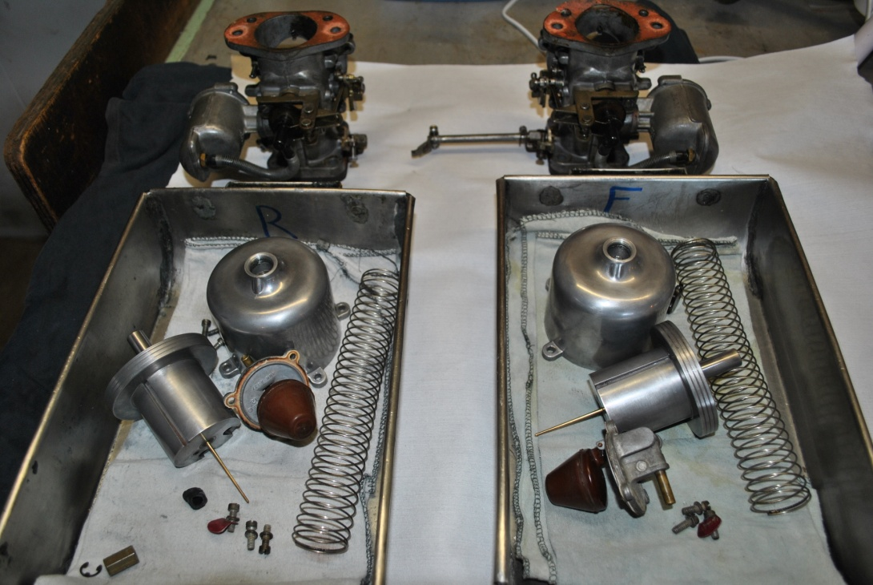

Remove old gaskets and clean the mating surfaces on carbys and intake manifold as well as air filter backing plate.

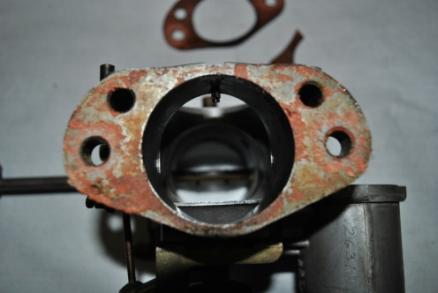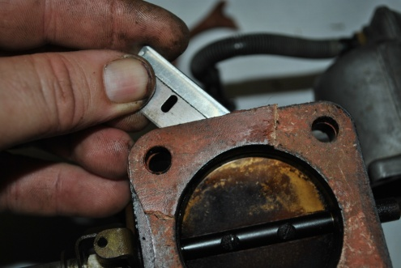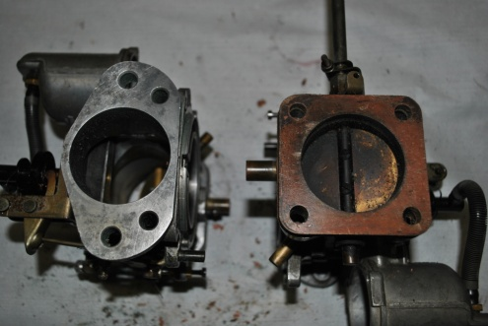

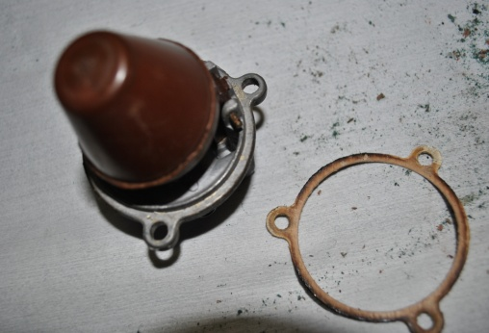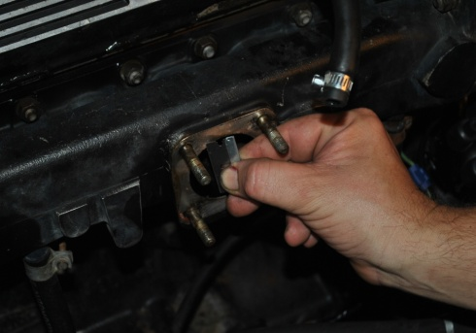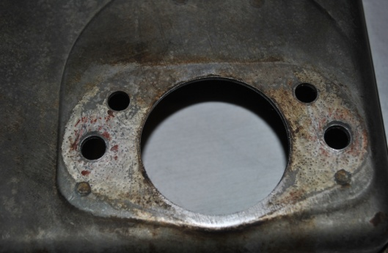

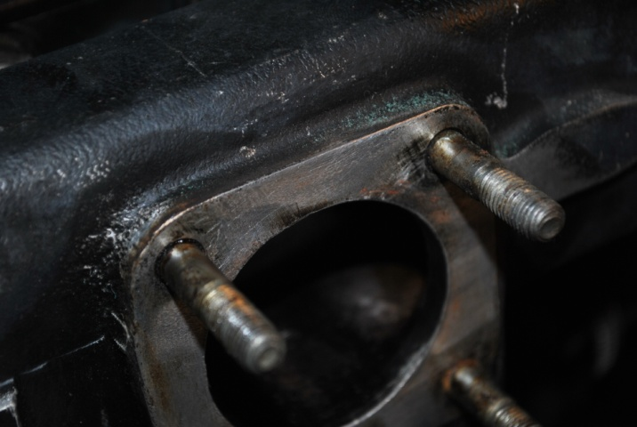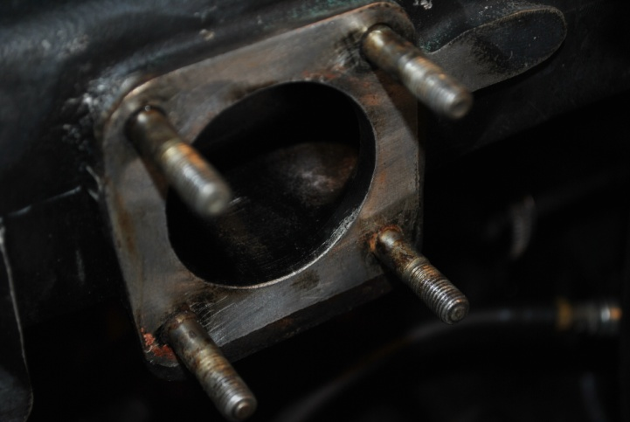
Blow out all dust and debris left from removing old gaskets. With compressed air if available.

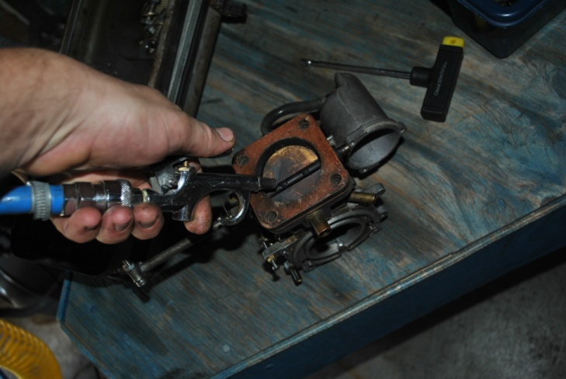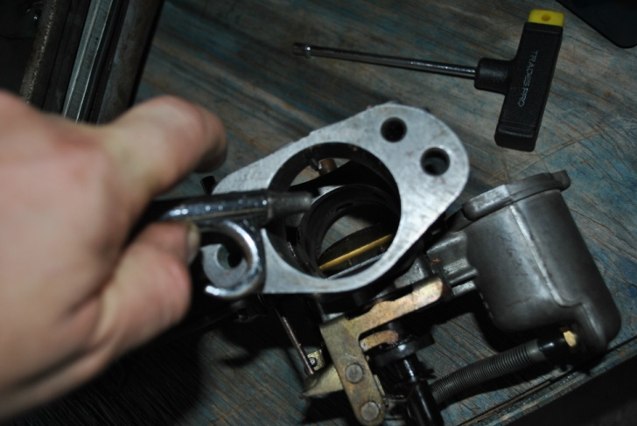

Degrease and scrub carbys with a toothbrush and hose away gunk. This makes removing and replacing serviceable parts clean and contamination free.

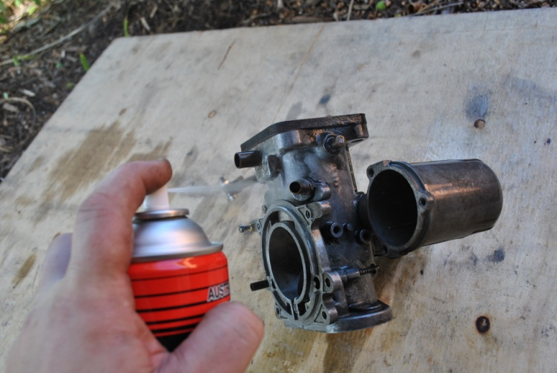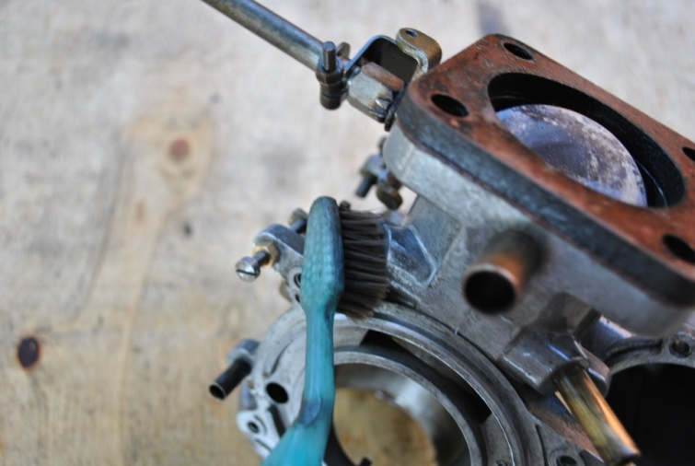

I seem to buying this stuff in bulk since the XJ6 arrived in my garage.

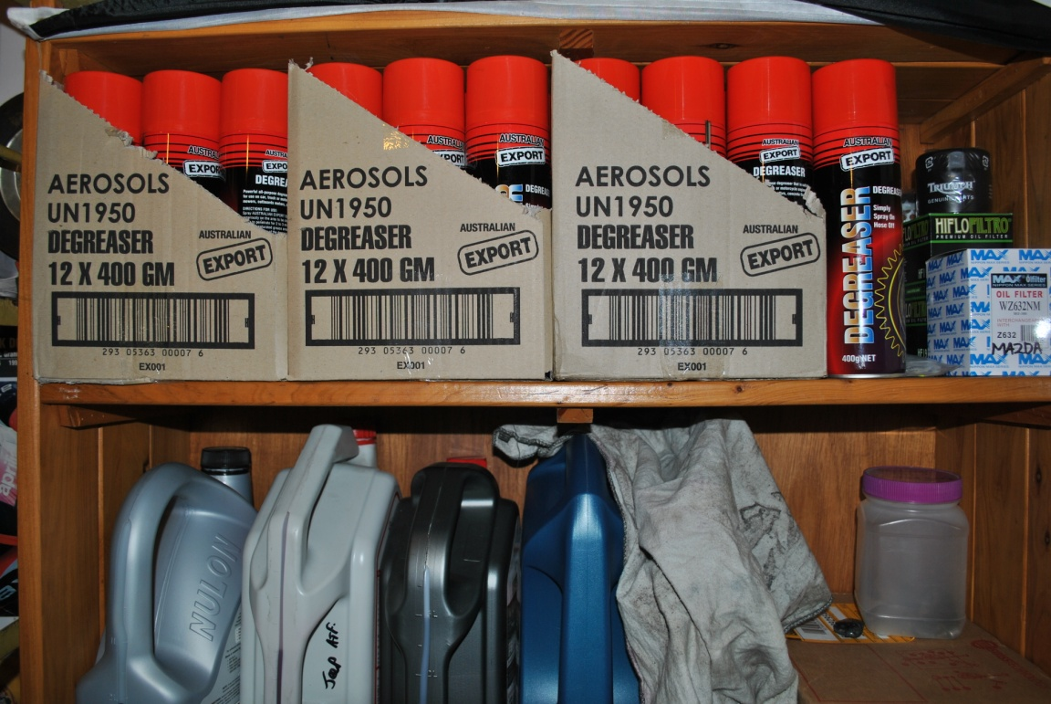

Spray with IPA (isopropyl alcohol) and blow out with compressed air if available. As it leaves no residue and evaporates quickly taking water with it. Buy some from a computer parts supplier o repairer, you won’t believe how many uses it has.
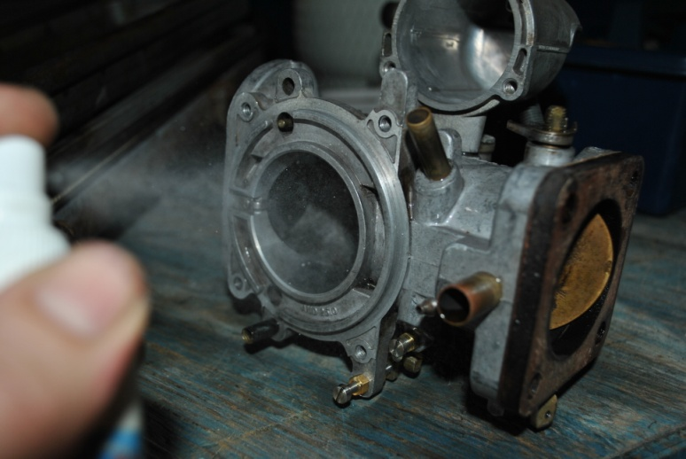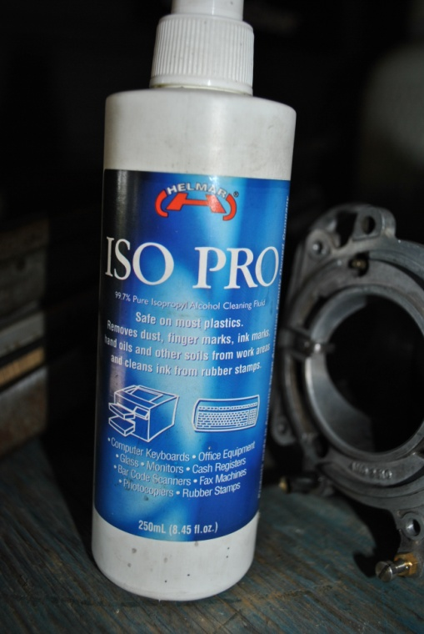

Clean up your work space and put down a clean lint free cloth to work on, this way you avoid getting bits of old gasket etc caught up inside carby causing problems after assembly.

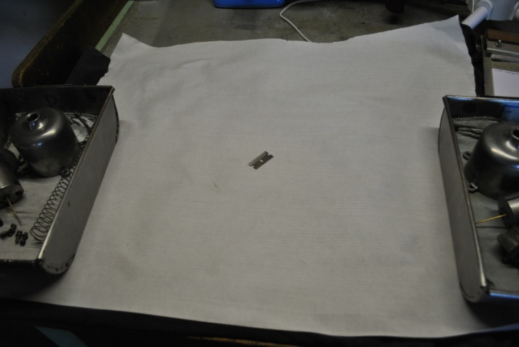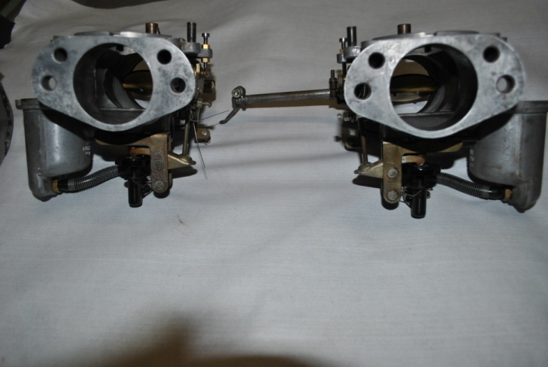

Ready to start parts replacement....tomorrow
Time for a well earned “Amber happy Juice” in my local footy teams cooler
“Jindalee Jaguars Australian Football Club”

