Instrument Panel and Console - Glove Compartment
Removal and Installation
Removal

1. Remove the instrument panel end trim panel.
● Release the 3 clips.
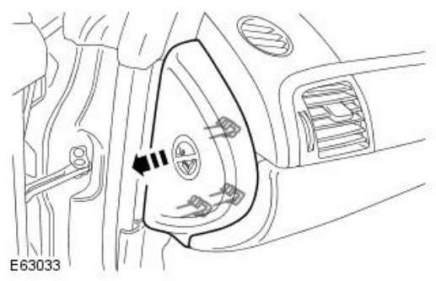
2. CAUTION: Removal of the clips is a delicate
procedure, damage will occur if any force is used.

Remove the passenger side footwell trim panel.
- Remove the 3 clips.
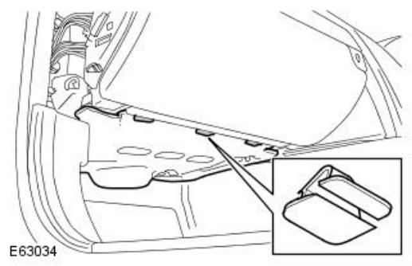
3. Release the glove compartment.
              - Remove the 5 Torx screws.
              - Release the 2 clips.
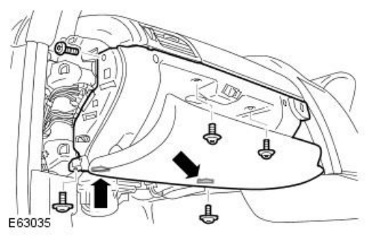

4. Remove the glove compartment.
              - Disconnect the 2 electrical connectors.
              - Release the glove compartment lamp assembly.
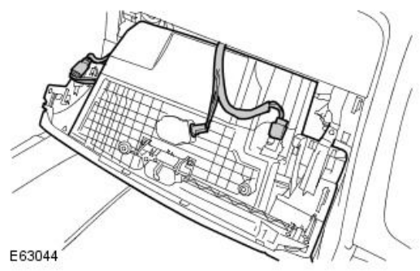
.
Installation

1. Install the glove compartment.
● Install the lamp assembly.
● Connect and secure the electrical connectors.
● Tighten the Torx screws.
2. Install the passenger side footwell trim panel.
● Carefully secure the clips.
3. Install the instrument panel end trim panel.
● Release the door aperture seal.
● Carefully secure the clips.
● Install the aperture seal.

