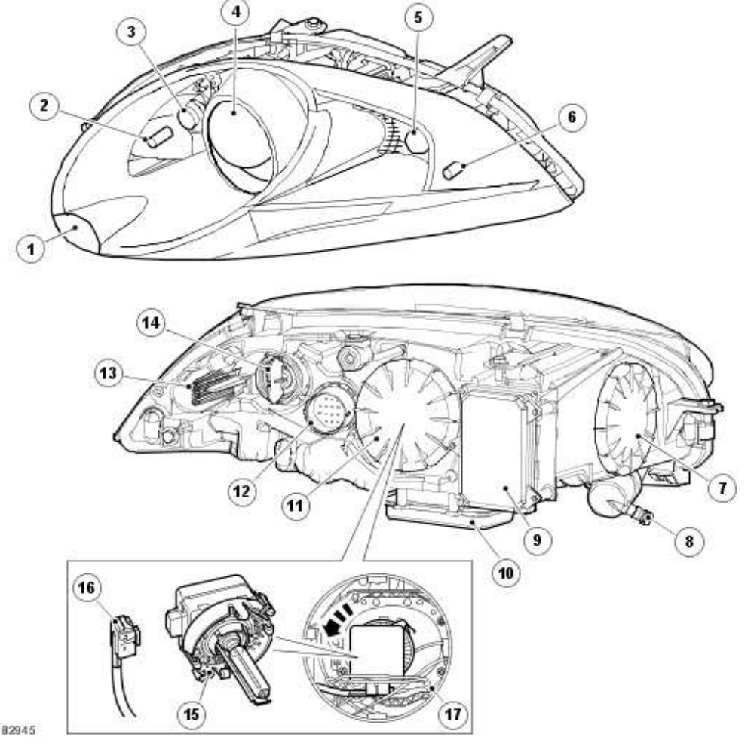

ADAPTIVE FRONT LIGHTING SYSTEM (AFS)
The AFS headlamp is similar in its construction to the Xenon, non-AFS headlamp. The projector module is constructed and functions as described for the Xenon headlamp but with the addition of the AFS system which allows the projector module to be moved vertically and horizontally. The AFS system is controlled by an AFS control module which is integral with the headlamp levelling module. The AFS headlamp assembly contains an additional carrier frame which provides location for the AFS actuators. The remaining lamps are as described previously. The carrier frame is attached to the AFS vertical actuator. The projector module has a central pivot point which allows the module to move horizontally in response to operation of the AFS horizontal actuator.

