2008 XKR interior rear quarter trim panel removal
My “new” 2008 XKR convertible arrived with the leather damaged on the passenger rear quarter panel. I was able to remove it, cut out the damaged part and refit a leather piece to recover it. Not perfect, but barely noticeable.
Getting the panel out was tedious, but not technically difficult. It’ll require the convertible top to be folded and the tonneau cover to be open for access to all parts.
- Retract the top into the storage area behind the seats and turn the car off.
- Remove both rear seat bottoms by inserting your fingers under the front lip and pulling up, dislodging the “fir tree” fasteners under the seat.
- Slip you fingers behind the top of the center bolster and pry it loose (not off) and then the bottom. Lift up slightly and wiggle it back and forth to unhook it. Study the picture below to see why the top hooks are tricky to get off because of the T shaped slots.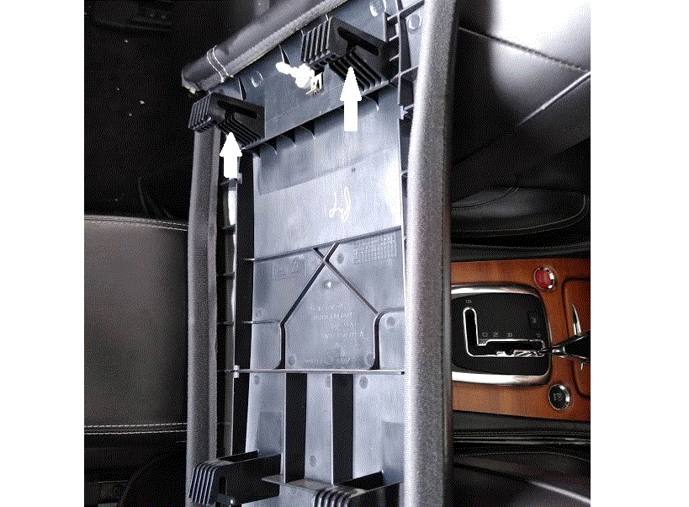
- The seat back unit is fastened with a T40 screw and washer below the seatback on both sides. Remove the screws and lift the seat back up and out of the seat belts.
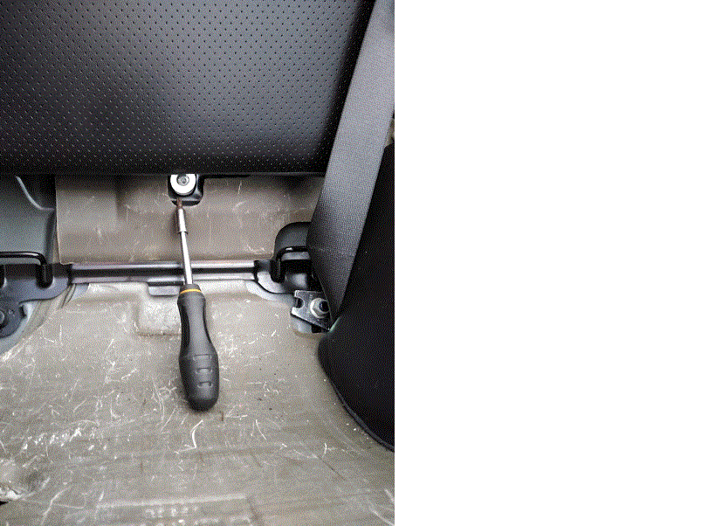
- The tonneau cover can only be lifted with the convertible top pump released for manual operation. Retrieve the hex key/wrench stored above the fuse/relay box under the center between the rear seats. Now open the trunk. On the right inside of the trunk is a vented access door. Behind this door is a plastic covered box with a hole in the center. Insert the hex wrench into the hole and turn it counter-clockwise a half turn to allow manual operation of the top mechanism. In that same access door is a cable loop (you may have to feel around and fish it out). Pull the cable toward the rear of the car to release the tonneau cover. See your owner’s manual for directions on how to release the tonneau and manually operate the top. Props (boards or whatever) may be used to support the tonneau cover at times.
- Close the trunk for clearance, and lift the tonneau cover to expose the hinges for the top. Look carefully and you’ll see a black string looped over an anchor point on the top mechanism and then over to a white plastic spring cover for a “door” on top of the upholstered quarter trim panel. The string holds that door in a closed position when the top is down. Pull the string rearward and unhook it from its anchor point on the top mechanism.
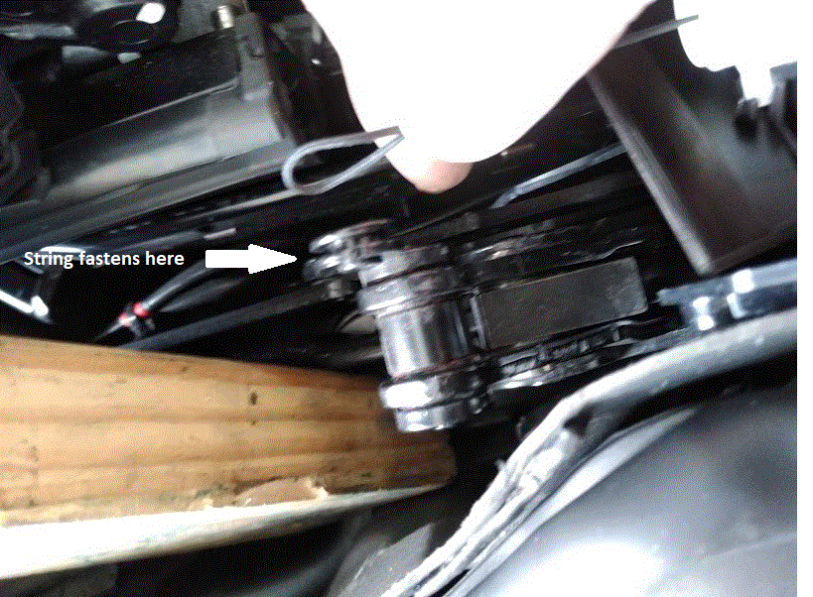
- Look below the open door slot to find the T40 screw that binds the trim panel to the outside of the cavity. It’s difficult to access. I used a quarter inch ratchet, coupler and T40 bit (picture on right below).
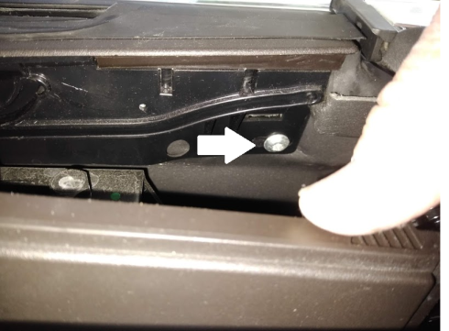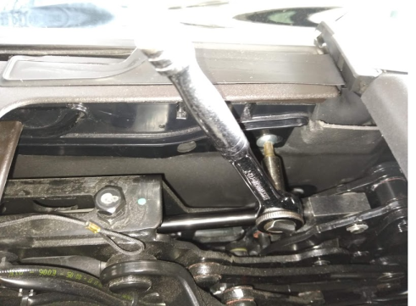
- The rubber seal next to the door opening will pry off, but it stays attached to the car, not the trim panel. Insert a plastic tool under the inside rear of the flat area and pry up. Again in the center. The front edge has a tab that slips under the groove. See picture below.
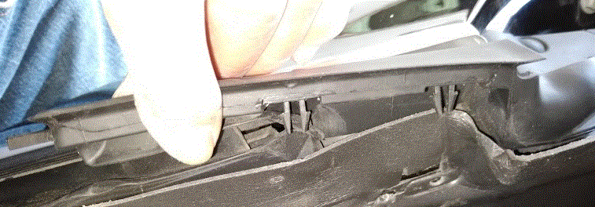
- Remove the T40 screws on the rear section of the trim panel – one on the curved metal strap near the top and one in the center of the rear of the panel. See panel picture below for locations.
- Unsnap the rear seat buckle cover by pulling from the bottom. Remove the seat belt buckle bolt with a T50 bit.
- Remove the inner door sill plastic trim. Slip your fingers under the forward end edge (near the door hinge) and pull up. Work rearward and then slip the rear edge from under the quarter trim panel.
- On the lower front edge of the trim panel you’ll see a small plastic screw cover. Pry it from the bottom with a plastic tool. Remove the T40 screw.
- Pry the whole quarter trim panel toward the inside the car to unseat the “friction fasteners” holding it.
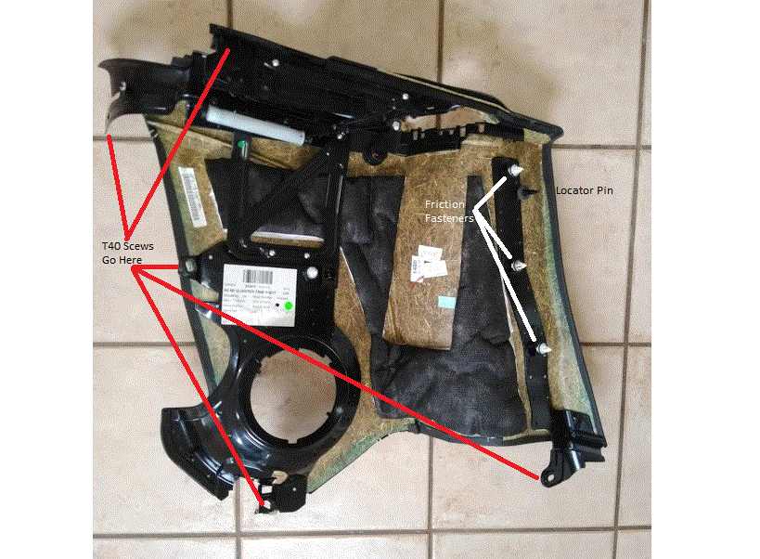
- A few caution notes on reinstalling the panel and associated parts:
  - Be gentle with the sliding door. It’s hard plastic and could snap. Don’t lift the quarter trim panel by putting your fingers below the sliding door because the nubs that hold the door in its tracks may flex and dislocate, requiring a gentle urging back into the proper track. If you hear a “snap” while in that section, slide the door back and forth to ensure proper track location and door positioning. Fix if necessary.
  - When replacing the quarter trim panel, you might want to start that “difficult to reach” T40 screw below the sliding door FIRST – before you do other screws. It’s easy to drop, and if you do, you’ll have to remove the panel again. Once it’s seated firmly in the treads, you should be safe to seat the panel into place and return to that difficult screw to finish tightening it.
  - After fastening the trim panel, don’t forget to refit the string to its anchor point. Once the panel is back in, lower the tonneau cover into place, but don’t try to snap it down. Go back to the trunk and close the top pump valve with the hex wrench (turn clockwise until it stops and then firm it up). Reinstall the access door.
  - Return the hex wrench to its holder above the rear fuse panel. Reinstall the seat back, seat bottoms and fuse cover.
  - Close the trunk and raise the top, being ready to stop if there are any problems.

