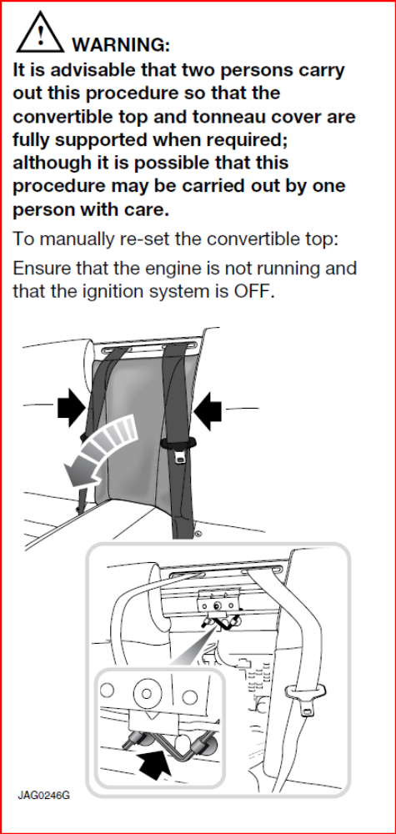
Appendix A – Manual reset of Convertible Top (Only required if Top malfunctions)
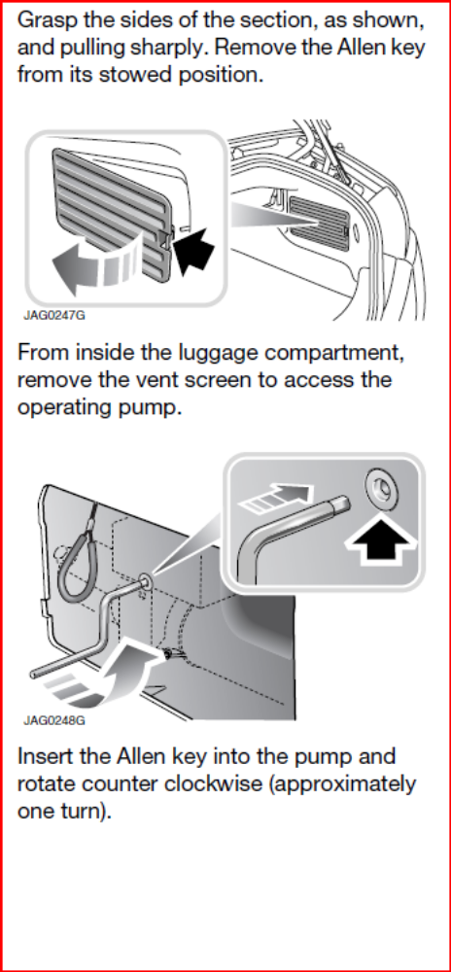

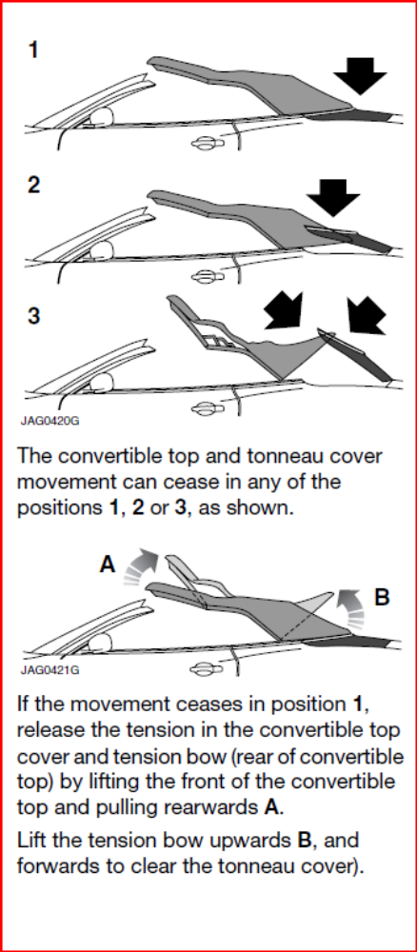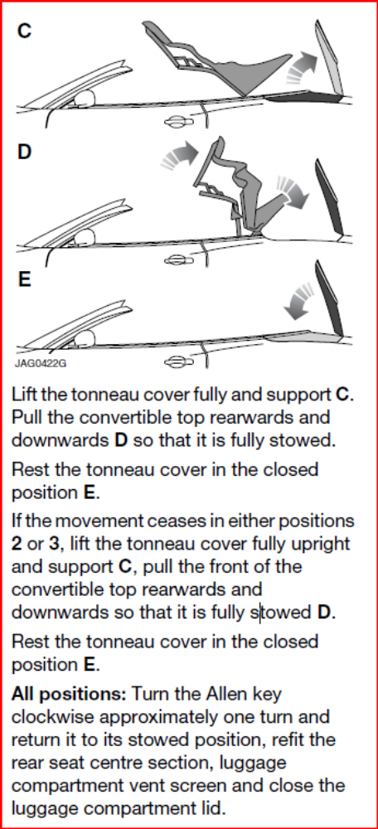
The top is now reset. Always operate the top for the first time after a reset with the console button (not the remote) and the engine running. Do not use the remote until proper operation is restored.

