Rear View Mirrors - Exterior Mirror Cover
Removal and Installation
Removal
1. Remove the exterior mirror glass.
For additional information, refer to Exterior Mirrror Glass in this section.
2. Detach the inner edge of the exterior mirror cover.
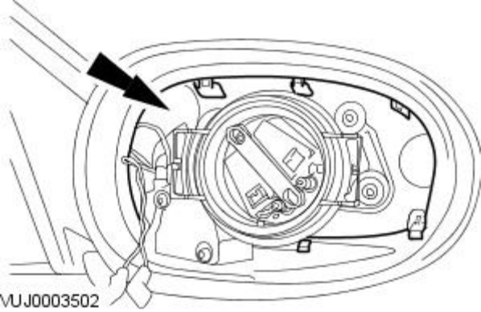
3. Detach the outer edge of the exterior mirror cover.
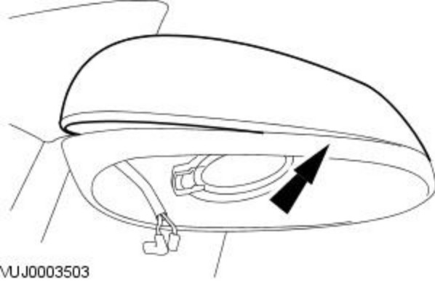
4. Remove the exterior mirror cover.
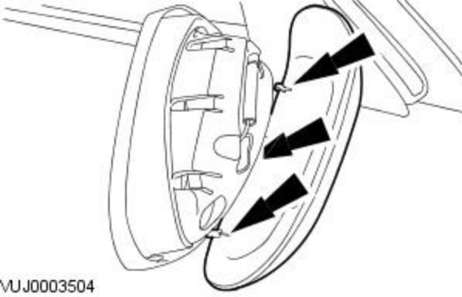
Installation
1. To install, reverse the removal procedure.

