Jaguar Grille Project
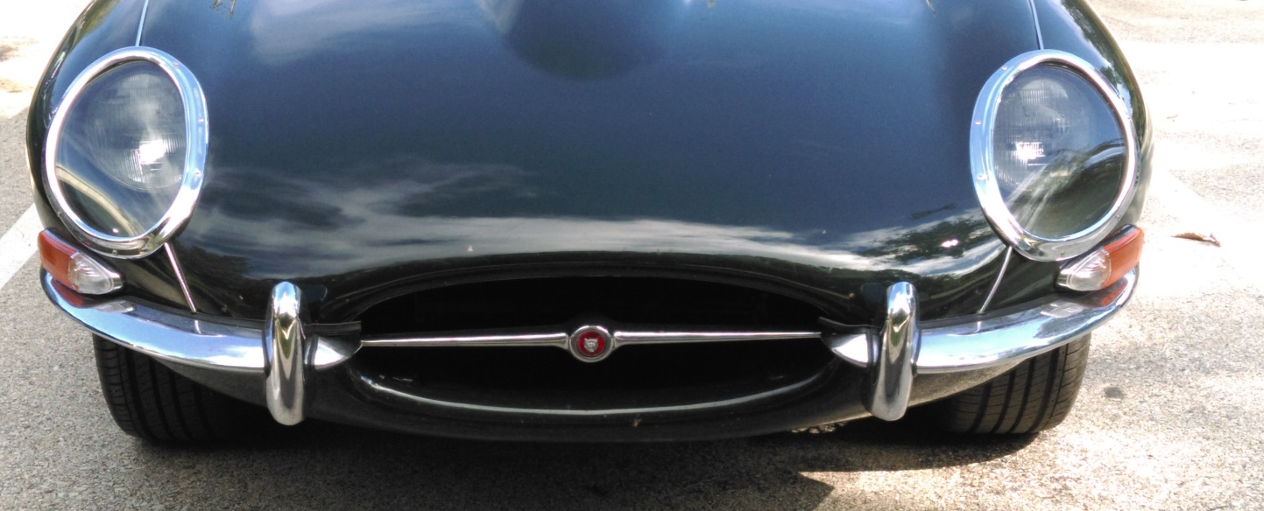
1963 Jaguar XKE
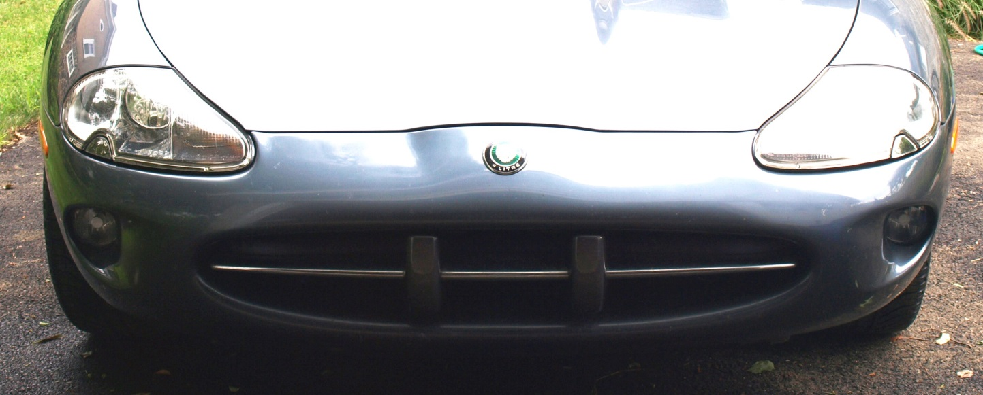
2000 Jaguar XK8 (Before)
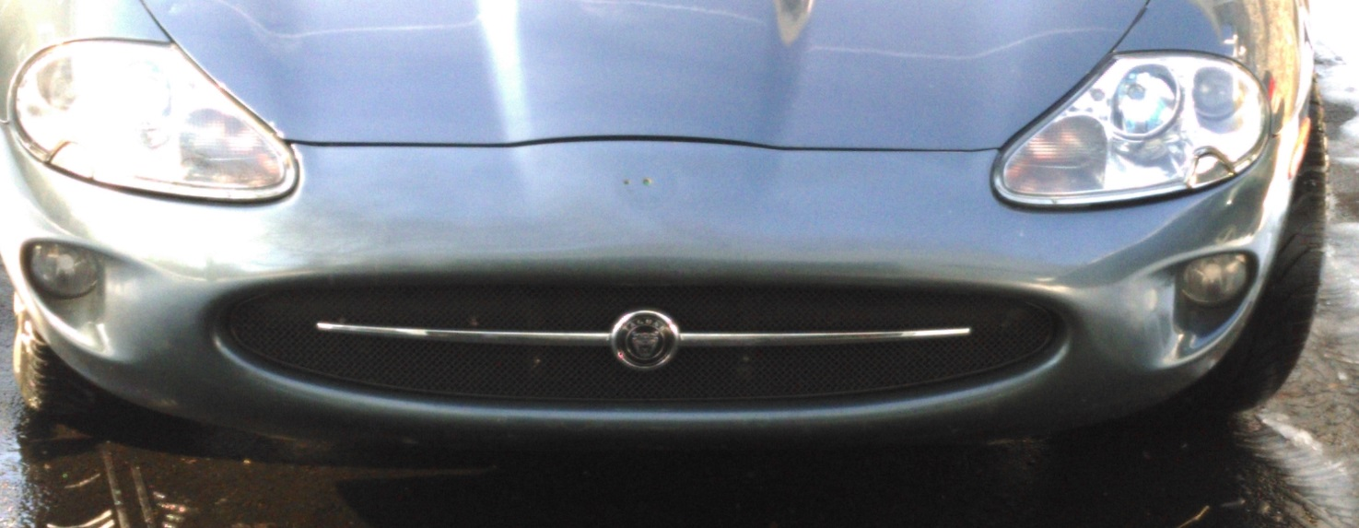
2000 Jaguar XK8 (After)

