https://www.jaguarforums.com/forum/xk8-xkr-x100-17/2000-xk8-power-steering-hose-108685/

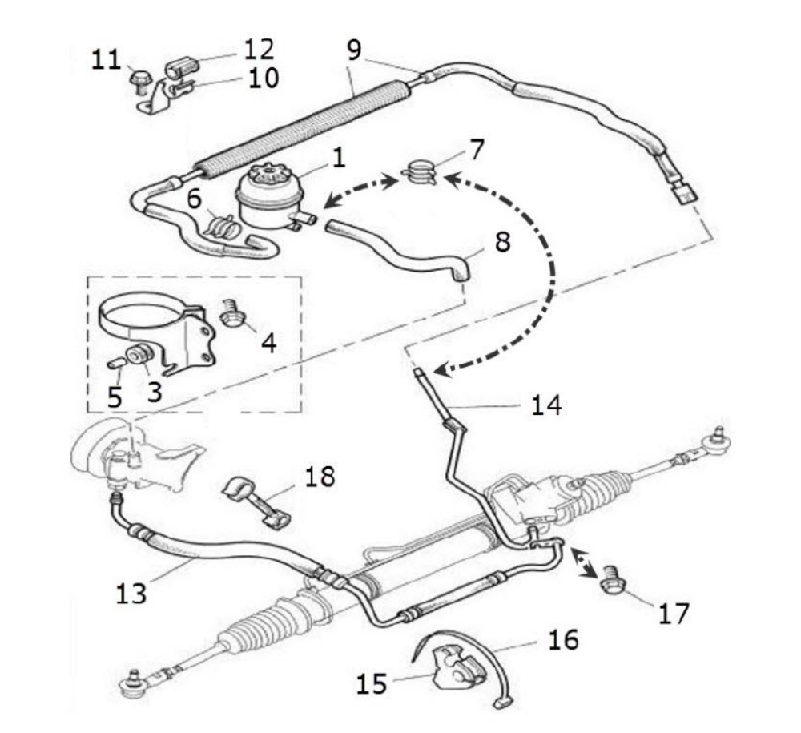
Hello, this will be My first how to post, hope will help. Just completed the job this weekend and estimate in a scale of 1 to 3 a mechanics ability of 2.
TOOLS REQUIRED
1-T-40 Torx
2-5/8 Crow Feet
3-12'' to 20'' extension
4-Patience
PROCEDURE
1-Disengage old hose from bottom flange with the #40 Torx, be prepare to collect the liquid and You will decide the removing of the X cross member.
2-Use the 5/8 Crow feet to remove the other end of the hose at the underneath of the pump.
3-Be aware that the new hose (MJB3985AB) requires a new route, go to photo 1.
4-Just connect everything back and remember to always use original liquids to maintain the systems working correctly.

