Replacing the “door-open” micro-switch
I have a 2003 XKR convertible. Within two weeks of each other the door windows would move down when the door was opened and move immediately back up when the door handle was released. This made it difficult to close the either door.

The solution to the problem is to replace the “door-open” micro-switch located in the door lock assembly. I found instructions on this forum on how to remove the interior door panels and remove the lock assembly.

I want to underscore the importance of disconnecting the battery when you have your hands inside the door while removing or replacing the lock assembly or doing anything else. I was able to remove, repair, and replace first the passenger side and then the driver side assemblies with almost no loss of blood. My only mistake was when replacing the driver side door handle. I had the key off but the battery connected and with my hand in the door triggered the window to go down (the top went down also!!). I managed to escape with a couple of cuts on my wrist and hand.

From past posts on this subject the difficult part has been finding a suitable replacement switch. The dealer sells only the entire lock assembly. I found an almost exact replacement made by Omron (part # D2SW-3L3MS) at Digikey (part# SW297-ND). The switches are almost the exact size. I paid $5.80 per switch and $5.49 shipping.

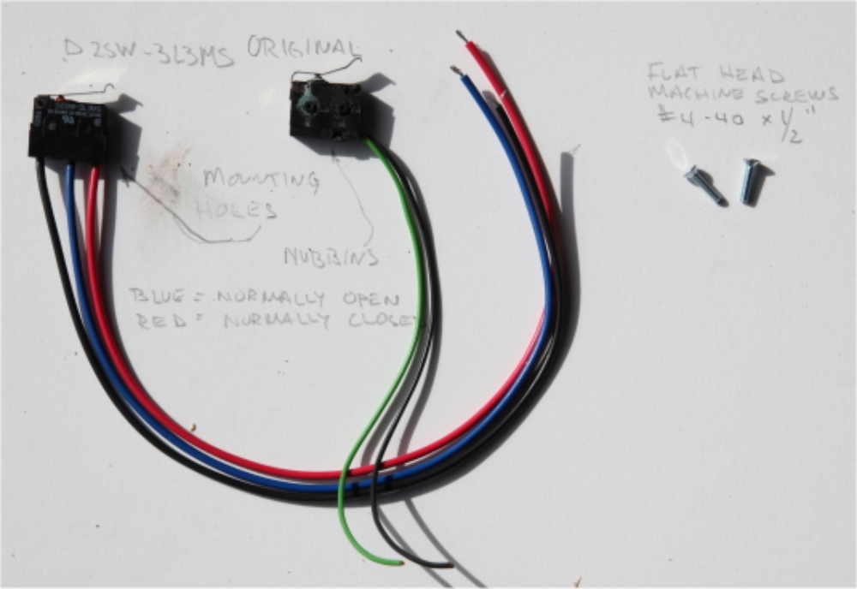
The differences are:
- The Omron comes with three leads; common (black), normally closed (red), and normally open (blue) while the original was two, common and normally closed.
- The wires on the Omron are heavier than the original.
- The Omron had mounting holes while the original has nubbins. Conveniently, the mounting holes are in the same position as the nubbins.
- The “roller” arm on the Omron is flat while the original is bent.

This is what I did.

- Remove the door-lock assembly (instructions can be found in this forum).
- Bend the lever of the new switch to match the bend in the original.
- Remove the switch; just wiggle it out from where it is held and cut the wires near the connector.
- Splice in the new switch using the common and normally closed wires. Solder the wires and insulate with heat-shrink. I cut the blue wire back to its insulation and tucked it in among the other wires.
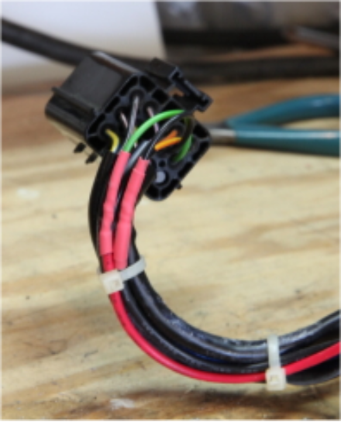
- Countersink the switch mounting holes in the door-lock assembly. 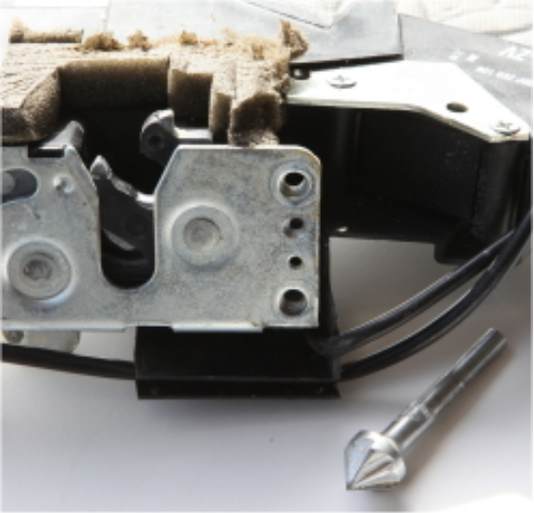
- Mount the switch using two #4-40 x ½” screws. No need to use nuts as the screw heads mount onto the face of the latch assembly; they are not going anywhere.
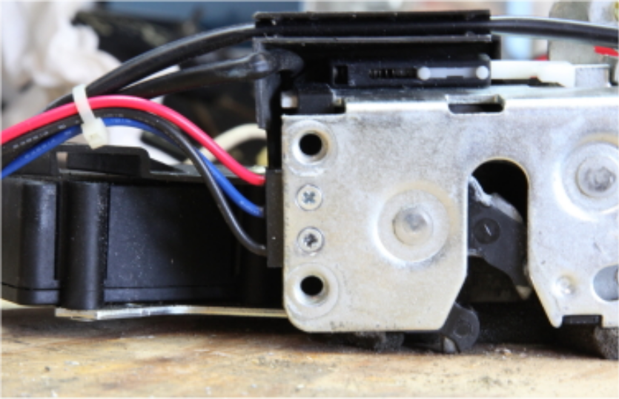

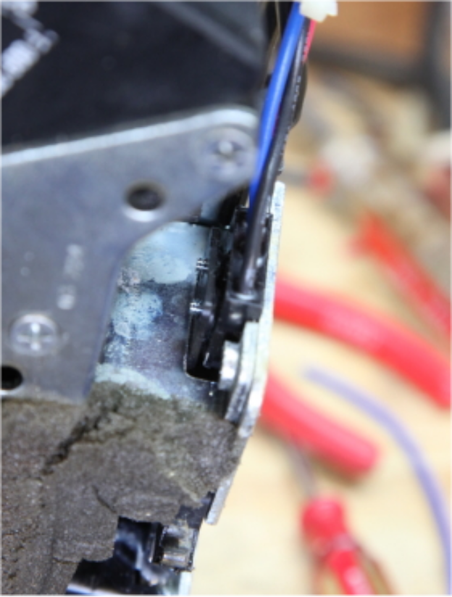

- This is a good time to lubricate the window regulator and gears, tighten loose mounting screws, and adjust the window position.
- Put it all back together.

